PRESS RELEASE

Wurth Electronics Hosts Annual Technical Training Show

Watertown (USA), 11 October 2018 – For the fourth year, Wurth Electronics has successfully held its technical seminars and tabletop show, WE Day, in Mexico and Canada. WE Day offers unbiased training from a diverse range of exhibitor. The comprehensive WE Day event allows engineers to find suppliers from printed circuit boards (PCBs), harness, distributors, and IC manufacturers at the same time.
“This event is an opportunity for us to improve our relationship with our customers, presenting topics of their interest,” says Gabriel Castaneda, Wurth Electronics Region Sales Manager in Mexico.
This year’s WE Day shows included guest speakers from IC partners, EMC labs, and distributors, and provided software training using the Wurth Electronics REDEXPERT tool. Wurth Electronics looks forward to returning to Mexico and Canada for WE Day, and is looking to expand the event to the United States in 2019.

Available images
The following images can be downloaded from the Internet in printable quality: http://www.htcm.de/kk/wuerth
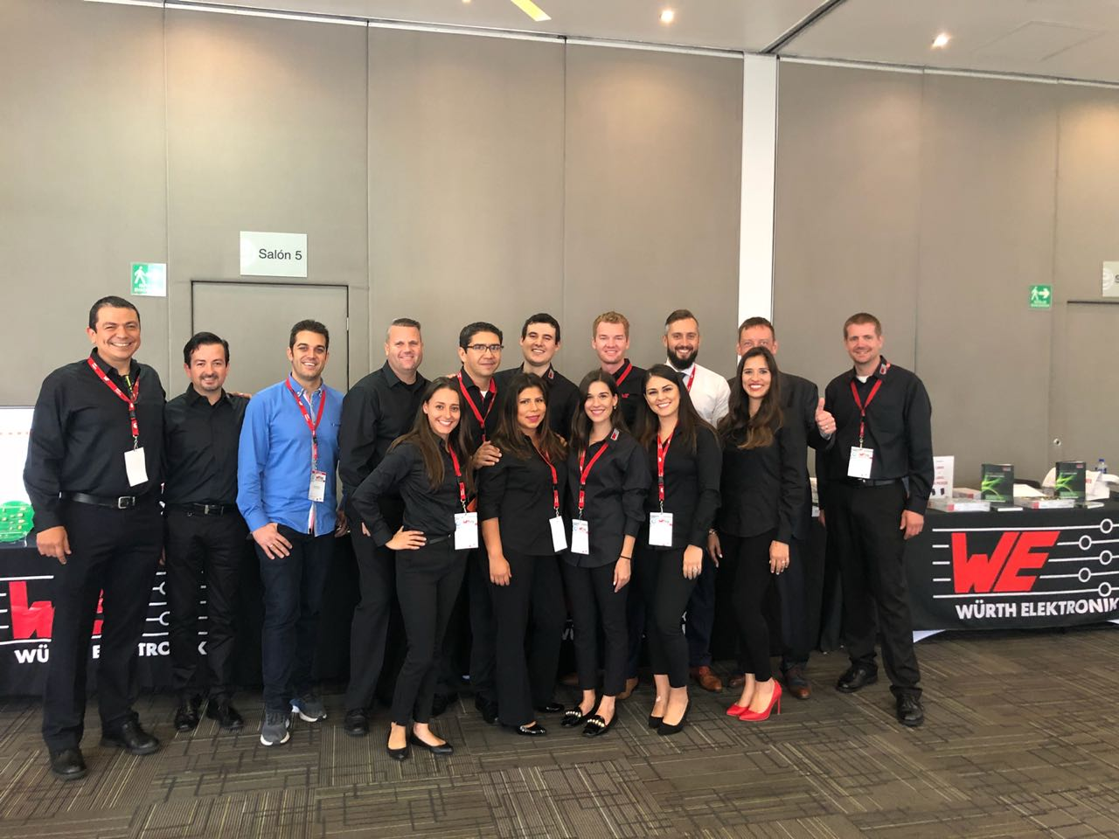Image source: Wurth Electronics Midcom
Wurth Electronics hosts at the technical seminars and the tabletop show, WE Day, in Mexico, September 2018.

About Wurth Electronics Midcom, Inc.
Wurth Electronics Midcom is a global leader in the design and manufacture of custom magnetics. A standard line of magnetics is offered, including inductors, ferrites, chokes, and EMI shielding materials. Recently, the electromechanical and interconnect line was added to the product offering, which includes Board-to-Board, Wire-to-Board, Terminal Blocks, and Input/Output Communication.
Customers in Asia, Europe and the Americas are supported through a local direct technical sales network, regional design and applications engineers and manufacturing based in the People’s Republic of China.
Our standard lines and custom-made transformers are used around the world in LED lighting, smart grid and utility metering, industrial controls, telecom (CPE and CO), home automation, and home appliances.
Wurth Electronics Midcom offers all catalog products in stock. Free samples are offered to customers on connectors and both catalog and custom magnetics.
Further information at www.we-online.com

Further information:  Wurth Electronics Midcom, Inc.  Lindsey Esche  121 Airport Drive  PO Box 1330  Watertown, SD 57201 USA  Phone: +1 605 886 4385  Toll-free (in the U.S.):  Phone: +1 800 643 2661  E-mail: lindsey.esche@we-online.com  www.we-online.com | Press contact:  HighTech communications GmbH  Brigitte Basilio  Brunhamstrasse 21  81249 Munich  Germany  Phone: +49 89 500778-20  Fax: +49 89 500778-77  E-mail: b.basilio@htcm.de  www.htcm.de

