PRESS RELEASE
Reference design with MagI³C Power Module now available
Precise Constant Current Generation with DC/DC Converters
Waldenburg (Germany), 13 June 2019 – MagI³C Power Modules from Würth Elektronik are DC/DC converters with integrated controller IC, inductors and capacitors. Using the "MagI³C Power Supply Reference Design", the manufacturer now demonstrates the ease with which an adjustable current or voltage source can be built with a MagI³C Power Module. The board is based on the MagI³C VDRM (Variable Step Down Regulator Module) to which two additional control loops have been added.
The design is aimed at various applications that require an adjustable power source: The reference design generates a constant voltage with an adjustable maximum current on the one hand, or can be set to generate a constant current with adjustable maximum voltage on the other. In the two operating modes, the output voltage can be set from 0 to 15 V and the current from 0 to 2.5 A. The input voltage range is 7 to 36 V. LEDs on the board indicate the voltage regulation mode, current regulation mode and a missing output voltage. The output voltage and output current are conveniently set on two potentiometers.
The reference design can be used as a driver for white, infrared and ultraviolet power LEDs or as a battery charger for lead, NiCd, NiMH or lithium-ion batteries. It can be used as super cap charger and mini lab power supply.
The board can be ordered immediately under article number 178002. The documentation DNS002 for the reference design and the CAD data are available online in the product catalog (Reference Designs).

Available images
The following images can be downloaded from the Internet in printable quality: http://www.htcm.de/kk/wuerth

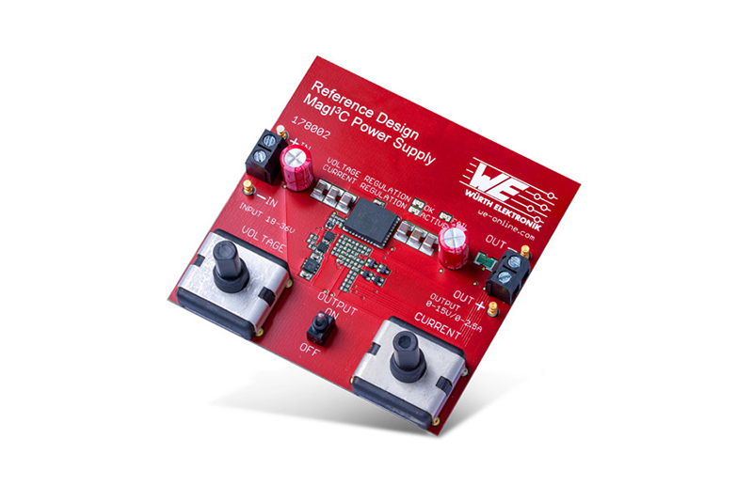
Image source: Würth Elektronik
With the "MagI³C Power Supply" board, Würth Elektronik demonstrates the ease with which a laboratory power supply can be built with a MagI³C Power Module.

About Würth Elektronik eiSos Group
Würth Elektronik eiSos Group is a manufacturer of electronic and electromechanical components for the electronics industry and a technology company that spearheads pioneering electronic solutions. The company currently employs 8,300 staff and generated sales of 848 million euros in 2018. Würth Elektronik eiSos is one of the largest European manufacturers of passive components and is active in 50 countries. Production sites in Europe, Asia and North America supply a growing number of customers worldwide.
The product range includes EMC components, inductors, transformers, RF components, varistors, capacitors, resistors, quartz crystals, oscillators, power modules, Wireless Power Transfer, LEDs, sensors, connectors, power supply elements, switches, push-buttons, connection technology, fuse holders and solutions for wireless data transmission.
The unrivaled service orientation of the company is characterized by the availability of all catalog components from stock without minimum order quantity, free samples and extensive support through technical sales staff and selection tools.
Through its technology partnership with the Audi Sport ABT Schaeffler Formula E Team and its support for the Formula Student racing series, the company demonstrates its innovative strength in eMobility
(www.we-speed-up-the-future.com).
Würth Elektronik eiSos is part of the Würth Group, the world market leader for assembly and fastening technology.
Würth Elektronik: more than you expect!
Further information at www.we-online.com

Further information:  Würth Elektronik eiSos GmbH & Co. KG  Sarah Hurst  Max-Eyth-Strasse 1  74638 Waldenburg  Germany  Phone: +49 7942 945-5186  E-mail: sarah.hurst@we-online.de  www.we-online.de | Press contact:  HighTech communications GmbH  Brigitte Basilio  Brunhamstrasse 21  81249 Munich  Germany  Phone: +49 89 500778-20  Telefax: +49 89 500778-77  E-mail: b.basilio@htcm.de  www.htcm.de

