PRESS RELEASE

Würth Elektronik eiSos supplements its SMT spacers with plastic accessories

Thermally and Electrically Insulating Assembly
Waldenburg (Germany), 13 March 2019 – Würth Elektronik eiSos offers the WA-SCAP spacer cap to complement its SMT spacers. M3 Nylon 66 Phillips screws are available in lengths from 4 to 10 mm for insulated assembly. The operating temperature extends from -30 to +85°C. The WA-SCRW screw series is available in flammability classes UL94 V-2 and UL94 V-0. The assembly hardware is available from stock in bulk packs of 1000 pcs.

Available images
The following images can be downloaded from the Internet in printable quality: http://www.htcm.de/kk/wuerth
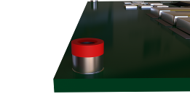
Image source: Würth Elektronik eiSos
Insulated assembly for SMT spacers from Würth Elektronik eiSos

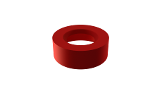  Image source: Würth Elektronik eiSos  WA-SCAP spacer cap | 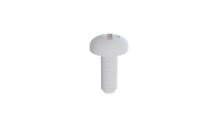  Image source: Würth Elektronik eiSos  WA-SCRW plastic flat head screw

About Würth Elektronik eiSos
Würth Elektronik eiSos GmbH & Co. KG is a manufacturer of electronic and electromechanical components for the electronics industry. The company currently employs 8,300 staff and generated sales of 848 million euros in 2018. Würth Elektronik eiSos is one of the largest European manufacturers of passive components and is active in 50 countries. Production sites in Europe, Asia and North America supply a growing number of customers worldwide.
The product range includes EMC components, inductors, transformers, RF components, varistors, capacitors, resistors, quartz crystals, oscillators, power modules, Wireless Power Transfer, LEDs, sensors, connectors, power supply elements, switches, push-buttons, connection technology, fuse holders and solutions for wireless data transmission.
Through its technology partnership with the Audi Sport ABT Schaeffler Formula E Team and its support for the Formula E racing series, the company demonstrates its innovative strength in eMobility
(www.we-speed-up-the-future.com).
Würth Elektronik eiSos is part of the Würth Group, the world market leader for assembly and fastening technology.
Würth Elektronik: more than you expect!
Further information at www.we-online.com

Further information:  Würth Elektronik eiSos GmbH & Co. KG  Sarah Hurst  Max-Eyth-Strasse 1  74638 Waldenburg  Germany  Phone: +49 7942 945-5186  E-mail: sarah.hurst@we-online.de  www.we-online.de | Press contact:  HighTech communications GmbH  Brigitte Basilio  Brunhamstrasse 21  81249 Munich  Germany  Phone: +49 89 500778-20  Telefax: +49 89 500778-77  E-mail: b.basilio@htcm.de  www.htcm.de

