PRESS RELEASE
Würth Elektronik eiSos opens new building of the Quality Design Center in Shenzhen
Growth Potential for Research, Development and Quality Assurance
Waldenburg (Germany) / Shenzhen (China), February 27, 2019 – On February 20, 2019, Prof. Dr. h. c. mult. Reinhold Würth opened the new site of the Würth Elektronik eiSos Quality Design Center (QDC) in the Chinese technology metropolis Shenzhen, accompanied by Xingdong Jia, Chairman of the "Bureau of Industry and Information Technology of Shenzhen” as a representative of the Chinese government. The QDC team assumes functions in the areas of quality assurance, R&D, product qualification, material monitoring and after-sales service. Currently 133 employees work in the building, compliant with the latest energy standards, which was built and put into operation in seven months. Located in the high-tech district of Low Carbon City, the building offers space for up to 250 employees.
Other guests of honor among the 40 or so participants at the opening were besides Reinhold Würth, Chairman of the Supervisory Board of the Würth Group’s Family Trusts, Benjamin Würth, Member of the Supervisory Board, Robert Friedmann, Chairman of the Central Managing Board of the Würth Group, Rolf Bauer, Honorary Member of the Advisory Board of the Würth Group, as well as the CEOs of the Würth Elektronik eiSos Group, Oliver Konz, Thomas Schrott and CTO Alexander Gerfer. Special recognition was given to Project Managers Dirk Knorr, Head of Total Quality Management, as well as Yangyang Chen and Michael Weser, Division Managers at QDC Shenzhen, who succeeded in expanding, relocating and commissioning the QDC in record time.
Happy with the strategic decision
A team of local Chinese employees designed and managed the expansion and design of the QDC highlighting the importance Würth Elektronik places on encouraging and supporting local responsibility within its global organization. In addition, the company strives to create motivating working conditions that meet the employees’ requirements. “With these premises, the Würth Elektronik eiSos Group has offices at its disposal in the growth market China with space for more than 100 additional workplaces, state-of-the-art laboratories for technical monitoring, as well as its own ESD area and a large reliability laboratory,” explains Dirk Knorr. “The QDC Shenzhen thus becomes an important hub in our worldwide service network.”

Expression of dynamism and creativity
As CTO of the Würth Elektronik eiSos Group, Alexander Gerfer is enthusiastic about the impact of the new facilities: “The QDC has been ensuring the quality of our production facilities for the Asia Pacific region for years. With the remodeling of our QDC in Shenzhen, we not only have space to grow, but also facilities to receive customers in an atmosphere that expresses our dynamism and creativity. We are far more than just a manufacturer of components, we are technology enablers and promote our research and development in areas such as power management, optoelectronics and eMobility. We are globally active and locally present for our customers with a highly motivated team - this is what these modern new facilities stand for, in which we welcome our customers to seminars, for instance.”
Sisters under one roof
At the same time, the QDC is the new location of Würth Elektronik CBT Asia Production. From here, the printed circuit board manufacturer from Niedernhall monitors a network of qualified contract manufacturers that support its German plants in mass production. Würth Elektronik CBT will also use the QDC laboratories for quality control purposes.

Available images
The following images can be downloaded from the Internet in printable quality: http://www.htcm.de/kk/wuerth
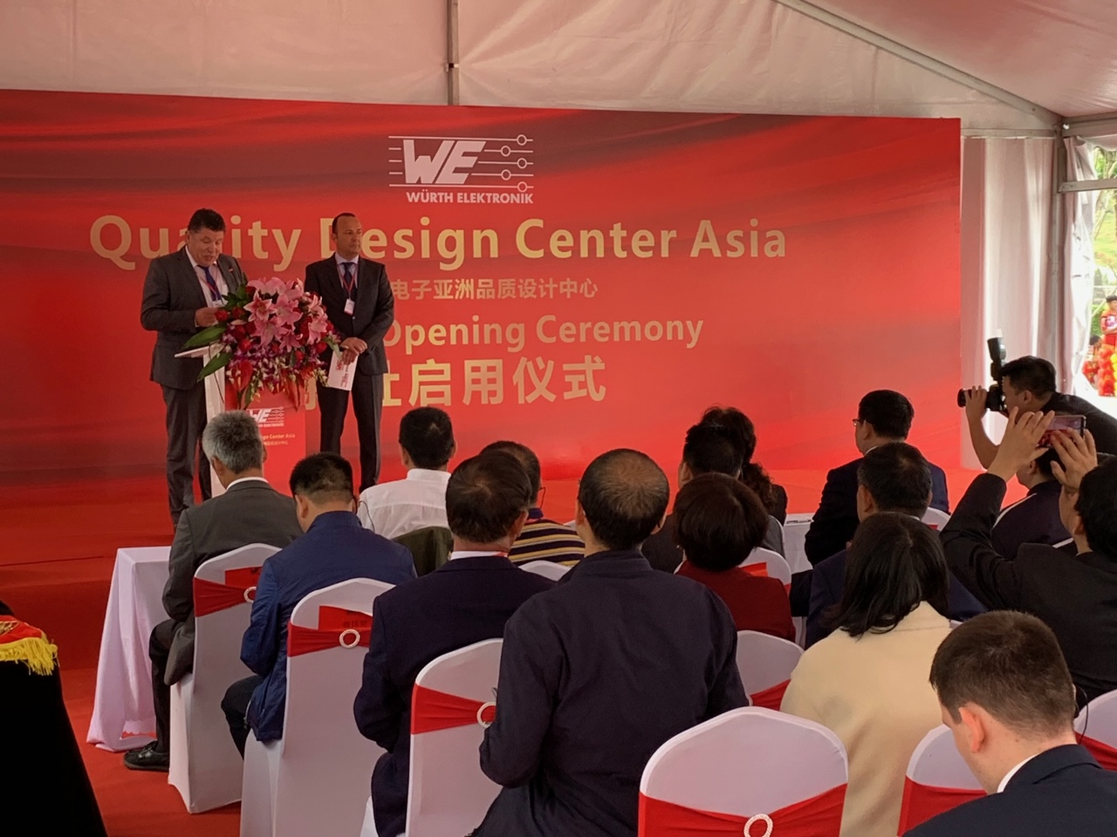  Image source: Würth Elektronik eiSos  Oliver Konz (left) and Thomas Schrott, CEOs of the Würth Elektronik eiSos Group, at the opening of the Quality Design Center (QDC)  in China’s technology capital Shenzhen. | 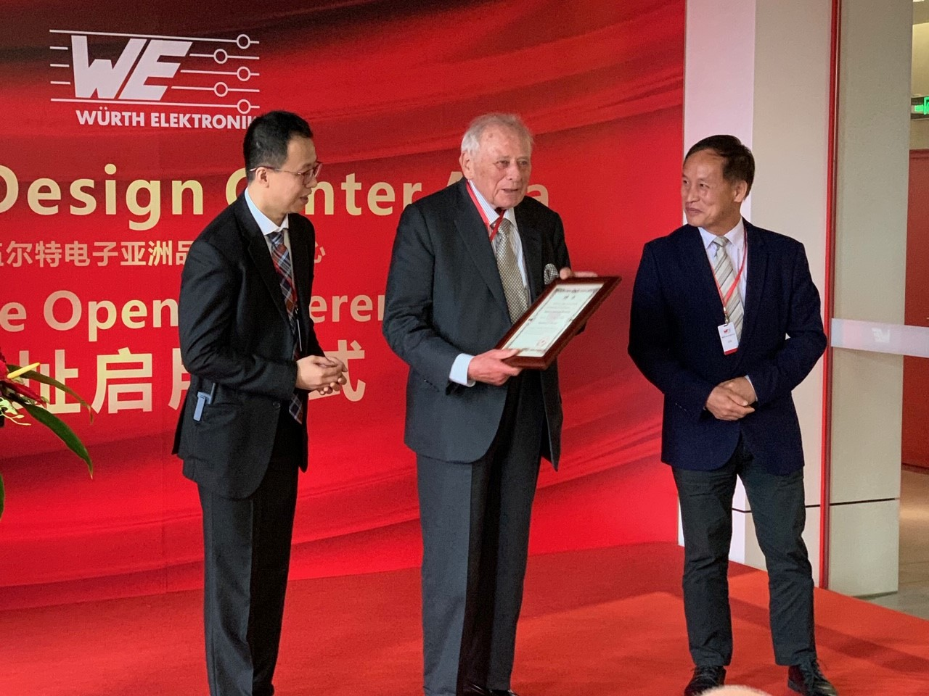 Image source: Würth Elektronik eiSos  Yangyang Chen, Division Manager QDC Shenzhen (left), and Mr. Gang Xu, Vice President of Shenzhen Technology University (right) with Prof. Dr. h. c. mult. Reinhold Würth (middle), Chairman of the Supervisory Board of the Würth Group's Foundations, who receives the honorary professorship of Shenzhen Technology University.

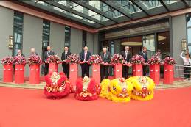  Image source: Würth Elektronik eiSos  Cutting the red ribbon for the opening of the QDC.  (From l. to r.: Alexander Gerfer, CTO Würth Elektronik eiSos Group; Rolf Bauer, Honorary Member of the Advisory Board of the Würth Group; Thomas Schrott, CEO Würth Elektronik eiSos Group; Yangyang Chen, Division Manager QDC Shenzhen; Xingdong Jia, Chairman of the "Bureau of Industry and Information Technology of Shenzhen" as representative of the Chinese government; Prof. Dr. h. c. mult. Reinhold Würth, Chairman of the Supervisory Board of the Würth Group’s Family Trusts; Robert Friedmann, Chairman of the Central Managing Board of the Würth Group; Benjamin Würth, Member of the Supervisory Board of the Würth Group; Oliver Konz, CEO Würth Elektronik eiSos Group) | 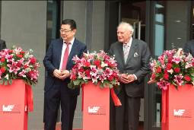  Image source: Würth Elektronik eiSos  Xingdong Jia, Chairman of the "Bureau of Industry and Information Technology of Shenzhen" as representative of the Chinese government (left) and Prof. Dr. h. c. mult. Reinhold Würth, Chairman of the Supervisory Board of the Würth Group’s Family Trusts.
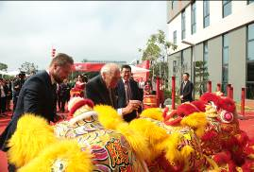Image source: Würth Elektronik eiSos  (Left to right): Benjamin Würth, Member of the Supervisory Board of the Würth Group; Prof. Dr. h. c. mult. Reinhold Würth, Chairman of the Supervisory Board of the Würth Group’s Family Trusts and Xingdong Jia, Chairman of the "Bureau of Industry and Information Technology of Shenzhen" as representative of the Chinese government, participate in the symbolic and traditional Chinese opening ceremony. They are presented with paintbrushes to paint the eyes of a lion. | 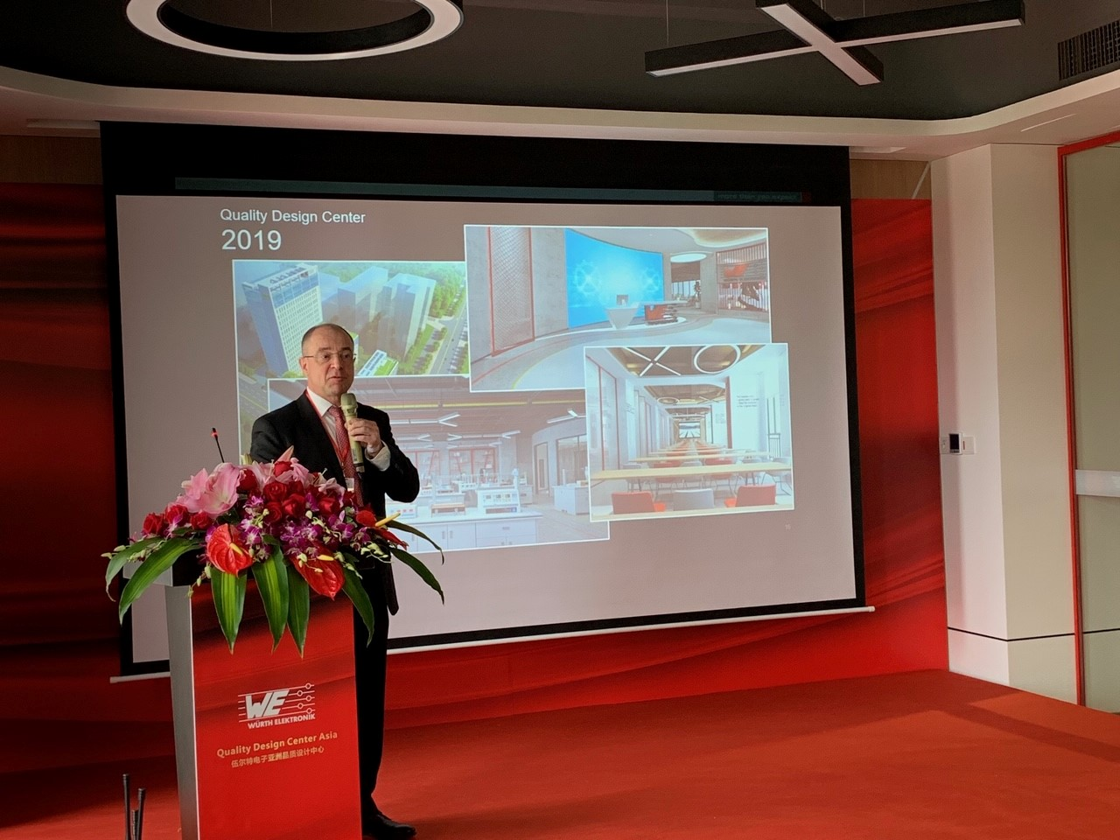  Image source: Würth Elektronik eiSos  Alexander Gerfer, CTO Würth Elektronik eiSos Group
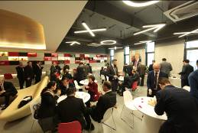  Image source: Würth Elektronik eiSos  An inside view of the Quality Design Center (QDC) | 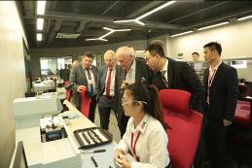  Image source: Würth Elektronik eiSos  Touring the state-of-the-art Quality Design Center (QDC)

About Würth Elektronik eiSos
Würth Elektronik eiSos GmbH & Co. KG is a manufacturer of electronic and electromechanical components for the electronics industry. The company currently employs 8,300 staff and generated sales of 848 million euros in 2018. Würth Elektronik eiSos is one of the largest European manufacturers of passive components and is active in 50 countries. Production sites in Europe, Asia and North America supply a growing number of customers worldwide.
The product range includes EMC components, inductors, transformers, RF components, varistors, capacitors, resistors, quartz crystals, oscillators, power modules, Wireless Power Transfer, LEDs, sensors, connectors, power supply elements, switches, push-buttons, connection technology, fuse holders and solutions for wireless data transmission.
Through its technology partnership with the Audi Sport ABT Schaeffler Formula E Team and its support for the Formula E racing series, the company demonstrates its innovative strength in eMobility
(www.we-speed-up-the-future.com).
Würth Elektronik eiSos is part of the Würth Group, the world market leader for assembly and fastening technology.
Würth Elektronik: more than you expect!
Further information at www.we-online.com

Further information:  Würth Elektronik eiSos GmbH & Co. KG  Sarah Hurst  Max-Eyth-Strasse 1  74638 Waldenburg  Germany  Phone: +49 7942 945-5186  E-mail: sarah.hurst@we-online.de  www.we-online.de | Press contact:  HighTech communications GmbH  Brigitte Basilio  Brunhamstrasse 21  81249 Munich  Germany  Phone: +49 89 500778-20  Telefax: +49 89 500778-77  E-mail: b.basilio@htcm.de  www.htcm.de

