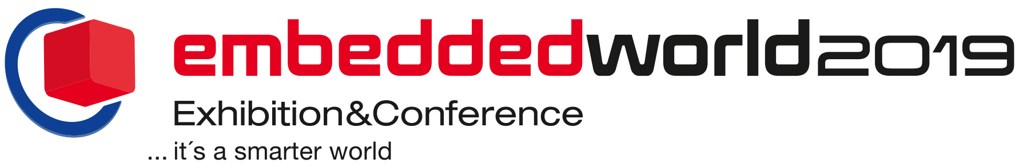
PRESS RELEASE
26–28 February 2019
Hall 3, Booth 3-247
Würth Elektronik eiSos at embedded world 2019
New Components for Smart Systems
Waldenburg (Germany), 30 January 2019 – Würth Elektronik eiSos presents a wide variety of new electronic and electromechanical components at embedded world (Nuremberg Exhibition Center, February 26-28, 2019, Hall 3, Booth 3-247). A focus in the manufacturer’s extensive trade show program: sensors and wireless modules for embedded systems. In various forums at the trade show as well as in many presentations, technicians and developers from the leading European manufacturer of electronic and electromechanical components will inform about technological trends and new products.
At embedded world, Würth Elektronik eiSos provides the first insights and outlooks on its new product family - Sensors: temperature sensors, absolute and differential pressure sensors as well as three-axis acceleration sensors. Moreover the proprietary module Thebe II, the WiFi module Calypso and the Bluetooth modul Proteus II represent the next represent the next step towards digital communication.
Component solutions from many fields
The wide bandwidth and high performance of the MagI³C power modules from Würth Elektronik eiSos are represented by MagI³C-VDRM (Variable Step Down Regulator Module). The compact step-down converter scores with integrated inductor and capacitors. Capacitors themselves are represented with no fewer than four different product series of H-Chip aluminum-polymer capacitors.
Miniaturization is an important topic for Würth Elektronik eiSos: With WE-CBF HF, the SMT ferrite for high frequency applications, tiny components make a huge impact on suppression. Further product highlights from the EMC specialists’ portfolio: WE-MAPI, one of the world’s smallest metal alloy power inductors, and WE-MCRI, an innovative, molded double choke. USB-3.1 type-C connectors with SuperSpeed technology are presented from the field of electromechanical components.
Wireless power transmission
The Wireless Power Congress has been integrated into embedded world and Würth Elektronik eiSos is also very strongly represented in the new form of the congress. Experts from Würth Elektronik eiSos provide information with the following specialist presentations:
“Market and Future of the Global Wireless Power Transfer Industry” (Jörg Hantschel, Thursday, February 28, 2019, 9.30-10.00 am)
“15W Inductive Wireless Power Transfer with Integrated Data Communication” (Cem Som, Thursday, February 28, 2019,11.30-12.00 am)
“Wireless Power Transfer in Rotating Assemblies” (Jelena Mijuskovic, Thursday, February 28, 2019, 2.30-3.00 pm)
Further presentations
Würth Elektronik eiSos employees also contribute to the regular trade show program with the following presentations:
“SPICE Simulation of 100Base-TX LAN-Transformer in an Ethernet Transmission Path” (Simon Mark, Tuesday, February 26, 2019, 5.00-5.30 pm)
“PoE: The Power Oriented Era” (Jairo Bustos Heredia, Wednesday, February 27, 2019, 2.30-3.00 pm)
“Ferrite for EMC – What Do I Need to Know?” (George Slama, Wednesday, February 27, 2019, 5.00-5.30 pm)
“Protect the Ports!” (George Slama, Wednesday, February 27, 2019, 10.30-11.00 am)
Sporting application example
To set the scene for the trade show focus on sensors and wireless modules, Würth Elektronik eiSos throws out a challenge to its booth visitors. “Step into the ring and measure your power”. A punching bag and boxing gloves are equipped with the manufacturer’s new acceleration sensors and wireless modules. Those who accept the sporting challenge see on a display how strong their punch is. From the acceleration of the punching bag and its mass, the force the boxer transfers to the punching bag is calculated in real time.

Available images
The following images can be downloaded from the Internet in printable quality: http://www.htcm.de/kk/wuerth
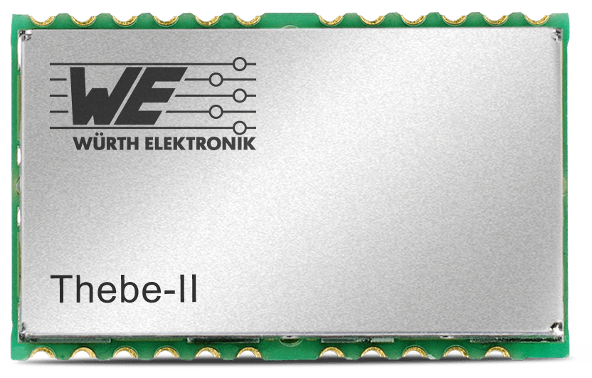Image source: Würth Elektronik eiSos
Thebe II wireless module connectivity solution

About Würth Elektronik eiSos
Würth Elektronik eiSos GmbH & Co. KG is a manufacturer of electronic and electromechanical components for the electronics industry. In 2017, the company employed 6 700 people. Würth Elektronik eiSos is one of the largest European manufacturers of passive components and is active in 50 countries. Production sites in Europe, Asia and North America supply a growing number of customers worldwide.
The product range includes EMC components, inductors, transformers, RF components, varistors, capacitors, resistors, quartz crystals, oscillators, power modules, Wireless Power Transfer, LEDs, sensors, connectors, power supply elements, switches, push-buttons, connection technology, fuse holders and solutions for wireless data transmission.
Through its technology partnership with the Audi Sport ABT Schaeffler Formula E Team and its support for the Formula E racing series, the company demonstrates its innovative strength in eMobility
(www.we-speed-up-the-future.com).
Würth Elektronik eiSos is part of the Würth Group, the world market leader for assembly and fastening technology.
Würth Elektronik: more than you expect!
Further information at www.we-online.com

Further information:  Würth Elektronik eiSos GmbH & Co. KG  Sarah Hurst  Max-Eyth-Strasse 1  74638 Waldenburg  Germany  Phone: +49 7942 945-5186  E-mail: sarah.hurst@we-online.de  www.we-online.de | Press contact:  HighTech communications GmbH  Brigitte Basilio  Brunhamstrasse 21  81249 Munich  Germany  Phone: +49 89 500778-20  Telefax: +49 89 500778-77  E-mail: b.basilio@htcm.de  www.htcm.de

