PRESS RELEASE

Custom Capabilities Catalog is Released, Featuring New Bobbin and Toroidal Packages

Watertown (USA), 14 December 2018 – Wurth Electronics is proud to announce the publication of the newest Capabilities Catalog. This comprehensive catalog includes capabilities for the design of custom transformers, the focus of the company for over 25 years.
This catalog offers customers over 110 packages as the foundation for a custom design. Five new bobbin packages, including extended rail RM6 and RM10 packages, in addition to EPQ13, EPW15, and EE20/10/6 packages, are featured this year. This catalog also includes two new toroid headers, TOR-6P-HT4-SFTY and TOR-9P-HT7.3. In addition to the existing technical content, this year Wurth Electronics added a section that provides a comprehensive breakdown of design considerations as well.
Download the digital copy www.we-online.com/CustomCapabilitiesCatalog.

Available images
The following images can be downloaded from the Internet in printable quality: http://www.htcm.de/kk/wuerth
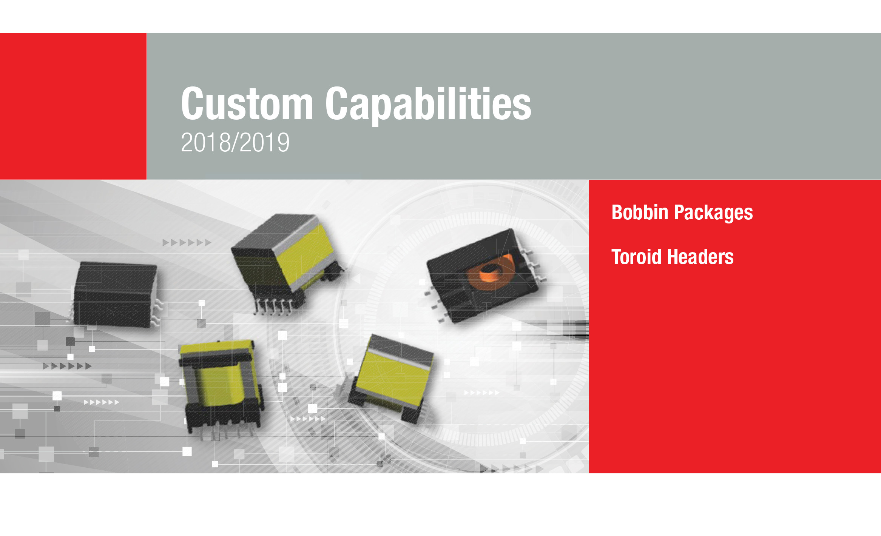
Image source: Wurth Electronics
Wurth Electronics is proud to announce the publication of the newest Capabilities Catalog

About Wurth Electronics
Wurth Electronics is a global leader in the design and manufacture of custom magnetics. A standard line of magnetics is offered, including inductors, ferrites, chokes, and EMI shielding materials. Recently, the electromechanical and interconnect line was added to the product offering, which includes Board-to-Board, Wire-to-Board, Terminal Blocks, and Input/Output Communication.
Customers in Asia, Europe and the Americas are supported through a local direct technical sales network, regional design and applications engineers and manufacturing based in the People’s Republic of China.
Our standard lines and custom-made transformers are used around the world in LED lighting, smart grid and utility metering, industrial controls, telecom (CPE and CO), home automation, and home appliances.
Wurth Electronics offers all catalog products in stock. Free samples are offered to customers on connectors and both catalog and custom magnetics.
Further information at www.we-online.com

Further information:  Wurth Electronics Midcom, Inc.  Lindsey Esche  121 Airport Drive  PO Box 1330  Watertown, SD 57201 USA  Phone: +1 605 886 4385  Toll-free (in the U.S.):  Phone: +1 800 643 2661  E-mail: lindsey.esche@we-online.com  www.we-online.com | Press contact:  HighTech communications GmbH  Brigitte Basilio  Brunhamstrasse 21  81249 Munich  Germany  Phone: +49 89 500778-20  Fax: +49 89 500778-77  E-mail: b.basilio@htcm.de  www.htcm.de

