PRESS RELEASE
Würth Elektronik eiSos: Update for award-winning BLE module
More than Twice as Fast and Fully Individualizable
Waldenburg (Germany), 28 February 2019 – The Wireless Connectivity and Sensors division at Würth Elektronik eiSos presents firmware version 3.4.0 of its Proteus I Bluetooth module. The most important innovation is the more than two-fold increase in UART (Universal Asynchronous Receiver Transmitter) baud rate with the maximum data throughput going from 36 kbps to 80 kbps. The newly introduced UART flow control at the same time guarantees that no data packets get lost on the UART. This and extensive possibilities for firmware individualization are further improvements on an already highly regarded product: Proteus I has just been distinguished as “Product of the year 2018” in the category “Smart Automation” by the trade magazine SmarterWorld.
With firmware version 3.4.0, the data throughput of 80 kbps can be achieved with a single BLE (Bluetooth Low Energy) packet per connection interval and is therefore compatible with all BLE 4.2 devices on the market. Manufacturers that make their products Bluetooth-enabled using the Proteus I Bluetooth low energy module can now also completely determine how it appears to the communication partner. This starts with its appearance, i.e. the device name and icon displayed to the user in the list of possible Bluetooth connections. A profile can also be added with the Device Information Service (DIS) to make more of the device’s information available with wireless technology – for example the name of the device manufacturer or the serial number.
Selectable UUID (Universally Unique Identifier)
The Proteus II 2.4-GHz BLE wireless module with dimensions of just 11 x 8 x 1.8 mm has something that is actually no longer intended in the Bluetooth Low Energy standard (Bluetooth Smart): The serial port profile for emulating a serial cable connection. Data transmission is enabled with the AMBER SPP-like (Serial Port Profile) profile, which is based on the optional Bluetooth 4.2 feature “data length extension” and increases the data throughput. Firms can make this BLE profile their own by assigning their own UUID, for example to register the profile with the Bluetooth Special Interest Group (SIG). Würth Elektronik eiSos also offers customers individualization of the firmware and yet guarantees adherence with the relevant guidelines in the wireless domain.

Available images
The following images can be downloaded from the Internet in printable quality: http://www.htcm.de/kk/wuerth
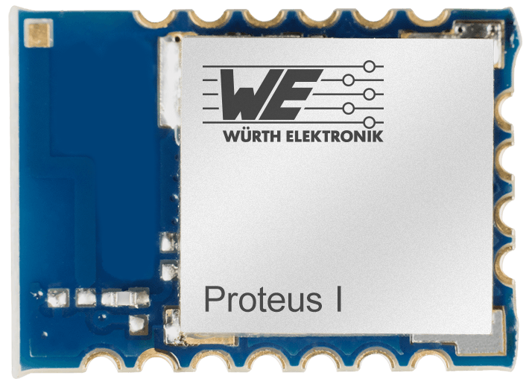  Image source:  Würth Elektronik eiSos  Firmware version 3.4.0 of the Proteus I Bluetooth module | 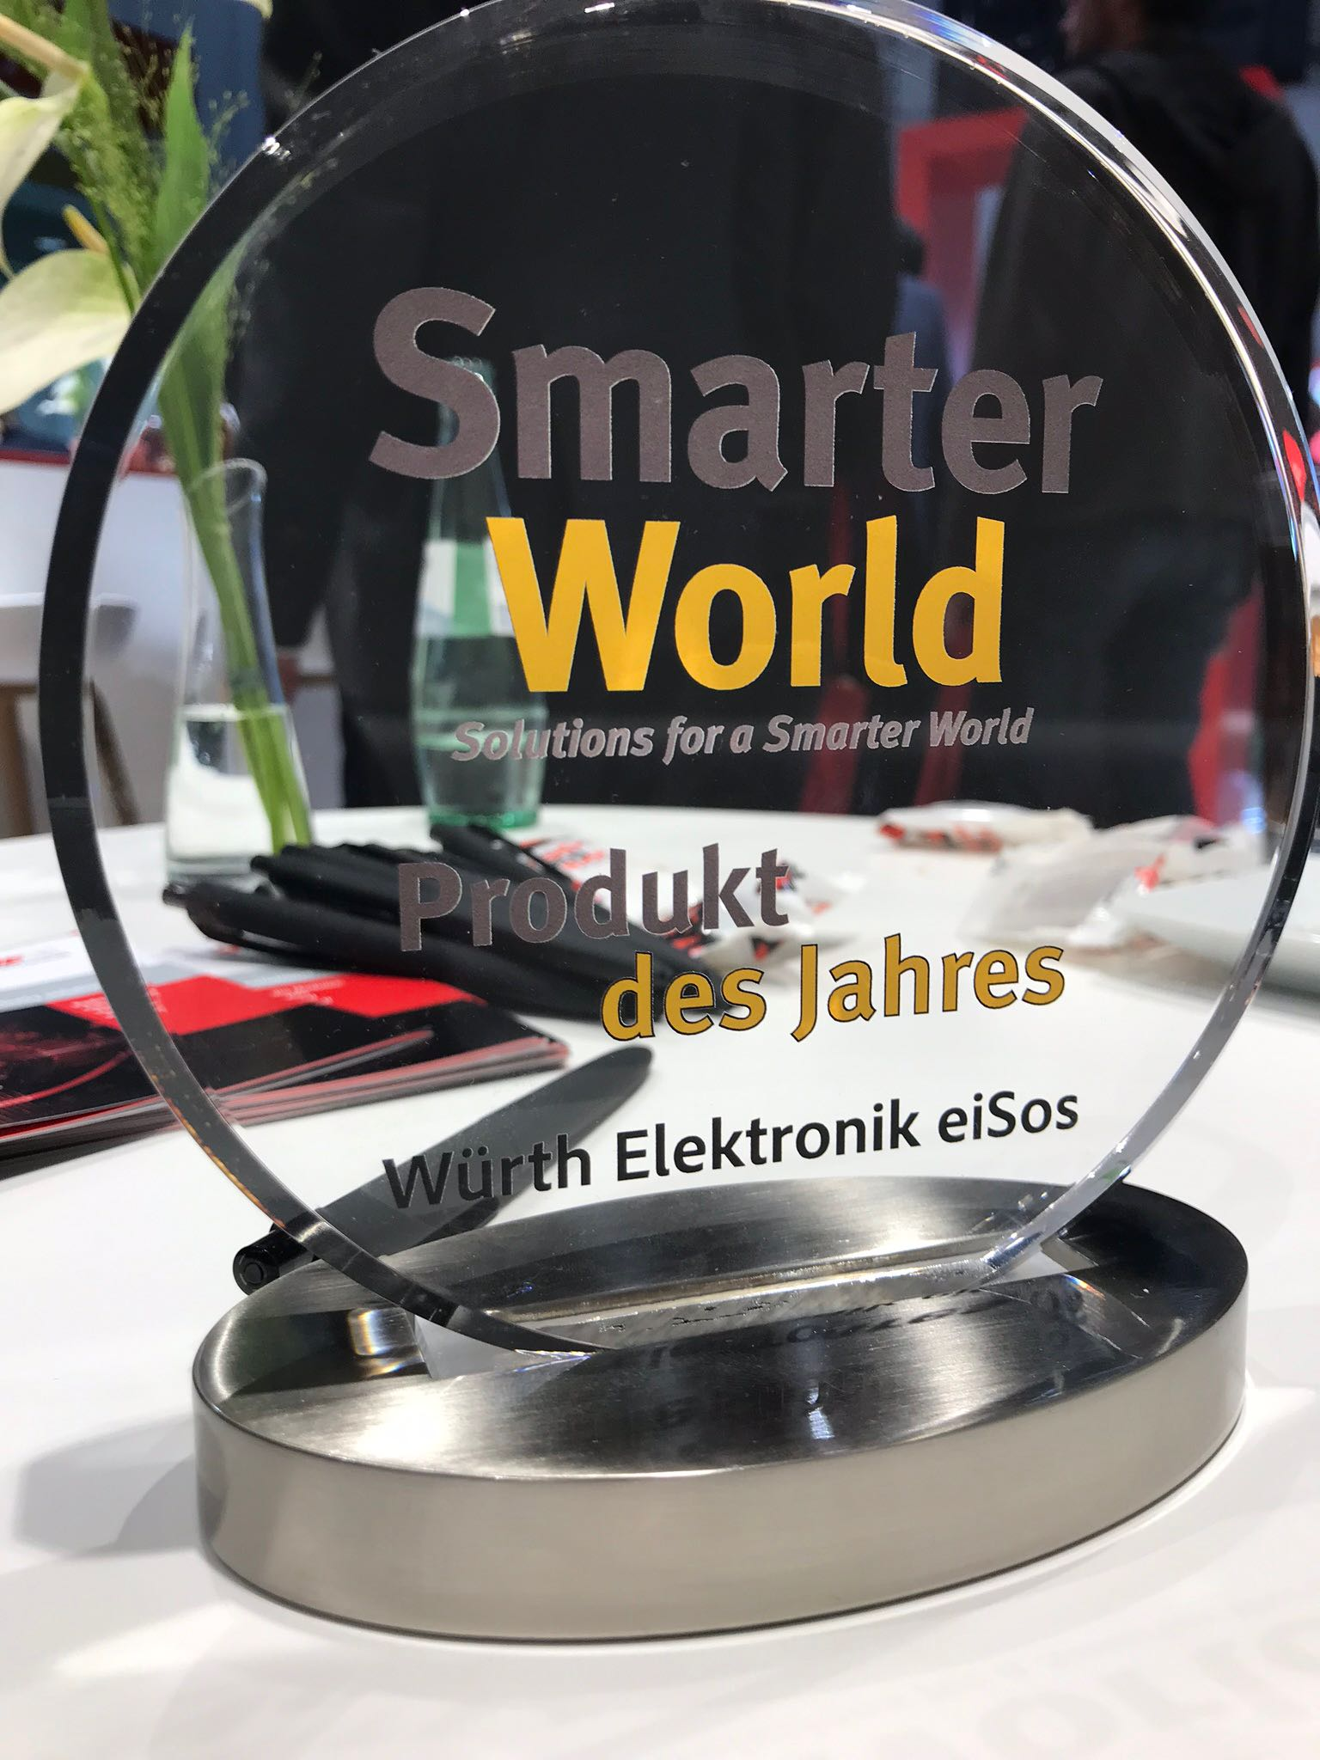 Image source:  Würth Elektronik eiSos  Proteus-I was awarded "Product of the Year 2018" in the category "Smart Automation" by the trade magazine SmarterWorld.

About Würth Elektronik eiSos
Würth Elektronik eiSos GmbH & Co. KG is a manufacturer of electronic and electromechanical components for the electronics industry. The company currently employs 8,300 staff and generated sales of 848 million euros in 2018. Würth Elektronik eiSos is one of the largest European manufacturers of passive components and is active in 50 countries. Production sites in Europe, Asia and North America supply a growing number of customers worldwide.
The product range includes EMC components, inductors, transformers, RF components, varistors, capacitors, resistors, quartz crystals, oscillators, power modules, Wireless Power Transfer, LEDs, sensors, connectors, power supply elements, switches, push-buttons, connection technology, fuse holders and solutions for wireless data transmission.
Through its technology partnership with the Audi Sport ABT Schaeffler Formula E Team and its support for the Formula E racing series, the company demonstrates its innovative strength in eMobility
(www.we-speed-up-the-future.com).
Würth Elektronik eiSos is part of the Würth Group, the world market leader for assembly and fastening technology.
Würth Elektronik: more than you expect!
Further information at www.we-online.com

Further information:  Würth Elektronik eiSos GmbH & Co. KG  Sarah Hurst  Max-Eyth-Strasse 1  74638 Waldenburg  Germany  Phone: +49 7942 945-5186  E-mail: sarah.hurst@we-online.de  www.we-online.de | Press contact:  HighTech communications GmbH  Brigitte Basilio  Brunhamstrasse 21  81249 Munich  Germany  Phone: +49 89 500778-20  Telefax: +49 89 500778-77  E-mail: b.basilio@htcm.de  www.htcm.de

