PRESS RELEASE
Wurth Electronics’ REDEXPERT Tool Launches Flyback Transformer Selector

Waldenburg (Germany), 18 March 2019 – Wurth Electronics is pleased to announce the launch of their Flyback Transformer Selector in the newest release of their REDEXPERT tool. The integration of the Transformer Selector into REDEXPERT is a complete makeover of the original Smart Transformer Selector. This free tool is available in seven languages and requires no login.
More options are included in the REDEXPERT tool, including performance simulation, filter settings for over 20 electrical and mechanical parameters, direct access to product datasheets, and direct free sampling. The original transformer selector tool, The Smart Transformer Selector (STS), will be available until the end of the year, and then redirected to the REDEXPERT version.
Try REDEXPERT and calculate your losses in real-time at www.we-online.com/redexpert.

Available images
The following images can be downloaded from the Internet in printable quality: http://www.htcm.de/kk/wuerth
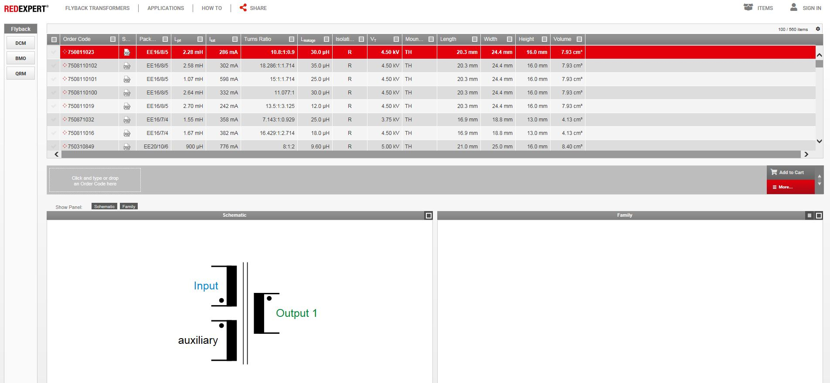
Image source: Wurth Electronics
REDEXPERT Transformer Selector

About Wurth Electronics
Wurth Electronics is a global leader in the design and manufacture of custom magnetics. A standard line of magnetics is offered, including inductors, ferrites, chokes, and EMI shielding materials. Recently, the electromechanical and interconnect line was added to the product offering, which includes Board-to-Board, Wire-to-Board, Terminal Blocks, and Input/Output Communication.
Customers in Asia, Europe and the Americas are supported through a local direct technical sales network, regional design and applications engineers and manufacturing based in the People’s Republic of China.
Our standard lines and custom-made transformers are used around the world in LED lighting, smart grid and utility metering, industrial controls, telecom (CPE and CO), home automation, and home appliances.
Wurth Electronics offers all catalog products in stock. Free samples are offered to customers on connectors and both catalog and custom magnetics.
Further information at www.we-online.com

Further information:  Wurth Electronics Midcom, Inc.  Lindsey Esche  121 Airport Drive  PO Box 1330  Watertown, SD 57201 USA  Phone: +1 605 886 4385  Toll-free (in the U.S.):  Phone: +1 800 643 2661  E-mail: lindsey.esche@we-online.com  www.we-online.com | Press contact:  HighTech communications GmbH  Brigitte Basilio  Brunhamstrasse 21  81249 Munich  Germany  Phone: +49 89 500778-20  Fax: +49 89 500778-77  E-mail: b.basilio@htcm.de  www.htcm.de

