PRESS RELEASE

Embedded Show launch for IQD’s New Reduced size Disciplined OCXO
Waldenburg (Germany), 20 February 2019 – IQD’s new IQCM-160 disciplined OCXO module is housed in a 30 x 25 x 14.6mm hermetically sealed through-hole metal package which covers approx. half the area of the current models. The IQCM-160 can achieve a holdover specification of 1.5 microseconds over a period of 8 hours when locked to a 1PPS (Pulse Per Second) input from an external GPS, GLONASS, BEIDOU, GALILEO or alternative 1PPS source.
The design incorporates an internal adaptive algorithm which enables the module to ‘learn’ the parameters of the GPS signal after a period of 2 days of lock so that the holdover function can start in the event of signal failure. An internal alarm is built-in to indicate lock failure and subsequent restoration of signal. In addition, the unit incorporates a serial connection for more detailed interrogation of the device’s performance. Frequency is accurate to within ±0.005ppb when locked to a 1PPS external signal and can compete with the performance of many atomic clock references.
The standard operating temperature range of the module is -40 to 85 degrees C. The required power supply is 3.3V with the output being standard HCMOS. Current consumption is only 750mA maximum during warm-up with this reducing to 350mA once the steady-state condition is reached.
The IQCM-160 has 1PPS and 10MHz output and also UART interfaces for software management, this has a fixed baud rate of 115200 using 1 stop bit and no parity.
Intended for a range of applications including land based telecommunications systems as well as marine based navigation systems the IQCM-160 forms part of a range of highly specified modules and Oven Controlled Crystal Oscillators (OCXOs) available from IQD.
Packaged in ‘Bulk’ either direct from IQD or via its extensive range of worldwide distributors. Further details are available on IQD’s website at www.iqdfrequencyproducts.com or for further advice, speak to a member of our Applications Support Team.

Available images
The following images can be downloaded from the Internet in printable quality: http://www.htcm.de/kk/wuerth

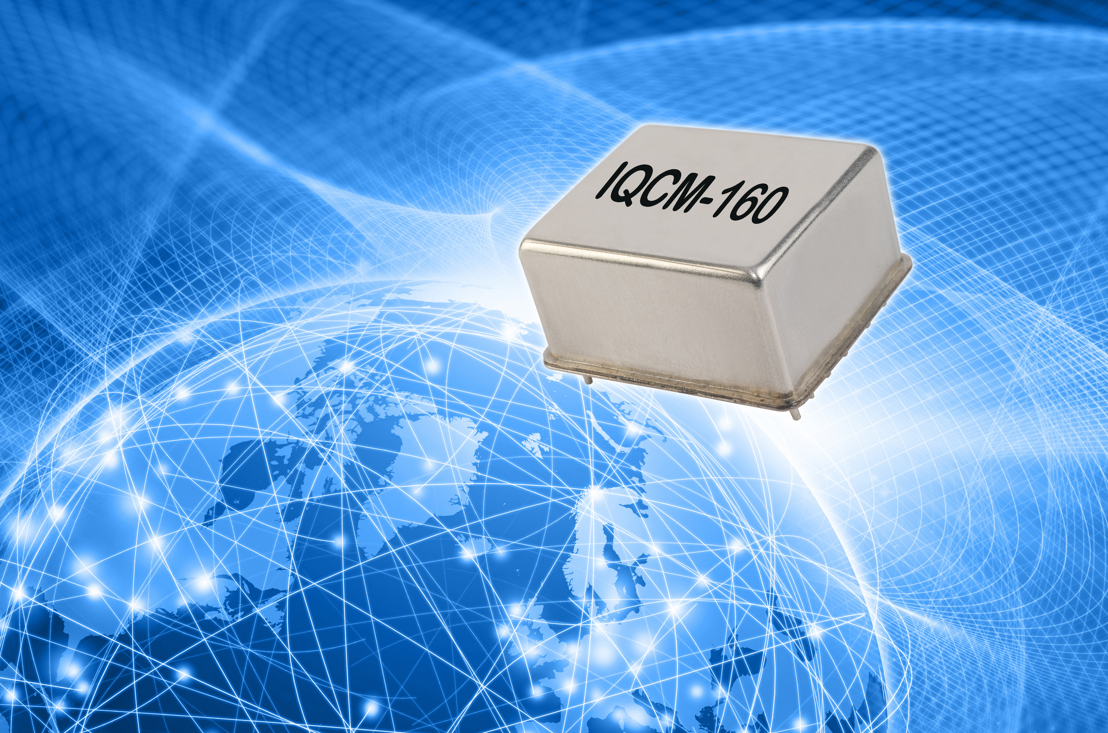
Image source: IQD
New Reduced size Disciplined OCXO from IQD

About IQD
Backed by over 40 years’ experience in the manufacture of frequency products, IQD is a recognised market leader in the frequency control market and part of the Würth Elektronik eiSos group, one of the leading European manufacturers of passive components. With active customers in over 80 countries, IQD offers one of the most comprehensive frequency product ranges available, from low cost commercial grade product to that used in high reliability industrial and automotive applications including: Quartz Crystals, Clock Oscillators, AEC-Q200 Crystals & Oscillators, VCXOs, TCXOs, OCXOs, GPS Disciplined OCXOs, and Rubidium Oscillators.
Manufacturing capacity totals over 40 million units per month covering quantities from one off specials to multi-million unit orders. In addition, IQD offers customers a range of engineering support services including: application support, custom product design, sample development, electrical testing & screening, frequency/temperature testing, accelerated ageing, circuit characterisation and MTIE/TDEV testing. IQD’s products are specified by leading manufacturers in the aerospace, automotive, communications, computing, consumer and industrial industries throughout the world. The full range of products is available direct through sales offices or via an extensive worldwide distribution network.
Further info at www.iqdfrequencyproducts.com

More information:  IQD Frequency Products Ltd  Rebecca Long  Station Road  Crewkerne  Somerset  TA18 8AR  United Kingdom  Phone: +44 1460 270270  E-mail: rebecca.long@iqdfrequencyproducts.com  www.we-online.com  www.iqdfrequencyproducts.com | Press contact:  HighTech communications GmbH  Brigitte Basilio  Brunhamstrasse 21  81249 Munich  Germany  Phone: +49 89 500778-20  Telefax: +49 89 500778-77  E-mail:  b.basilio@htcm.de  www.htcm.de

