PRESS RELEASE
Würth Elektronik website now with chat function
Individual Support with the Very First Online Contact
Waldenburg (Germany), 25 April 2019 – Since October 2018, Würth Elektronik has made a chat function available to its www.we-online.com website visitors. The new convenience function is activated in Australia, Germany, France, India, Austria, Spain, UK und USA Prospects can get direct and non-binding answers to their questions here.
In the test phase it was already apparent that the chat function is very well accepted. Further planning therefore includes the integration of additional countries such as Italy.
"Uncomplicated, direct access and fast, convenient and personal support is getting customers excited," reports Jochen Baier, Head of Technical Marketing at Würth Elektronik eiSos. "Our company motto "more than you expect!" can be felt in the quality of the answers, because our Field Application Engineers and the experts from Product Management are there to assist the chat team to offer our visitors a solution even for more specialized topics. Those who wish to, can make use of our individual support with their first visit to our homepage, including our added values such as the dispatching of free samples and the small quantity service for prototypes and pre-series."

Available images
The following images can be downloaded from the Internet in printable quality: http://www.htcm.de/kk/wuerth

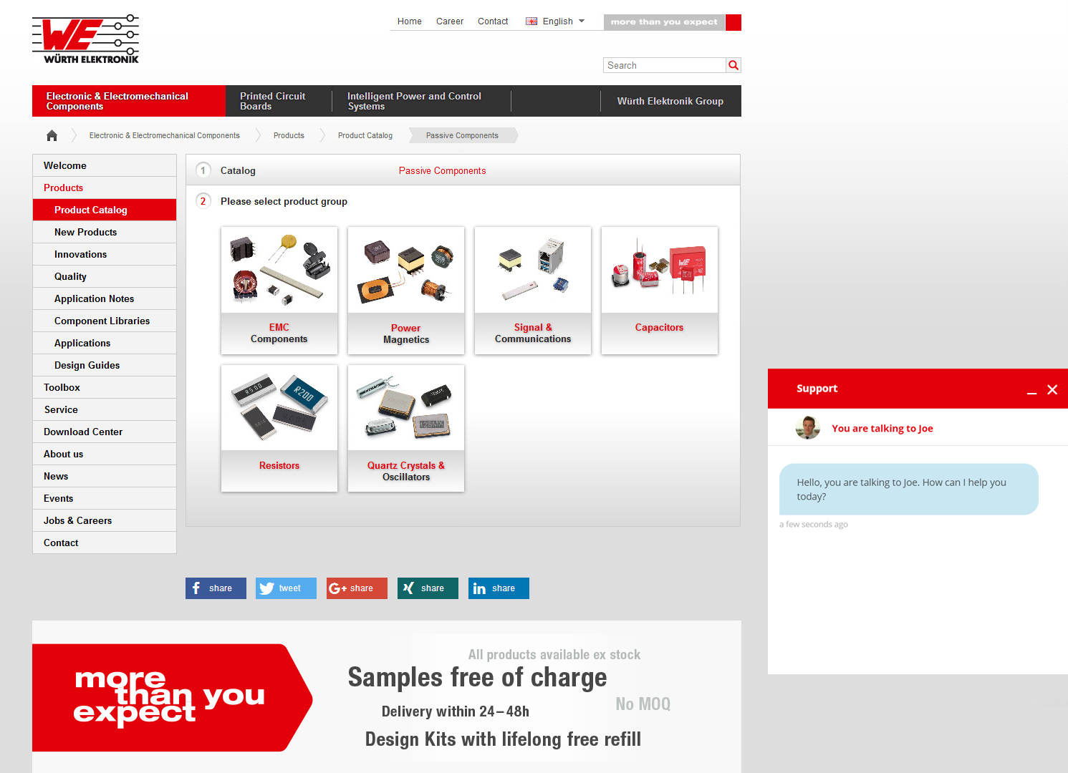
Image source: Würth Elektronik
Würth Elektronik now also answers inquiries by chat.

About Würth Elektronik eiSos Group
Würth Elektronik eiSos Group is a manufacturer of electronic and electromechanical components for the electronics industry and a technology company that spearheads pioneering electronic solutions. The company currently employs 8,300 staff and generated sales of 848 million euros in 2018. Würth Elektronik eiSos is one of the largest European manufacturers of passive components and is active in 50 countries. Production sites in Europe, Asia and North America supply a growing number of customers worldwide.
The product range includes EMC components, inductors, transformers, RF components, varistors, capacitors, resistors, quartz crystals, oscillators, power modules, Wireless Power Transfer, LEDs, sensors, connectors, power supply elements, switches, push-buttons, connection technology, fuse holders and solutions for wireless data transmission.
The unrivaled service orientation of the company is characterized by the availability of all catalog components from stock without minimum order quantity, free samples and extensive support through technical sales staff and selection tools.
Through its technology partnership with the Audi Sport ABT Schaeffler Formula E Team and its support for the Formula Student racing series, the company demonstrates its innovative strength in eMobility
(www.we-speed-up-the-future.com).
Würth Elektronik eiSos is part of the Würth Group, the world market leader for assembly and fastening technology.
Würth Elektronik: more than you expect!
Further information at www.we-online.com

Further information:  Würth Elektronik eiSos GmbH & Co. KG  Sarah Hurst  Max-Eyth-Strasse 1  74638 Waldenburg  Germany  Phone: +49 7942 945-5186  E-mail: sarah.hurst@we-online.de  www.we-online.de | Press contact:  HighTech communications GmbH  Brigitte Basilio  Brunhamstrasse 21  81249 Munich  Germany  Phone: +49 89 500778-20  Telefax: +49 89 500778-77  E-mail: b.basilio@htcm.de  www.htcm.de

