PRESS RELEASE
Würth Elektronik eiSos: Formula E technology partnership with Audi and eMobility strategy
The eMobility World looks to Hong Kong
Waldenburg (Germany), 14 March 2019 – On March 10, 2019 the Formula E racing series started its fifth season with the first ePrix in Hong Kong, China. There, from the beginning, as a technology partner in this fascinating form of motor racing: Würth Elektronik eiSos. Europe's leading manufacturer of electronic components positions itself as a partner of the eMobility industry in Asia, because China is also particularly open to new mobility concepts beyond the sporting aspects of Formula E. For this reason, Würth Elektronik eiSos is rapidly expanding its sales and service network in the People's Republic and other Asian countries. The drivers of the Audi Sport ABT Schaeffler team were also fast, effective and successful at the opening race: they took 2nd and 4th place.
Not only is the Formula E race in Berlin (May 25, 2019) a "home game" for Würth Elektronik eiSos as a technology partner of the Audi Sport ABT Schaeffler racing team, but for some time now, the races in Asia too, because the company runs a large warehouse and logistics hub in Hong Kong. In neighboring Shenzhen, there is a large Quality Design Center (QDC), the spacious new building of which was only just opened in a ceremony in February by Prof. Dr. h. c. mult. Reinhold Würth, Chairman of the Supervisory Board of the Würth Group’s Family Trusts. The QDC assumes functions in the areas of Quality Assurance, R&D, Product Qualification, Material Monitoring and After-Sales Service. This illustrates that Würth Elektronik eiSos no longer sees itself merely as a manufacturer of components, but has grown into the role of a technology enabler whose research and development advances technologies such as power management, optoelectronics and eMobility.
Partnership part of an overall concept
Würth Elektronik eiSos is involved in numerous global technology partnerships to promote the innovation driver eMobility. The support for eRacing has been a key part of this strategic concept right from the start. The focus is on the technology partnership with the Formula E team, Audi Sport ABT Schaeffler. The electric speedsters not only prove the high and rapidly growing performance of electric vehicles, but also serve as a proving ground for electronic applications under extreme conditions. On board the racing car Audi e-tron FE05, there are REDCUBE terminals and a backup battery co-developed by Würth Elektronik eiSos. The electronics manufacturer is also a partner of various Formula Student teams and the University of Nottingham, which is chalking up success with an eMotorbike.
"The Formula E race in Hong Kong perfectly symbolizes our commitment in Asia: We are rapidly stepping up the expansion of our service network in the Chinese market. Here we meet a large, enthusiastic audience for our innovation field of eMobility off the race track as well. Asia now has a strong lead over Europe with its mobility concepts. Here we contribute the experience we have gained to projects and products throughout the world - so companies, the economy and society in other countries profit from our eMobility activities in Asia," says Alexander Gerfer, CTO of the Würth Elektronik eiSos Group.
The season opener in Hong Kong proved very successful for the Audi Sport ABT Schaeffler team: 2nd place for Lucas di Grassi and 4th place for Daniel Abt.

Available images
The following images can be downloaded from the Internet in printable quality: http://www.htcm.de/kk/wuerth
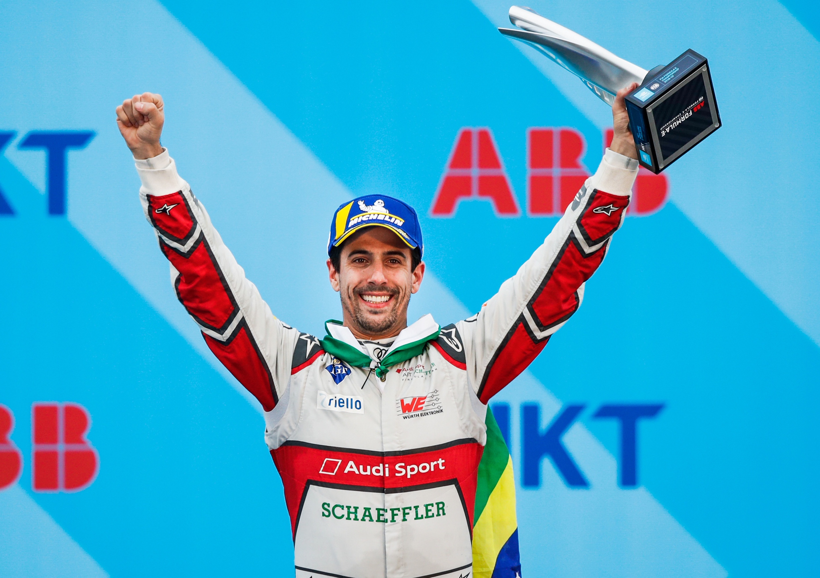Image source: Audi Communications Motorsport  2nd place for Lucas di Grassi from the Audi Sport ABT Schaeffler racing team at the opening race in Hong Kong, China. | Image source: Audi Communications Motorsport  The Audi Sport ABT Schaeffler team with racing drivers Lucas di Grassi (left) and Daniel Abt.
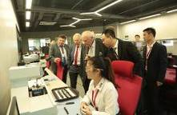
Image source: Würth Elektronik eiSos
Taking a look at the premises of the newly opened Quality Design Center (QDC) of Würth Elektronik eiSos in Shenzhen.

About Würth Elektronik eiSos
Würth Elektronik eiSos GmbH & Co. KG is a manufacturer of electronic and electromechanical components for the electronics industry. The company currently employs 8,300 staff and generated sales of 848 million euros in 2018. Würth Elektronik eiSos is one of the largest European manufacturers of passive components and is active in 50 countries. Production sites in Europe, Asia and North America supply a growing number of customers worldwide.
The product range includes EMC components, inductors, transformers, RF components, varistors, capacitors, resistors, quartz crystals, oscillators, power modules, Wireless Power Transfer, LEDs, sensors, connectors, power supply elements, switches, push-buttons, connection technology, fuse holders and solutions for wireless data transmission.
Through its technology partnership with the Audi Sport ABT Schaeffler Formula E Team and its support for the Formula E racing series, the company demonstrates its innovative strength in eMobility
(www.we-speed-up-the-future.com).
Würth Elektronik eiSos is part of the Würth Group, the world market leader for assembly and fastening technology.
Würth Elektronik: more than you expect!
Further information at www.we-online.com

Further information:  Würth Elektronik eiSos GmbH & Co. KG  Sarah Hurst  Max-Eyth-Strasse 1  74638 Waldenburg  Germany  Phone: +49 7942 945-5186  E-mail: sarah.hurst@we-online.de  www.we-online.de | Press contact:  HighTech communications GmbH  Brigitte Basilio  Brunhamstrasse 21  81249 Munich  Germany  Phone: +49 89 500778-20  Telefax: +49 89 500778-77  E-mail: b.basilio@htcm.de  www.htcm.de

