PRESS RELEASE
Würth Elektronik eiSos online design platform REDEXPERT extended
Component Selection Based on Measured Data
Waldenburg (Germany), 4 April 2019 – Würth Elektronik eiSos has extended its free online design tool REDEXPERT. The simulation software, which has become known as the world's most precise option for AC loss calculation in switch mode power supplies, now supports calculations for a whole range of other components. LEDs for horticultural applications, wireless modules, photodiodes and foil capacitors are among the product groups now included in the simulation tool. The properties of the components can be predicted under different operating conditions using stored data. The special feature of REDEXPERT: The calculations are made on the basis of real measured laboratory data.
With REDEXPERT, Würth Elektronik eiSos relieves developers from having to do much of the mathematical calculating and simulating work involved with qualifying components. Taking DC foil capacitors as an example, all the graphs required for a powerful design analysis are available - based on the measurement data ∆CvsF, ZvsF, ESRvsF. The newly integrated "Horticulator" enables the design of individual lighting recipes for the use of horticulture LEDs. Starting with information on the number of LEDs used, the input current and the input connection temperature, the full spectra, photosynthetic photon flux (PPF) and wavelength color ratios can be calculated, among others.
Measured data instead of datasheet
REDEXPERT offers the great advantage that developers can base their selection of components on characteristics acquired by experimentation rather than calculations based simply on the specifications in the datasheet. For instance, the photodiodes and phototransistors from Würth Elektronik eiSos are now covered in REDEXPERT and are represented by curves of the viewing angle, spectral sensitivity, irradiance and emitter-collector. An extremely useful tool for the development of wireless solutions: the "Range Estimator". This REDEXPERT function allows distance ranges to be calculated as a function of a given data rate and link budget.
REDEXPERT is freely available at www.we-online.com/redexpert.

Available images
The following images can be downloaded from the Internet in printable quality: http://www.htcm.de/kk/wuerth
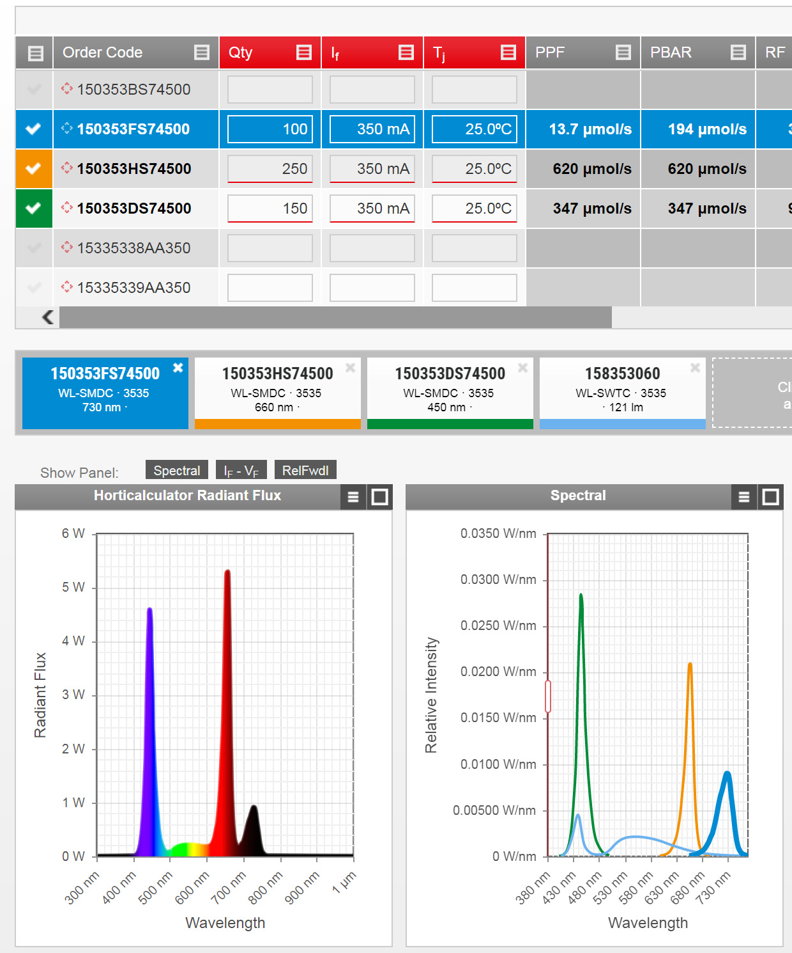  Image source:  Würth Elektronik eiSos  Design of individual lighting recipes for the use of horticulture LEDs with the newly integrated “Horticulator” | 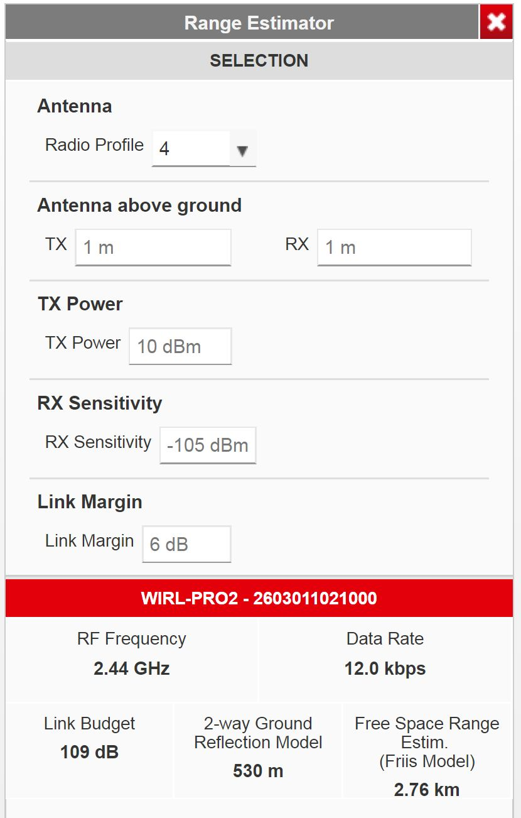  Image source:  Würth Elektronik eiSos  With the “Range Estimator”, ranges can be calculated depending on a given data rate and link budget.

About Würth Elektronik eiSos
Würth Elektronik eiSos is a manufacturer of electronic and electromechanical components for the electronics industry and a technology company that spearheads pioneering electronic solutions. The company currently employs 8,300 staff and generated sales of 848 million euros in 2018. Würth Elektronik eiSos is one of the largest European manufacturers of passive components and is active in 50 countries. Production sites in Europe, Asia and North America supply a growing number of customers worldwide.
The product range includes EMC components, inductors, transformers, RF components, varistors, capacitors, resistors, quartz crystals, oscillators, power modules, Wireless Power Transfer, LEDs, sensors, connectors, power supply elements, switches, push-buttons, connection technology, fuse holders and solutions for wireless data transmission.
The unrivaled service orientation of the company is characterized by the availability of all catalog components from stock without minimum order quantity, free samples and extensive support through technical sales staff and selection tools.
Through its technology partnership with the Audi Sport ABT Schaeffler Formula E Team and its support for the Formula Student racing series, the company demonstrates its innovative strength in eMobility
(www.we-speed-up-the-future.com).
Würth Elektronik eiSos is part of the Würth Group, the world market leader for assembly and fastening technology.
Würth Elektronik: more than you expect!
Further information at www.we-online.com

Further information:  Würth Elektronik eiSos GmbH & Co. KG  Sarah Hurst  Max-Eyth-Strasse 1  74638 Waldenburg  Germany  Phone: +49 7942 945-5186  E-mail: sarah.hurst@we-online.de  www.we-online.de | Press contact:  HighTech communications GmbH  Brigitte Basilio  Brunhamstrasse 21  81249 Munich  Germany  Phone: +49 89 500778-20  Telefax: +49 89 500778-77  E-mail: b.basilio@htcm.de  www.htcm.de

