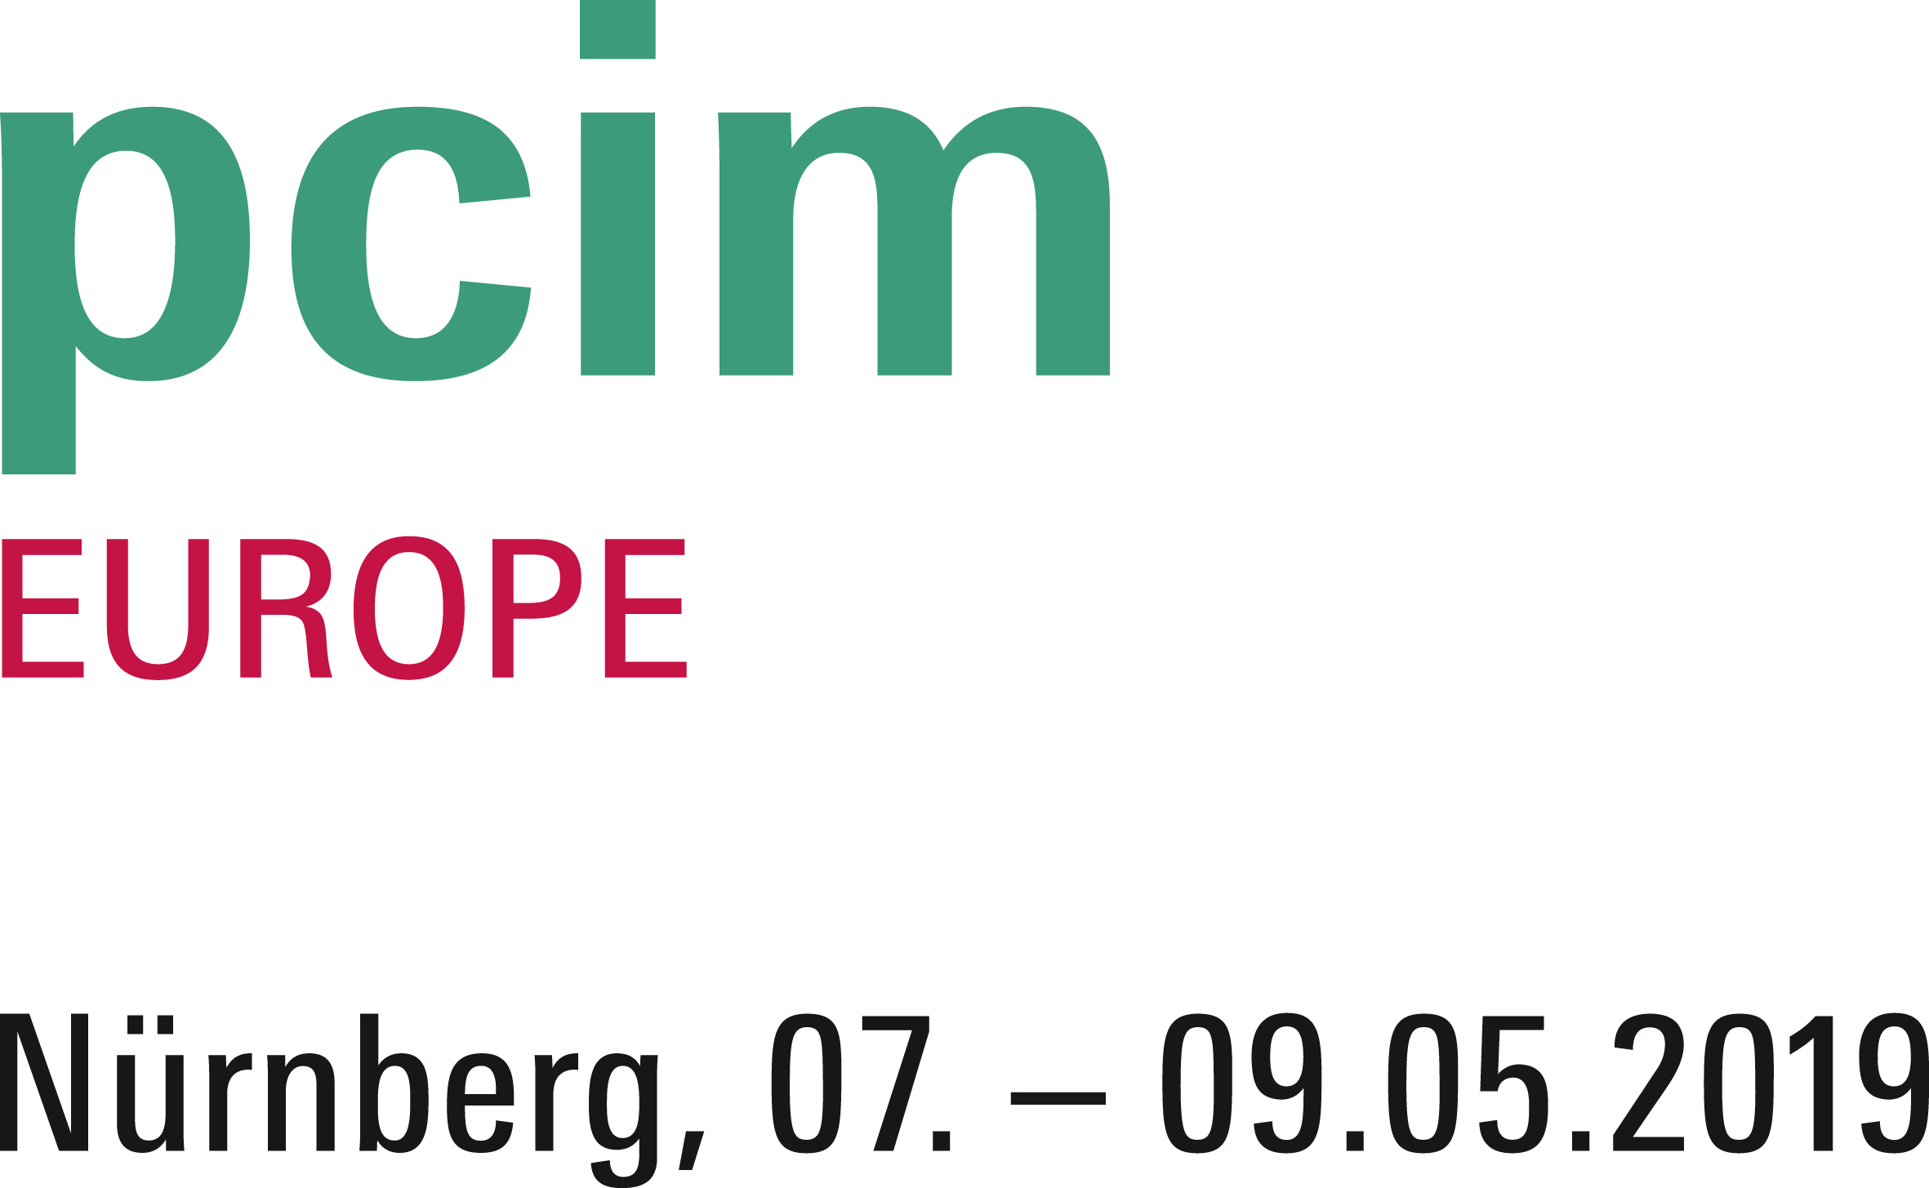
PRESS RELEASE
Würth Elektronik at PCIM 2019
Components for Modern Power Electronics
Hall 7, Booth 229
Waldenburg (Germany), 7 May 2019 – Würth Elektronik is exhibiting at the PCIM, May 7-9, 2019 (Nuremberg Convention Center, NCC, Hall 7, Booth 229). The focus of the trade show presentation is on high-current inductors, SMT-mountable double inductors and high-power terminals. The company is also involved in the congress program.
With WE-HCF and WE-HCFT, high-current inductors which have a current loading capacity of up to 75 A are in the limelight. Examples of products from the field of ferrites are WE-CBF, ideal as a data line filter and for supply voltage decoupling, and WE-MPSB, the world’s first SMD ferrite series with specified peak current capability for filtering highly efficient DC/DC converters in harsh industrial environments. Overvoltage protection is addressed with WE-VD, a disk varistor that continues to operate immediately after an overvoltage pulse without sequential current.
Double inductors in molding technology
WE-MCRI is an innovative, molded double choke. The fully automatic production process with bifilar windings enables a coupling coefficient of up to 0.995. Like the WE-CFWI, it displays a soft saturation behavior which is achieved by the core material and the distributed air gap within the core.
The same applies to the WE-CMBNC current-compensated line choke with its high permeability nanocrystalline core material. It is characterized by excellent broadband attenuation - with small size, high rated currents and low resistances. The robust component for the extended temperature range of up to +125°C is therefore ideally suited for motor interference suppression and as an input and output filter for mains applications.
Würth Elektronik is involved in the congress program. The topic "Combined Solutions for Thermal Management and Electromagnetic Shielding" will be discussed at a poster presentation (in the foyer of the ‘NCC Mitte’ hall) on May 7, 2019, between 3.15 and 5.15 pm. Leading you through the presentation: Sebastian Mirasol-Menacho, Antonio Alcarria and Jorge Victoria (all Würth Elektronik eiSos) as well as Adrian Suarez, Pedro A. Martinez, Jose Torres, Julio Martos, Raimundo Olcina and Jesus Soret (all ETSE University Valencia).
On May 9, 2019, Markus Stark, Head of Product Technology and Strategy Passive General Management, will speak about "Near Field Radiation - Causes, Effects & Suppression - Techniques of Power Inductors in Power Electronic Systems" (Hall 6, Booth 322) from 12.00 to 12.20 pm.
New products on the Würth Elektronik booth
Anyone looking for connection technology should also stop by the Würth Elektronik booth: The company will present its new products in the board-to-board and wire-to-board sector as well as coaxial connectors and high-power terminals.
Würth Elektronik also shows a special eye-catcher here: An example of the versatility of the electronic and electromechanical manufacturer’s components is a greenhouse with horticulture LEDs, i.e. light-emitting diodes whose light spectra are optimized for the needs of plants.

Available images
The following images can be downloaded from the Internet in printable quality: http://www.htcm.de/kk/wuerth
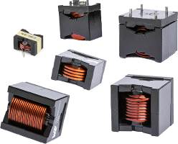
Image source: Würth Elektronik
Booth highlight: WE-HCFT high current inductance with current carrying capacity up to 75 A.

About Würth Elektronik eiSos Group
Würth Elektronik eiSos Group is a manufacturer of electronic and electromechanical components for the electronics industry and a technology company that spearheads pioneering electronic solutions. The company currently employs 8,300 staff and generated sales of 848 million euros in 2018. Würth Elektronik eiSos is one of the largest European manufacturers of passive components and is active in 50 countries. Production sites in Europe, Asia and North America supply a growing number of customers worldwide.
The product range includes EMC components, inductors, transformers, RF components, varistors, capacitors, resistors, quartz crystals, oscillators, power modules, Wireless Power Transfer, LEDs, sensors, connectors, power supply elements, switches, push-buttons, connection technology, fuse holders and solutions for wireless data transmission.
The unrivaled service orientation of the company is characterized by the availability of all catalog components from stock without minimum order quantity, free samples and extensive support through technical sales staff and selection tools.
Through its technology partnership with the Audi Sport ABT Schaeffler Formula E Team and its support for the Formula Student racing series, the company demonstrates its innovative strength in eMobility
(www.we-speed-up-the-future.com).
Würth Elektronik eiSos is part of the Würth Group, the world market leader for assembly and fastening technology.
Würth Elektronik: more than you expect!
Further information at www.we-online.com

Further information:  Würth Elektronik eiSos GmbH & Co. KG  Sarah Hurst  Max-Eyth-Strasse 1  74638 Waldenburg  Germany  Phone: +49 7942 945-5186  E-mail: sarah.hurst@we-online.de  www.we-online.de | Press contact:  HighTech communications GmbH  Brigitte Basilio  Brunhamstrasse 21  81249 Munich  Germany  Phone: +49 89 500778-20  Telefax: +49 89 500778-77  E-mail: b.basilio@htcm.de  www.htcm.de

