PRESS RELEASE
New Extended Rail RM6 and RM10 Transformers from Würth Elektronik Now Available
Watertown (USA), 15 April 2019 – The new MID-OLRM extended rail RM6 and RM10 transformer series for offline applications are now available from Würth Elektronik.
“For the past 30 years, the RM packages have required flying leads to meet reinforced insulation and creepage and clearance distances. We decided to change this by adding an extended rail to existing RM packages, eliminating the need to have flying leads. This package also meets the stringent IEC61558-2-16 standard with reinforced insulation,” explained Swaroop Vaidyanath, Product Marketing Engineer at Würth Elektronik.
Available with single or dual 5V, 12V, or 24V outputs, these flyback transformers feature a small footprint, high power density, and grounded cores for improved EMC performance.
These transformers are best suited for white goods, industrial controls, metering, LED lighting, offline flyback power supplies, space-constrained power supplies, and smart adapter applications.
To review the transformer family, visit www.we-online.com/mid-olrm.
Free samples can be requested at www.we-online.com.

Available images
The following images can be downloaded from the Internet in printable quality: http://www.htcm.de/kk/wuerth
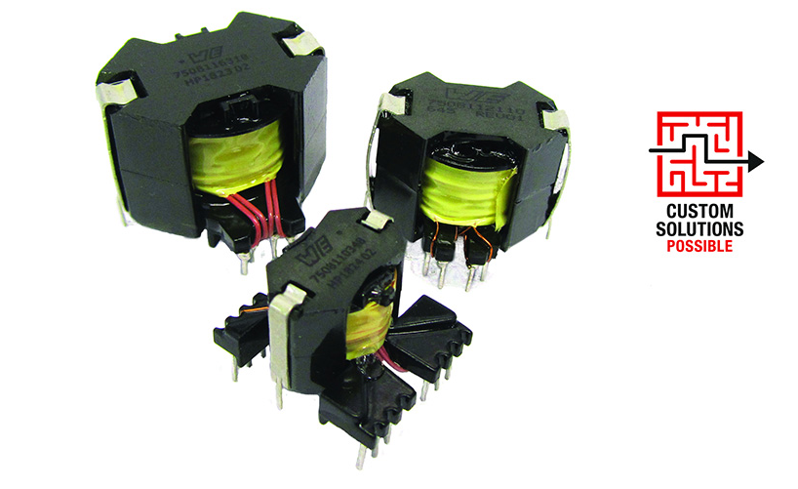
Image source: Würth Elektronik
New MID-OLRM extended rail RM6 and RM10 transformer series for offline applications

About Würth Elektronik eiSos Group
Würth Elektronik eiSos Group is a manufacturer of electronic and electromechanical components for the electronics industry and a technology company that spearheads pioneering electronic solutions. The company currently employs 8,300 staff and generated sales of 848 million euros in 2018. Würth Elektronik eiSos is one of the largest European manufacturers of passive components and is active in 50 countries. Production sites in Europe, Asia and North America supply a growing number of customers worldwide.
The product range includes EMC components, inductors, transformers, RF components, varistors, capacitors, resistors, quartz crystals, oscillators, power modules, Wireless Power Transfer, LEDs, sensors, connectors, power supply elements, switches, push-buttons, connection technology, fuse holders and solutions for wireless data transmission.
The unrivaled service orientation of the company is characterized by the availability of all catalog components from stock without minimum order quantity, free samples and extensive support through technical sales staff and selection tools.
Through its technology partnership with the Audi Sport ABT Schaeffler Formula E Team and its support for the Formula Student racing series, the company demonstrates its innovative strength in eMobility
(www.we-speed-up-the-future.com).
Würth Elektronik eiSos is part of the Würth Group, the world market leader for assembly and fastening technology.
Würth Elektronik: more than you expect!
Further information at www.we-online.com

Further information:  Wurth Electronics Midcom, Inc.  Lindsey Esche  121 Airport Drive  PO Box 1330  Watertown, SD 57201 USA  Phone: +1 605 886 4385  Toll-free (in the U.S.):  Phone: +1 800 643 2661  E-mail: lindsey.esche@we-online.com  www.we-online.com | Press contact:  HighTech communications GmbH  Brigitte Basilio  Brunhamstrasse 21  81249 Munich  Germany  Phone: +49 89 500778-20  Fax: +49 89 500778-77  E-mail: b.basilio@htcm.de  www.htcm.de

