PRESS RELEASE
Würth Elektronik offers photodiodes and phototransistors
Infrared Detector Components from a Single Source
Waldenburg (Germany), 17 April 2019 – Würth Elektronik eiSos, one of the leading European manufacturers of electronic and electromechanical components, is expanding its optoelectronics portfolio: Following infrared LEDs, the company now also has a wide range of detectors in its program that are perfectly matched to the LEDs. Developers of various infrared applications can be sure that the spectra of emitters and detectors match. All infrared components are available from stock any time, and free samples can be requested.
Infrared light (IR), invisible to the human eye, offers a huge number of possible applications - especially through the use of extremely compact components. In addition to classic light barrier installations, remote controls and smoke detectors, infrared can be used in many applications for data transmission. Infrared even goes under the skin:
An individual’s pulse can be monitored and blood pressure measured using fitness track watches. Another usage would be security systems, such as eye, face and gesture recognition, which can also work with IR products.
Since the spectra and wavelengths of Würth Elektronik IR LEDs and photodetectors match perfectly, the modules are ideally suited for data transmission. Identical design of IR LEDs and photodetectors facilitate PCB design. The photodetectors are available in numerous designs with or without daylight filter. All products are equipped with a gold wire for excellent contacting.
The detectors from Würth Elektronik can be selected at https://katalog.we-online.de/en/led/browse/infrared/infrared_phototransistors according to product families or parameters and ordered without a minimum order quantity.

Available images
The following images can be downloaded from the Internet in printable quality: http://www.htcm.de/kk/wuerth
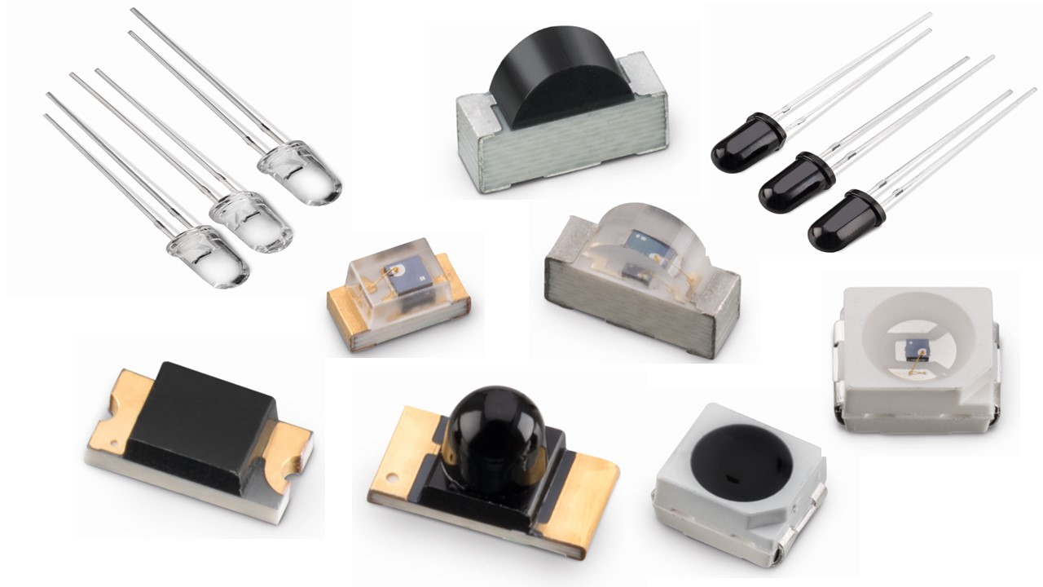
Image source: Würth Elektronik
New in the optoelectronics portfolio: Photodiodes and phototransistors for the development of a wide range of infrared applications

About Würth Elektronik eiSos Group
Würth Elektronik eiSos Group is a manufacturer of electronic and electromechanical components for the electronics industry and a technology company that spearheads pioneering electronic solutions. The company currently employs 8,300 staff and generated sales of 848 million euros in 2018. Würth Elektronik eiSos is one of the largest European manufacturers of passive components and is active in 50 countries. Production sites in Europe, Asia and North America supply a growing number of customers worldwide.
The product range includes EMC components, inductors, transformers, RF components, varistors, capacitors, resistors, quartz crystals, oscillators, power modules, Wireless Power Transfer, LEDs, sensors, connectors, power supply elements, switches, push-buttons, connection technology, fuse holders and solutions for wireless data transmission.
The unrivaled service orientation of the company is characterized by the availability of all catalog components from stock without minimum order quantity, free samples and extensive support through technical sales staff and selection tools.
Through its technology partnership with the Audi Sport ABT Schaeffler Formula E Team and its support for the Formula Student racing series, the company demonstrates its innovative strength in eMobility
(www.we-speed-up-the-future.com).
Würth Elektronik eiSos is part of the Würth Group, the world market leader for assembly and fastening technology.
Würth Elektronik: more than you expect!
Further information at www.we-online.com

Further information:  Würth Elektronik eiSos GmbH & Co. KG  Sarah Hurst  Max-Eyth-Strasse 1  74638 Waldenburg  Germany  Phone: +49 7942 945-5186  E-mail: sarah.hurst@we-online.de  www.we-online.de | Press contact:  HighTech communications GmbH  Brigitte Basilio  Brunhamstrasse 21  81249 Munich  Germany  Phone: +49 89 500778-20  Telefax: +49 89 500778-77  E-mail: b.basilio@htcm.de  www.htcm.de

