PRESS RELEASE

Würth Elektronik Expands Annual Technical Training Show
Watertown (USA), 7 May 2019 – For the fifth year, Würth Elektronik has successfully held its first set of annual WE Day exhibitions. WE Days are technical seminars and a tabletop show. Along with hosting shows in Canada and Mexico, Würth Elektronik has expanded its WE Day into the United States, appearing in Dallas, Texas in April.
WE Day offers unbiased training from a diverse range of exhibitors. The comprehensive WE Day event allows engineers to find suppliers from printed circuit boards (PCBs), harness, distributors, and IC manufacturers at the same time.
“Our goal is to reach out to as many customers as possible, and provide technical training to our customers. We also include all of our IC partners to present,” says Matt Jackson, Area Sales Manager in Ontario, Canada. “There is no other place other than WE Day where all of us come together in one day to provide the best technical presentations on passive and active solutions.”
This year’s WE Day shows included speakers from IC partners and Würth Elektronik technical experts. Würth Elektronik looks forward to returning to Mexico for WE Day in Monterrey, Guadalajara, and Mexico City in October.
To find more information, visit www.we-online.com/weday.
To exhibit at WE Day 2020, visit www.we-online.com/wedaypreregistration.

Available images
The following images can be downloaded from the Internet in printable quality: http://www.htcm.de/kk/wuerth
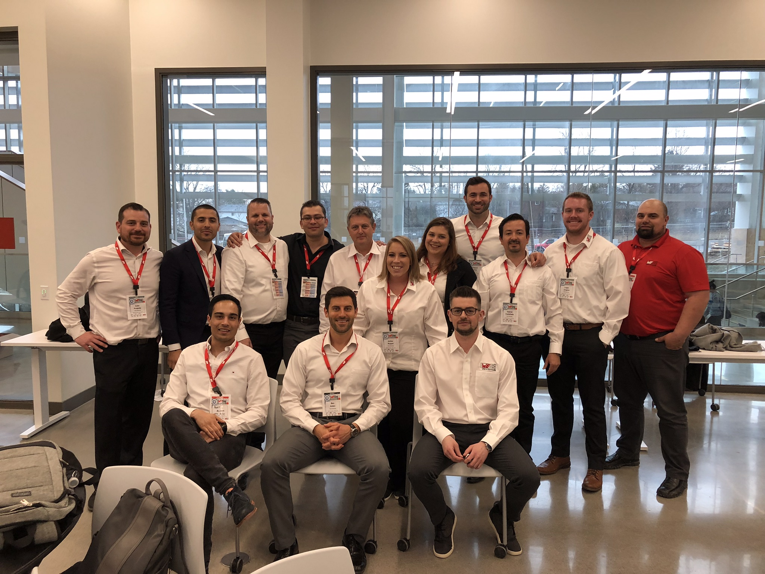
Image source: Würth Elektronik
The Würth Elektronik Team which has held its annual WE Day exhibition.

About Würth Elektronik eiSos Group
Würth Elektronik eiSos Group is a manufacturer of electronic and electromechanical components for the electronics industry and a technology company that spearheads pioneering electronic solutions. The company currently employs 8,300 staff and generated sales of 848 million euros in 2018. Würth Elektronik eiSos is one of the largest European manufacturers of passive components and is active in 50 countries. Production sites in Europe, Asia and North America supply a growing number of customers worldwide.
The product range includes EMC components, inductors, transformers, RF components, varistors, capacitors, resistors, quartz crystals, oscillators, power modules, Wireless Power Transfer, LEDs, sensors, connectors, power supply elements, switches, push-buttons, connection technology, fuse holders and solutions for wireless data transmission.
The unrivaled service orientation of the company is characterized by the availability of all catalog components from stock without minimum order quantity, free samples and extensive support through technical sales staff and selection tools.
Through its technology partnership with the Audi Sport ABT Schaeffler Formula E Team and its support for the Formula Student racing series, the company demonstrates its innovative strength in eMobility
(www.we-speed-up-the-future.com).
Würth Elektronik eiSos is part of the Würth Group, the world market leader for assembly and fastening technology.
Würth Elektronik: more than you expect!
Further information at www.we-online.com

Further information:  Wurth Electronics Midcom, Inc.  Lindsey Esche  121 Airport Drive  PO Box 1330  Watertown, SD 57201 USA  Phone: +1 605 886 4385  Toll-free (in the U.S.):  Phone: +1 800 643 2661  E-mail: lindsey.esche@we-online.com  www.we-online.com | Press contact:  HighTech communications GmbH  Brigitte Basilio  Brunhamstrasse 21  81249 Munich  Germany  Phone: +49 89 500778-20  Fax: +49 89 500778-77  E-mail: b.basilio@htcm.de  www.htcm.de

