PRESS RELEASE
Würth Elektronik introduces WSEN-PADS absolute pressure sensor
Slim Sensor Delivers Calibrated Data
Waldenburg (Germany), 30 October 2019 — Würth Elektronik presents a very compact MEMS-based (Micro-Electro-Mechanical Systems) absolute pressure sensor: The 2.0 x 2.0 x 0.8 mm sized WSEN-PADS measures pressure in the range between 26 and 126 kPa. Its output data rate can be selected between 1 and 200 Hz. The sensor contains an ASIC (application-specific integrated circuit) and a temperature sensor. This means the output values are already calibrated.
The WSEN-PADS absolute pressure sensor offers the possibility of preparing the measured data for various applications using activatable integrated algorithms in such a way that the programming workload for a connected controller is greatly reduced. The measured data can be read out via a standard I²C interface. The I²C interface is extended by an additional interrupt pin whose function can be modified by the user. An application example is the use of the pressure sensor as an altimeter. Thanks to its high resolution, the sensor provides information that enables the position of individual floors in buildings to be mapped. This supports an indoor navigation system. WSEN-PADS is not only extremely suitable for mobile devices on account of its slim design: Since the sensor can be operated at very low power consumption, it is possible to supply it with batteries or even energy via energy harvesting—Würth Elektronik offers technical support here. The piezoresistive sensor is specified for an industrial temperature range from -40 to +85°C. Würth Elektronik offers a tailored evaluation board.
The special advantage for developers: The sensor is always available from stock without a minimum order quantity.

Available images
The following images can be downloaded from the Internet in printable quality: http://www.htcm.de/kk/wuerth

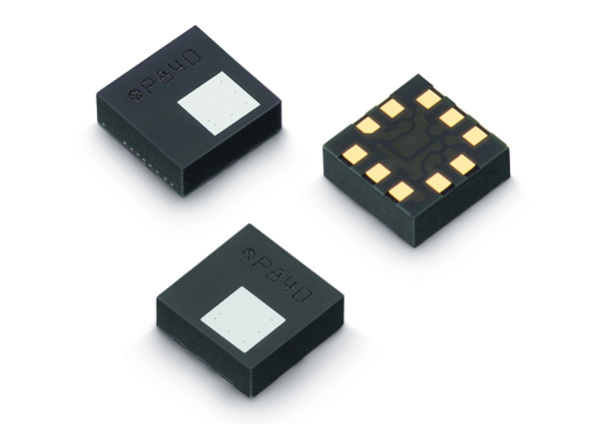Image source: Würth Elektronik
The WSEN-PADS absolute pressure sensor from Würth Elektronik

About Würth Elektronik eiSos Group
Würth Elektronik eiSos Group is a manufacturer of electronic and electromechanical components for the electronics industry and a technology company that spearheads pioneering electronic solutions. The company currently employs 8,300 staff and generated sales of 848 million euros in 2018. Würth Elektronik eiSos is one of the largest European manufacturers of passive components and is active in 50 countries. Production sites in Europe, Asia and North America supply a growing number of customers worldwide.
The product range includes EMC components, inductors, transformers, RF components, varistors, capacitors, resistors, quartz crystals, oscillators, power modules, Wireless Power Transfer, LEDs, sensors, connectors, power supply elements, switches, push-buttons, connection technology, fuse holders and solutions for wireless data transmission.
The unrivaled service orientation of the company is characterized by the availability of all catalog components from stock without minimum order quantity, free samples and extensive support through technical sales staff and selection tools.
Through its technology partnership with the Audi Sport ABT Schaeffler Formula E Team and its support for the Formula Student racing series, the company demonstrates its innovative strength in eMobility
(www.we-speed-up-the-future.com).
Würth Elektronik eiSos is part of the Würth Group, the world market leader for assembly and fastening technology.
Würth Elektronik: more than you expect!
Further information at www.we-online.com

Further information:  Würth Elektronik eiSos GmbH & Co. KG  Sarah Hurst  Max-Eyth-Strasse 1  74638 Waldenburg  Germany  Phone: +49 7942 945-5186  E-mail: sarah.hurst@we-online.de  www.we-online.de | Press contact:  HighTech communications GmbH  Brigitte Basilio  Brunhamstrasse 21  81249 Munich  Germany  Phone: +49 89 500778-20  Telefax: +49 89 500778-77  E-mail: b.basilio@htcm.de  www.htcm.de

