PRESS RELEASE
Würth Elektronik introduces its WSEN-ITDS 3-axis acceleration sensor
Motion Sensor with Preset Functionalities
Waldenburg (Germany), August 16, 2019—Würth Elektronik expands its sensor program with a compact, versatile 3-axis acceleration sensor. The WSEN-ITDS sensor, which measures only 2.0 × 2.0 × 0.7 mm and is offered in an LGA package, uses a MEMS-based capacitive measuring principle. Thanks to an integrated temperature sensor, the sensor outputs calibrate data directly. Four measuring ranges are available for selection: ±2, ±4, ±8 or ±16 g. Register settings can be used to select the application-specific functionalities for free fall, wake-up, tap, activity, motion and orientation detection.
The acceleration sensor can be used in a variety of ways: for example, high-resolution with up to 1,600 Hz output data rate for vibration monitoring, such as in the predictive maintenance of machines, or in low-power mode for recording a single pulse when a switch is touched, for instance. In this case, the energy-saving sensor can even be operated with energy harvesting. The ability to use integrated algorithms to prepare the measured data for application cases makes application development far easier. The WSEN-ITDS is specified for a temperature range from -40 to +85°C and is therefore extremely suitable for industrial applications, such as decentralized measurement data acquisition in IoT networks. Würth Elektronik offers developers intensive design-in consultation. In contrast to prevailing market practices, the sensors can be ordered from stock without a minimum order quantity.
At https://katalog.we-online.de/en/wco/WSEN-EVAL Würth Elektronik offers an evaluation board for the sensor.

Available images
The following images can be downloaded from the Internet in printable quality: http://www.htcm.de/kk/wuerth

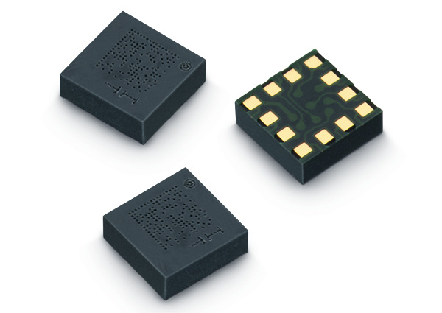
A versatile acceleration sensor: Würth Elektronik WSEN-ITDS

About Würth Elektronik eiSos Group
Würth Elektronik eiSos Group is a manufacturer of electronic and electromechanical components for the electronics industry and a technology company that spearheads pioneering electronic solutions. The company currently employs 8,300 staff and generated sales of 848 million euros in 2018. Würth Elektronik eiSos is one of the largest European manufacturers of passive components and is active in 50 countries. Production sites in Europe, Asia and North America supply a growing number of customers worldwide.
The product range includes EMC components, inductors, transformers, RF components, varistors, capacitors, resistors, quartz crystals, oscillators, power modules, Wireless Power Transfer, LEDs, sensors, connectors, power supply elements, switches, push-buttons, connection technology, fuse holders and solutions for wireless data transmission.
The unrivaled service orientation of the company is characterized by the availability of all catalog components from stock without minimum order quantity, free samples and extensive support through technical sales staff and selection tools.
Through its technology partnership with the Audi Sport ABT Schaeffler Formula E Team and its support for the Formula Student racing series, the company demonstrates its innovative strength in eMobility
(www.we-speed-up-the-future.com).
Würth Elektronik eiSos is part of the Würth Group, the world market leader for assembly and fastening technology.
Würth Elektronik: more than you expect!
Further information at www.we-online.com

Further information:  Würth Elektronik eiSos GmbH & Co. KG  Sarah Hurst  Max-Eyth-Strasse 1  74638 Waldenburg  Germany  Phone: +49 7942 945-5186  E-mail: sarah.hurst@we-online.de  www.we-online.de | Press contact:  HighTech communications GmbH  Brigitte Basilio  Brunhamstrasse 21  81249 Munich  Germany  Phone: +49 89 500778-20  Telefax: +49 89 500778-77  E-mail: b.basilio@htcm.de  www.htcm.de

