PRESS RELEASE
Würth Elektronik introduces WE-SMGS solderable seal
SMT Grounding Solution
Waldenburg (Germany), 23 October 2019 – With WE-SMGS, Würth Elektronik offers solderable seals for surface mounting. The WE-SMGS consists of a temperature resistant foam material, which combines the conductive seals with high elasticity. After compression, they then return to their original shape. The layer surrounding the heat-resistant foam is made of copper weave with tinning. It facilitates the soldering process in the reflow oven.
WE-SMGS can be used to establish contact between the PCB ground and metallic housing or other external metallic elements. It can also be used for low-resistance HF connections between the grounding points of two superimposed PCBs. These elements are designed for the pick-and-place/reflow process thus represent an alternative to WE-SECF contact fingers. WE-SMGS is available from stock in various heights from 2.5 to 15 mm. Würth Elektronik provides free samples on request.

Available images
The following images can be downloaded from the Internet in printable quality: http://www.htcm.de/kk/wuerth
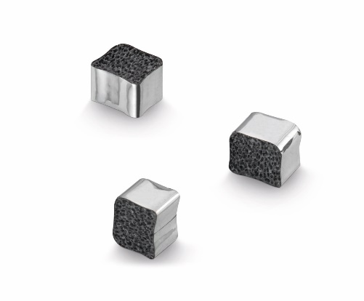
Image source: Würth Elektronik
SMT solution for connecting grounding points: WE-SMGS—consisting of a temperature-resistant foam and tin-plated copper foil

About Würth Elektronik eiSos Group
Würth Elektronik eiSos Group is a manufacturer of electronic and electromechanical components for the electronics industry and a technology company that spearheads pioneering electronic solutions. The company currently employs 8,300 staff and generated sales of 848 million euros in 2018. Würth Elektronik eiSos is one of the largest European manufacturers of passive components and is active in 50 countries. Production sites in Europe, Asia and North America supply a growing number of customers worldwide.
The product range includes EMC components, inductors, transformers, RF components, varistors, capacitors, resistors, quartz crystals, oscillators, power modules, Wireless Power Transfer, LEDs, sensors, connectors, power supply elements, switches, push-buttons, connection technology, fuse holders and solutions for wireless data transmission.
The unrivaled service orientation of the company is characterized by the availability of all catalog components from stock without minimum order quantity, free samples and extensive support through technical sales staff and selection tools.
Through its technology partnership with the Audi Sport ABT Schaeffler Formula E Team and its support for the Formula Student racing series, the company demonstrates its innovative strength in eMobility
(www.we-speed-up-the-future.com).
Würth Elektronik eiSos is part of the Würth Group, the world market leader for assembly and fastening technology.
Würth Elektronik: more than you expect!
Further information at www.we-online.com

Further information:  Würth Elektronik eiSos GmbH & Co. KG  Sarah Hurst  Max-Eyth-Strasse 1  74638 Waldenburg  Germany  Phone: +49 7942 945-5186  E-mail: sarah.hurst@we-online.de  www.we-online.de | Press contact:  HighTech communications GmbH  Brigitte Basilio  Brunhamstrasse 21  81249 Munich  Germany  Phone: +49 89 500778-20  Telefax: +49 89 500778-77  E-mail: b.basilio@htcm.de  www.htcm.de

