PRESS RELEASE
Würth Elektronik expands its MagI³C-VDMM power module series
More Magic Micro Modules
Waldenburg (Germany), 30 September 2019—The MagI³C-VDMM (Variable Step Down Micro Module) power module family from Würth Elektronik is supplemented by more powerful 1 A and 1.2 A versions. The input voltage range (from 2.5 to 5.5 V) covers the standard 3.3 and 5 V bus voltages, and the adjustable output voltage ranges from 0.8 to 5.5 V. The modules have been designed for high efficiency in the low load range. Integration of the DC-DC converter and coil makes for a very compact solution in an LGA-6EP package.
The MagI³C-VDMM series is particularly suitable as a replacement for linear regulators. Applications include the supply of interfaces, microcontrollers, microprocessors, DSPs and FPGAs. Thanks to their small size and high efficiency (over 96%), they are particularly suitable for use in mobile and battery-powered devices. To save energy, the VDMM can be "put to sleep" using an additional PIN, which extends battery life.
The MagI³C VDMM series features excellent electromagnetic compatibility. The modules meet the CISP-32 standard for Class B radiated interference without additional filter elements.
The new member of the MagI³C-VDMM family is available from stock. Free samples can be requested.

Available images
The following images can be downloaded from the Internet in printable quality: http://www.htcm.de/kk/wuerth
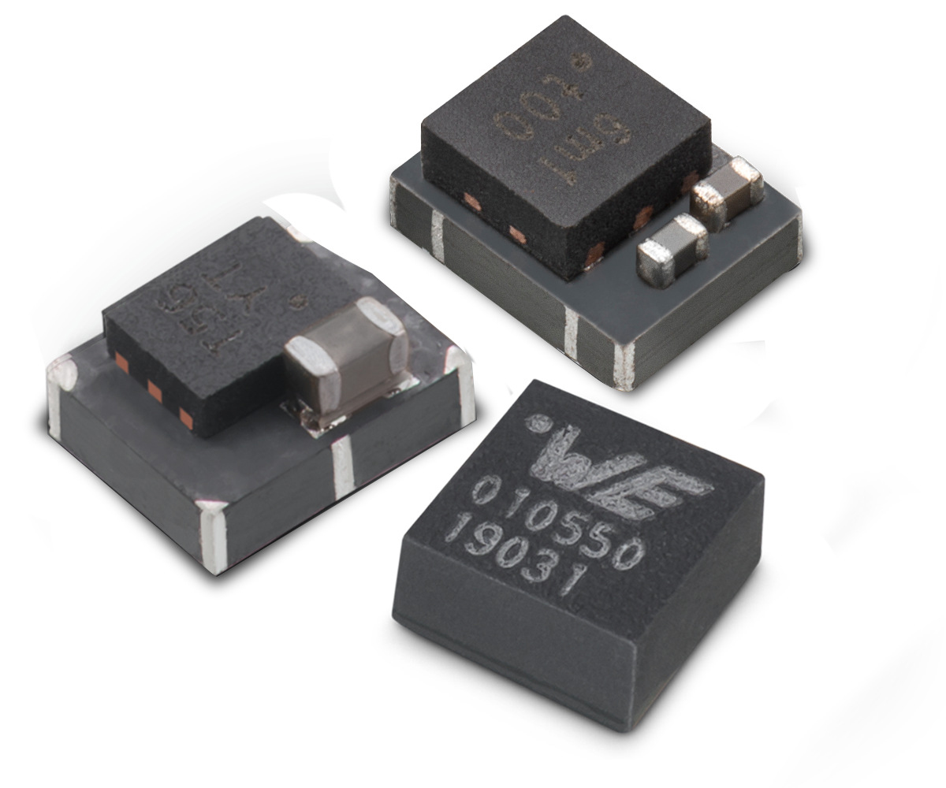Image source: Würth Elektronik
MagI³C-VDMM power module series

About Würth Elektronik eiSos Group
Würth Elektronik eiSos Group is a manufacturer of electronic and electromechanical components for the electronics industry and a technology company that spearheads pioneering electronic solutions. The company currently employs 8,300 staff and generated sales of 848 million euros in 2018. Würth Elektronik eiSos is one of the largest European manufacturers of passive components and is active in 50 countries. Production sites in Europe, Asia and North America supply a growing number of customers worldwide.
The product range includes EMC components, inductors, transformers, RF components, varistors, capacitors, resistors, quartz crystals, oscillators, power modules, Wireless Power Transfer, LEDs, sensors, connectors, power supply elements, switches, push-buttons, connection technology, fuse holders and solutions for wireless data transmission.
The unrivaled service orientation of the company is characterized by the availability of all catalog components from stock without minimum order quantity, free samples and extensive support through technical sales staff and selection tools.
Through its technology partnership with the Audi Sport ABT Schaeffler Formula E Team and its support for the Formula Student racing series, the company demonstrates its innovative strength in eMobility
(www.we-speed-up-the-future.com).
Würth Elektronik eiSos is part of the Würth Group, the world market leader for assembly and fastening technology.
Würth Elektronik: more than you expect!
Further information at www.we-online.com

Further information:  Würth Elektronik eiSos GmbH & Co. KG  Sarah Hurst  Max-Eyth-Strasse 1  74638 Waldenburg  Germany  Phone: +49 7942 945-5186  E-mail: sarah.hurst@we-online.de  www.we-online.de | Press contact:  HighTech communications GmbH  Brigitte Basilio  Brunhamstrasse 21  81249 Munich  Germany  Phone: +49 89 500778-20  Telefax: +49 89 500778-77  E-mail: b.basilio@htcm.de  www.htcm.de

