PRESS RELEASE
Würth Elektronik CTO at the DLD Conference in Singapore
Design competence for innovation
Waldenburg (Germany), October 31, 2019 – The Digital-Life-Design (DLD) Conference was once again held in the Asian metropolis of Singapore on October 22, 2019. On stage, Alexander Gerfer discussed with digital marketing researcher Joe Nguyen why companies have to reconsider their ideas about creativity.
Alexander Gerfer, CTO of one of Europe’s largest manufacturers of passive components, referred to the major importance of hardware partners for young, innovative digital companies. For them to be successful, it is crucial to have a partner that can advise them about the most suitable components and how best to use them – a partner that is also prepared to deliver these components in small quantities to developers. “The end customer doesn’t see us. But we are an important partner for developers and in the design process. It is especially the biggest ideas that need someone to take care of the details,” said Alexander Gerfer, getting to the heart of Würth Elektronik’s commitment, its intensive customer service, and its design support.
Würth Elektronik also researches and is a developer itself so that it can support the innovative concepts of its customers. In Singapore, Alexander Gerfer mentioned some examples of ongoing projects, such as the cooperation with the University of Munich in the area of LEDs for vertical farming, smart textiles, and the company's involvement in Formula E. Only because we are close to our customers, we are able to understand their challenges and find solutions.
The company's cooperation with GlobalFoundries in Singapore shows just what can emerge from creative ideas that aim to resolve customers’ pressing needs.
Jin Siew Lim, Head of Business Development at GlobalFoundries, revealed how the closeness to developers, customers, and market developments that his company gains from Würth Elektronik has given it a significant competitive advantage. In a joint project, the two partners developed miniaturized Power Supply in Package and Power Supply on Chip solutions. The target markets for these highly integrated components are mobile measuring devices in medicine and other industries. As highly integrated subsystems, they help reduce the number of components on PCBs and speed up design processes.

Available images
The following images can be downloaded from the Internet in printable quality: http://www.htcm.de/kk/wuerth
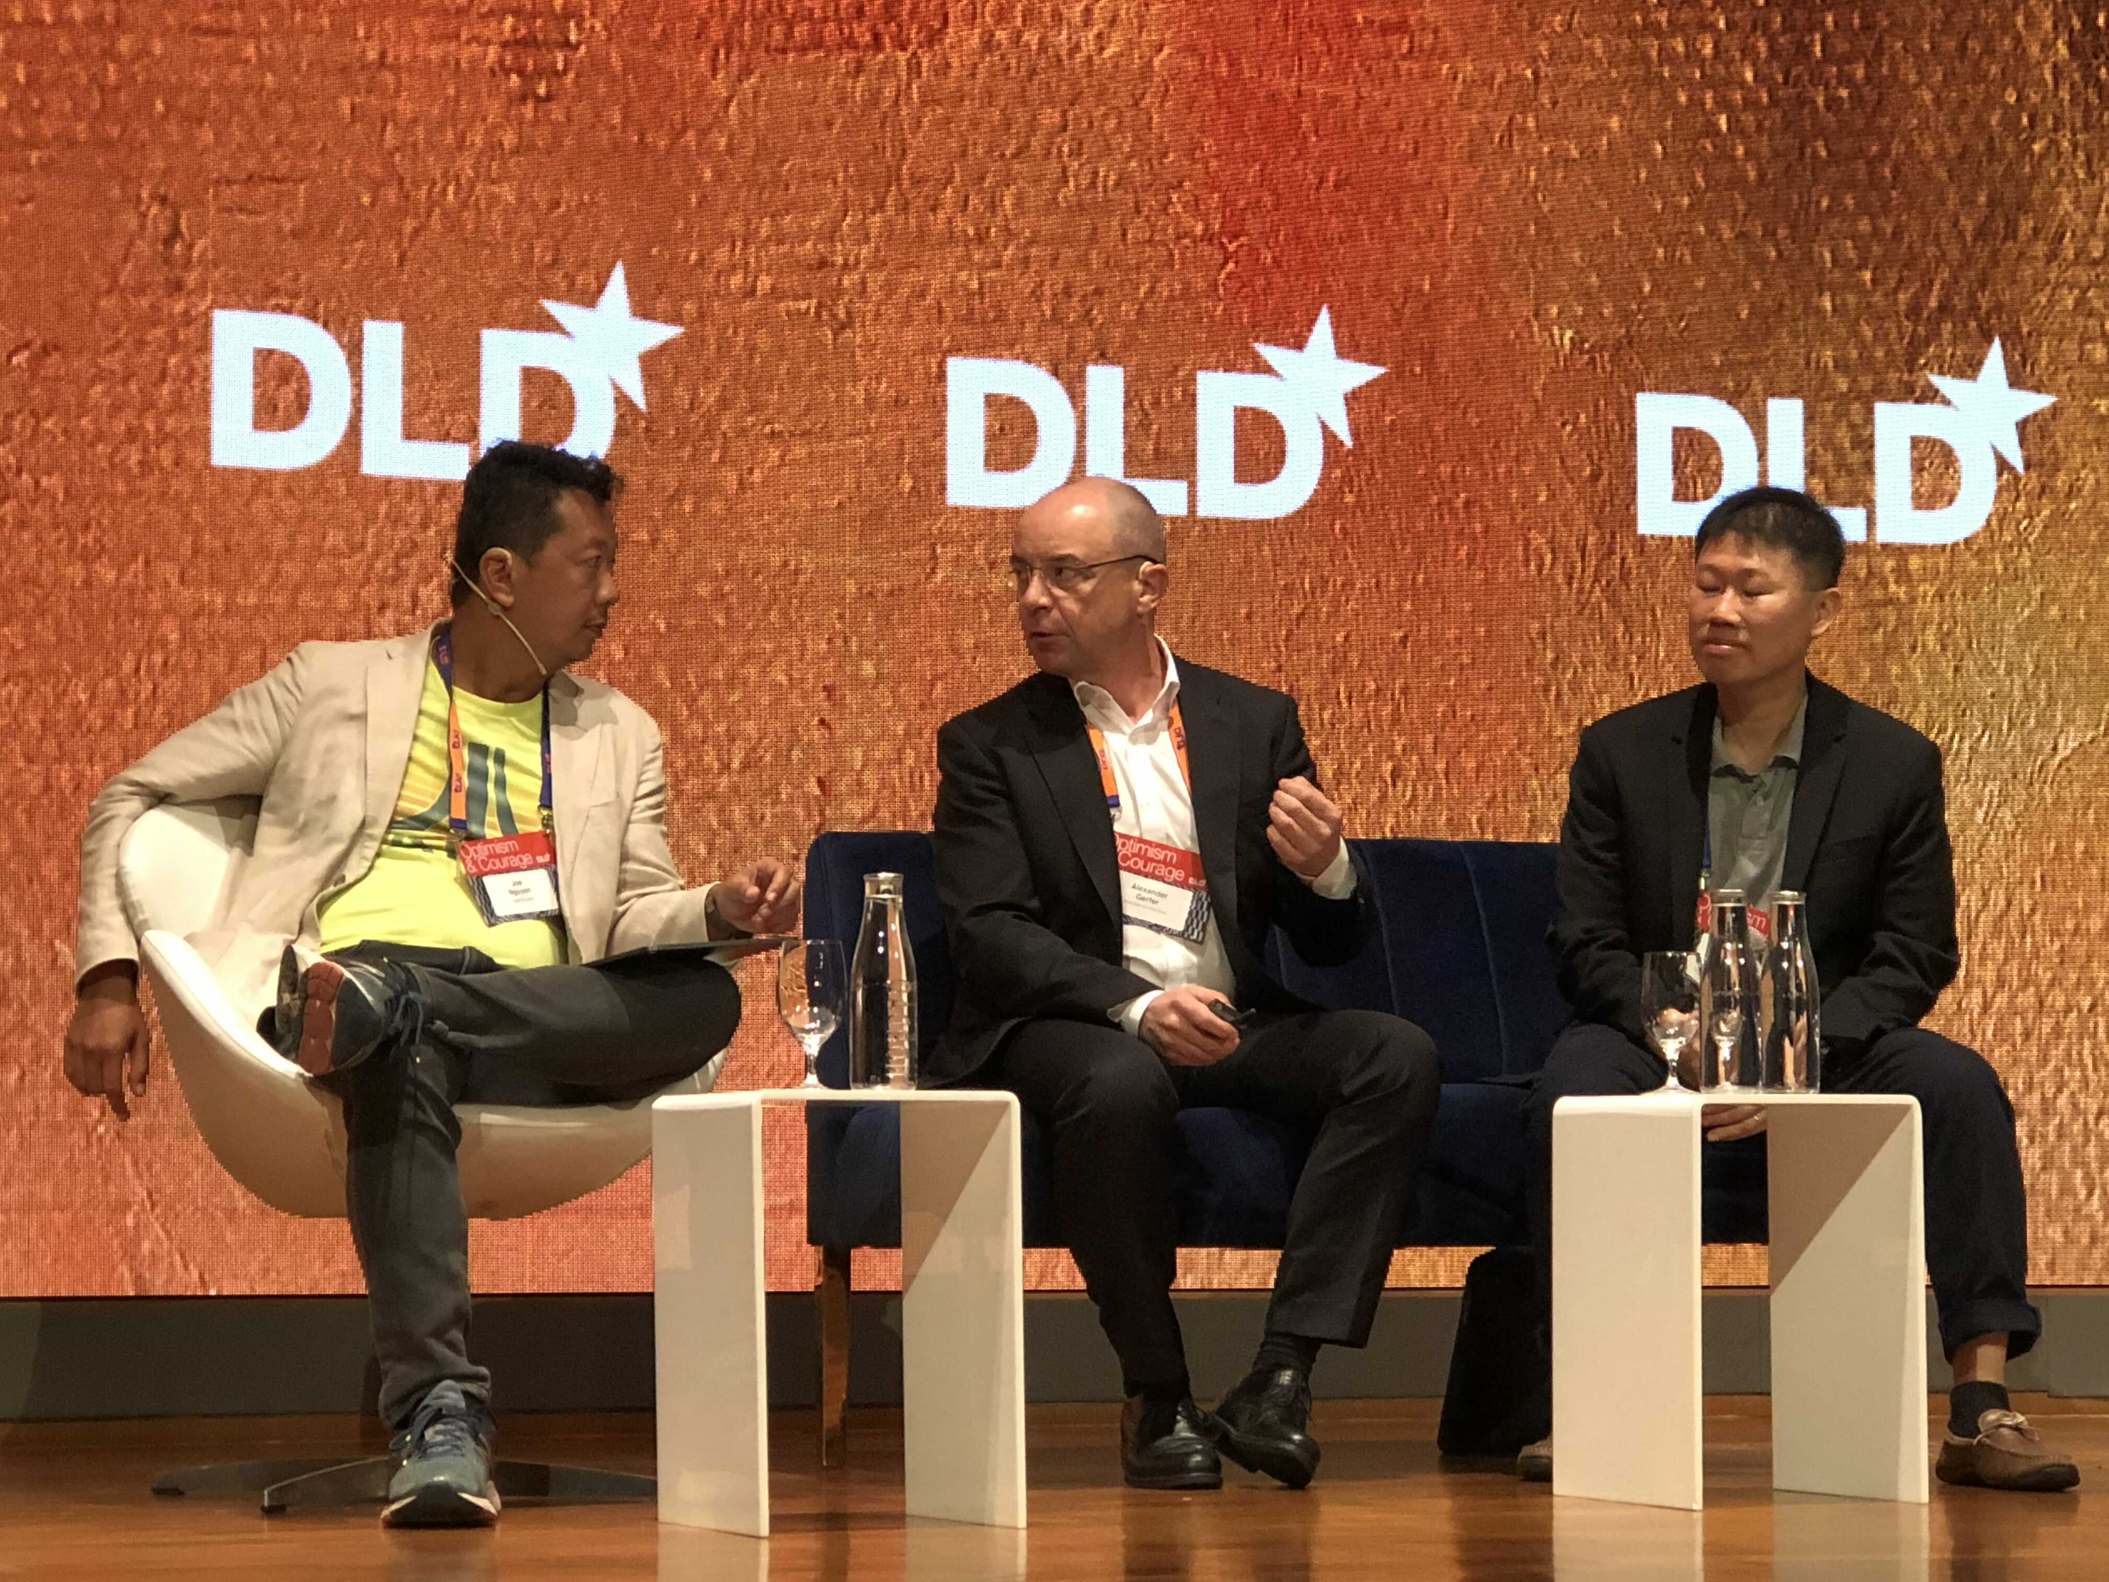  Image source: Würth Elektronik  Discussion at the DLD Congress in Singapore: Joe Nguyen (Senior Vice President, comScore), Alexander Gerfer (CTO, Würth Elektronik eiSos Group), Jin Siew Lim (Head of Business Development, GlobalFoundries) (l to r) | 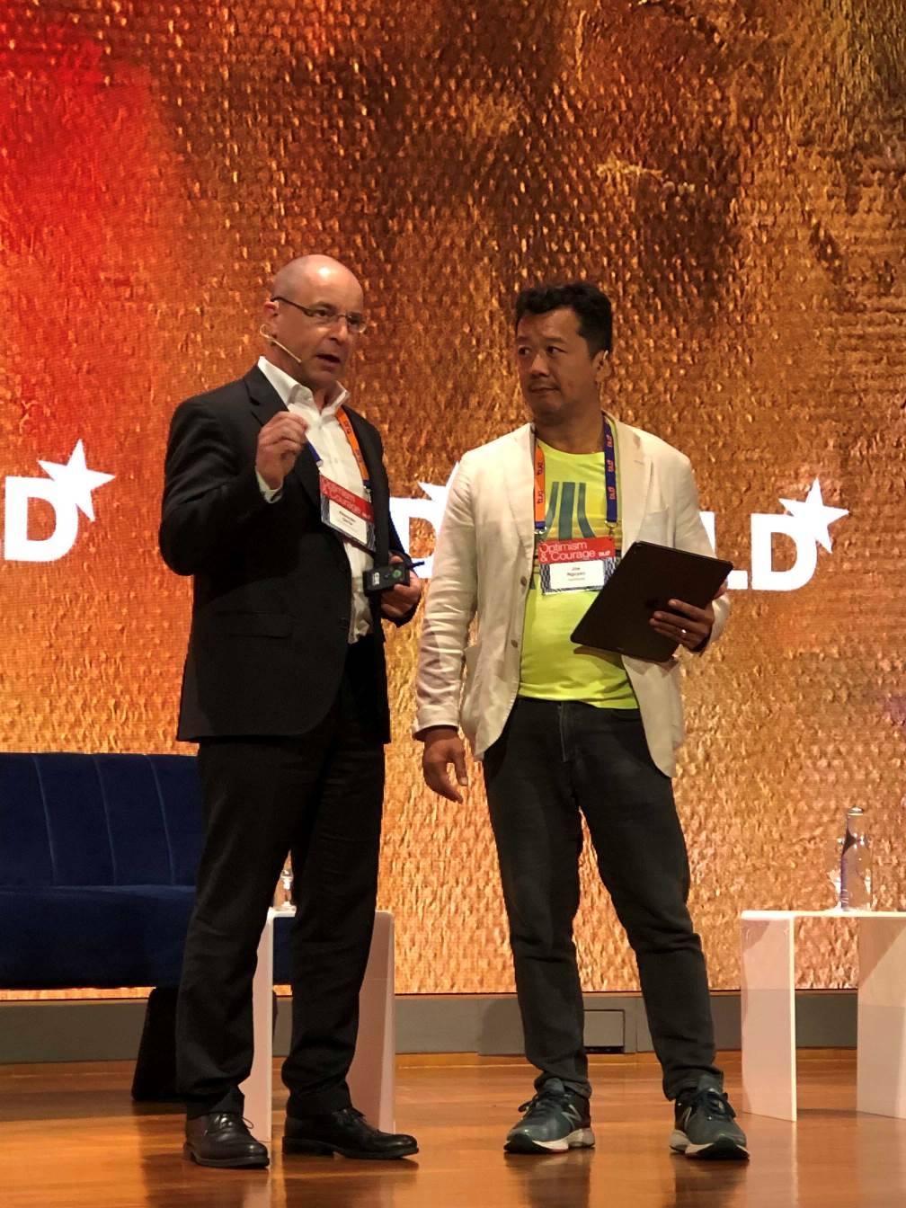  Image source: Würth Elektronik  Alexander Gerfer (CTO, Würth Elektronik eiSos Group) explains to Joe Nguyen (Senior Vice President, comScore) why Würth Elektronik sees itself as an enabler of innovative solutions.

About Digital Life Design (DLD)
DLD stands for Digital, Life, Design and examines how the digital age is fundamentally changing our lives, society and business. DLD was founded in 2005. Since then, it has developed into an interdisciplinary, internationally networked platform for those who have changed or are set to change the world - with their creativity, their business model, their research results or their personal commitment to something close to their hearts. DLD was recognized by The Economist as "one of the two most important innovation conferences in Europe".
Further info at www.dld-conference.com

About Würth Elektronik eiSos Group
Würth Elektronik eiSos Group is a manufacturer of electronic and electromechanical components for the electronics industry and a technology company that spearheads pioneering electronic solutions. The company currently employs 8,300 staff and generated sales of 848 million euros in 2018. Würth Elektronik eiSos is one of the largest European manufacturers of passive components and is active in 50 countries. Production sites in Europe, Asia and North America supply a growing number of customers worldwide.
The product range includes EMC components, inductors, transformers, RF components, varistors, capacitors, resistors, quartz crystals, oscillators, power modules, Wireless Power Transfer, LEDs, sensors, connectors, power supply elements, switches, push-buttons, connection technology, fuse holders and solutions for wireless data transmission.
The unrivaled service orientation of the company is characterized by the availability of all catalog components from stock without minimum order quantity, free samples and extensive support through technical sales staff and selection tools.
Through its technology partnership with the Audi Sport ABT Schaeffler Formula E Team and its support for the Formula Student racing series, the company demonstrates its innovative strength in eMobility
(www.we-speed-up-the-future.com).
Würth Elektronik eiSos is part of the Würth Group, the world market leader for assembly and fastening technology.
Würth Elektronik: more than you expect!
Further information at www.we-online.com

Further information:  Würth Elektronik eiSos GmbH & Co. KG  Sarah Hurst  Max-Eyth-Strasse 1  74638 Waldenburg  Germany  Phone: +49 7942 945-5186  E-mail: sarah.hurst@we-online.de  www.we-online.de | Press contact:  HighTech communications GmbH  Brigitte Basilio  Brunhamstrasse 21  81249 Munich  Germany  Phone: +49 89 500778-20  Telefax: +49 89 500778-77  E-mail: b.basilio@htcm.de  www.htcm.de

