PRESS RELEASE
Würth Elektronik publishes Electronic Components 2020 catalog
New Electronic Components in the Portfolio
Waldenburg (Germany), 12 March 2020 — Würth Elektronik has published its new products on 188 pages with the Electronic Components 2020 catalog. The catalog can be ordered in printed form, downloaded as a PDF or opened in the iOS Catalog app. It contains new products from the areas of passive components, optoelectronics and power modules.
Under the title "Focus Products", the Electronic Components 2020 catalog precisely explains innovative component developments in terms of their design, properties and applications. Furthermore, "Relaunches" has been added to the catalog: These are products that have been improved, e.g., through AECQ qualification or their electrical and mechanical properties. The products are supplemented with further information on product selection, reference designs and services. All products in the catalog are available from stock without a minimum order quantity.

Available images
The following images can be downloaded from the Internet in printable quality: http://www.htcm.de/kk/wuerth
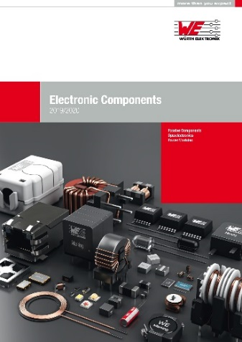
Electronic Components 2020 catalog
Image source: Würth Elektronik

About Würth Elektronik eiSos Group
Würth Elektronik eiSos Group is a manufacturer of electronic and electromechanical components for the electronics industry and a technology company that spearheads pioneering electronic solutions. The company currently employs 7,300 staff and generated sales of 822 million euros in 2019. Würth Elektronik eiSos is one of the largest European manufacturers of passive components and is active in 50 countries. Production sites in Europe, Asia and North America supply a growing number of customers worldwide.
The product range includes EMC components, inductors, transformers, RF components, varistors, capacitors, resistors, quartz crystals, oscillators, power modules, Wireless Power Transfer, LEDs, sensors, connectors, power supply elements, switches, push-buttons, connection technology, fuse holders and solutions for wireless data transmission.
The unrivaled service orientation of the company is characterized by the availability of all catalog components from stock without minimum order quantity, free samples and extensive support through technical sales staff and selection tools.
Through its technology partnership with the Audi Sport ABT Schaeffler Formula E Team and its support for the Formula Student racing series, the company demonstrates its innovative strength in eMobility
(www.we-speed-up-the-future.com).
Würth Elektronik eiSos is part of the Würth Group, the world market leader for assembly and fastening technology.
Würth Elektronik: more than you expect!
Further information at www.we-online.com

Further information:  Würth Elektronik eiSos GmbH & Co. KG  Sarah Hurst  Max-Eyth-Strasse 1  74638 Waldenburg  Germany  Phone: +49 7942 945-5186  E-mail: sarah.hurst@we-online.de  www.we-online.de | Press contact:  HighTech communications GmbH  Brigitte Basilio  Brunhamstrasse 21  81249 Munich  Germany  Phone: +49 89 500778-20  Telefax: +49 89 500778-77  E-mail: b.basilio@htcm.de  www.htcm.de

