PRESS RELEASE
Würth Elektronik publishes catalog of electromechanical components
The Whole World of Mechanical Connections in Electrical Engineering
Waldenburg (Germany), 6 February 2020 — Würth Elektronik has reissued its complete catalog of electromechanical components. The overview of connection technology, assembly, switches and keys can now be ordered in printed form, as a PDF or opened in the iOS Catalog app. On 799 pages you will find everything you need for the convenient connection of cables, the secure connection of PCBs or manual circuits — high-quality standard components, as well as the innovative solutions REDFIT IDC SKEDD and REDCUBE. The catalog also refers to Würth Elektronik’s assembly and customization services. All these products are available from stock without a minimum order quantity.
Among the new products featured in "Electromechanical Components 2020" are prefabricated cables with SKEDD connectors, WR-FAST as fast THT connectors for up to 16 A load and the WR-FPC Flexible Printed Circuit Connectors for connecting displays. Würth Elektronik places great importance on durable USB plugs and has expanded its portfolio here. Micro SD card interfaces for industrial applications are among the new additions, as are shielded WR-MJ modular jacks for 5 G to 10 G Ethernet protocols. Also added are new SMT mountable miniature pushbuttons and super-flat switches. The high-current terminal family REDCUBE—known for its extremely vibration-resistant press-fit connections—has also grown in the SMT sector. Würth Elektronik offers free samples for the entire range of electronic-mechanical components on request.

Available images
The following images can be downloaded from the Internet in printable quality: http://www.htcm.de/kk/wuerth

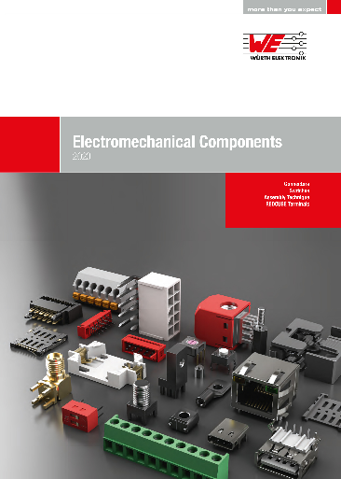Image source: Würth Elektronik
New comprehensive catalog — Electromechanical Components 2020

About Würth Elektronik eiSos Group
Würth Elektronik eiSos Group is a manufacturer of electronic and electromechanical components for the electronics industry and a technology company that spearheads pioneering electronic solutions. The company currently employs 8,300 staff and generated sales of 848 million euros in 2018. Würth Elektronik eiSos is one of the largest European manufacturers of passive components and is active in 50 countries. Production sites in Europe, Asia and North America supply a growing number of customers worldwide.
The product range includes EMC components, inductors, transformers, RF components, varistors, capacitors, resistors, quartz crystals, oscillators, power modules, Wireless Power Transfer, LEDs, sensors, connectors, power supply elements, switches, push-buttons, connection technology, fuse holders and solutions for wireless data transmission.
The unrivaled service orientation of the company is characterized by the availability of all catalog components from stock without minimum order quantity, free samples and extensive support through technical sales staff and selection tools.
Through its technology partnership with the Audi Sport ABT Schaeffler Formula E Team and its support for the Formula Student racing series, the company demonstrates its innovative strength in eMobility
(www.we-speed-up-the-future.com).
Würth Elektronik eiSos is part of the Würth Group, the world market leader for assembly and fastening technology.
Würth Elektronik: more than you expect!
Further information at www.we-online.com

Further information:  Würth Elektronik eiSos GmbH & Co. KG  Sarah Hurst  Max-Eyth-Strasse 1  74638 Waldenburg  Germany  Phone: +49 7942 945-5186  E-mail: sarah.hurst@we-online.de  www.we-online.de | Press contact:  HighTech communications GmbH  Brigitte Basilio  Brunhamstrasse 21  81249 Munich  Germany  Phone: +49 89 500778-20  Telefax: +49 89 500778-77  E-mail: b.basilio@htcm.de  www.htcm.de

