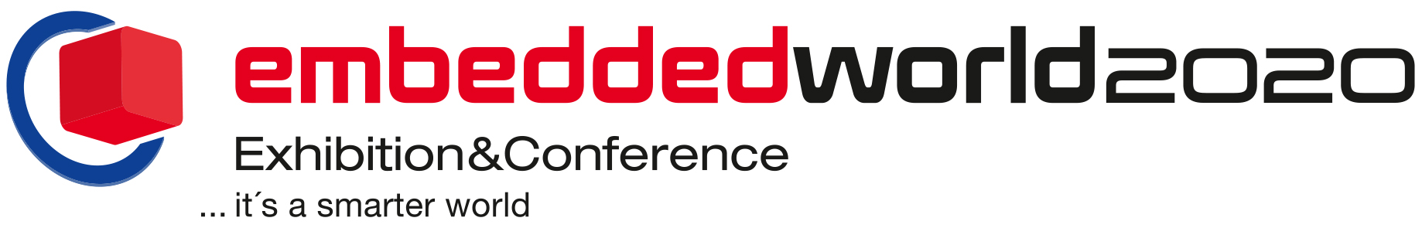
PRESS RELEASE
Hall 3, booth 3-247
Würth Elektronik at embedded world
New components, New Possibilities
Waldenburg (Germany), 11 February 2020 — Würth Elektronik, one of Europe’s biggest manufacturers of electronic and electromechanical components, is exhibiting at embedded world (Nuremberg, February 25 to 27, 2020). At booth 3-247 (covering 126.5 m²) in Hall 3, various company departments will present their product innovations and provide information about services for electronics developers. The range extends from components for EMC to optoelectronics, from oscillators and simulation tools, to radio modules and sensors. Experts from Würth Elektronik also participate in the show’s congress program with four lectures.
The central theme of the trade show is the Internet of Things and communication between machines. Here Würth Elektronik showcases its LAN transformer "WE-LAN AQ" for industrial Ethernet systems and the minute signal transformer "WE-STST", just 2.9 mm high, for LAN interfaces and single-pair Ethernet applications. “Proteus-III” is presented from the field of radio modules — a Bluetooth 5.1 low-energy module based on the Nordic nRF52840 IC. "Thyone-I" is another module enabling developers to implement proprietary wireless solutions based on the same chipset in the globally accessible 2.4 GHz band.
Rapid expansion of the sensor line
With its "Elara" and "Erinome" series of GNSS modules, the component manufacturer’s emerging "Wireless Connectivity & Sensors" division steps up for the first time to present solution components for global positioning. "Elara-I" is one of the smallest GNSS modules currently available on the market. Alongside their pressure and acceleration sensors, the Würth Elektronik portfolio now also includes temperature sensors.
Electromagnetic compatibility is one of Würth Elektronik’s traditional strengths. This year the focus is on the WE-MPSB-SMT ferrites with specified peak current capability and the compact WE-CCMF multilayer common mode choke, which is particularly suitable for use on high-speed data lines. The family of magnetically shielded WE-HCM SMT high current inductors has a recent addition with very low inductance values.
Good vibrations: High-end oscillators
IQD Frequency Products, the UK-based market leader in the field of frequency control and part of the Würth Elektronik eiSos Group, is represented on the booth with its high-end oscillators: The IQD rubidium oscillators offer a thousand times higher accuracy than conventional Oven Controlled Crystal Oscillators (OCXO), independent of temperature fluctuations. Central areas of application are network time servers, large PTP (Precision Time Protocol) clocks and LTE base stations. A Disciplined Oven Controlled Crystal Oscillator with integrated GNSS is released, and is available for use in smart power grids and radar. IQD also presents very stable OCXOs and a full range of digital and analog compensated ZCXO/VCTXOs.
Further product groups
The trade show audience can look forward to WCAP-CSRF MLCC, a new ceramic capacitor for high-frequency applications. The family of MagI³C Power Modules—DC/DC switching regulators with integrated regulator ICs and passive components (power inductors, capacitors, resistors) as a system-in-package (SiP)—is expanded with the extremely compact MagI³C VDMM in an LGA-6EP housing.
Among the electromechanical solutions on display in the booth are the REDFIT IDC SKEDD, (a solderless, multi-pluggable direct connector utilizing the SKEDD technology invented by Würth Elektronik), WR-FPC LIF connectors for SMT assembly, SMT spacers as well as new USB sockets, modular jacks (Cat 6 cable capability), REDCUBE terminals and various types of switches.
Lecture program
Würth Elektronik experts are participating in the congress program with the following lectures:
- Tuesday, February 25, 2020, 12.00-12.30 pm: Single Pair Ethernet Filter Design (Martin Leihenseder) (in session 2.1)
- Wednesday, February 26, 2020, 10.30-11.00 am: Analysis, Design and Optimization of a Combined Wireless Power Transfer and Near Field Communication System (Christian Merz) (in session 5.2)
- Wednesday, February 26, 2020, 2.00-2.30 pm: USB Type-C, A New Power Paradigm (George Slama) (in session 5.3)
- Wednesday, February 26, 2020, 5.00-5.30 pm: Surviving Automotive Power Transients (George Slama) (in session 5.3)

Available images
The following images can be downloaded from the Internet in printable quality: http://www.htcm.de/kk/wuerth

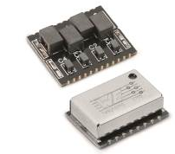  Image source: Würth Elektronik  WE-LAN AQ for high-quality Ethernet interfaces | 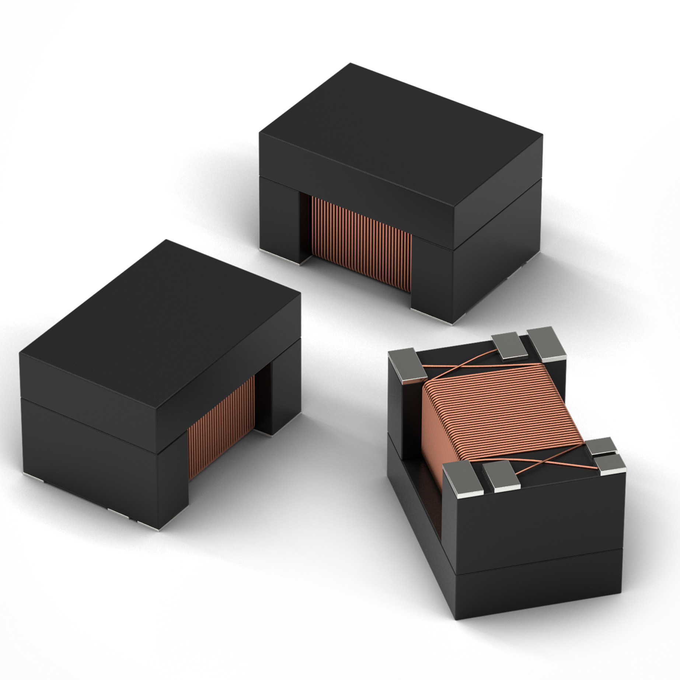  Image source: Würth Elektronik  New series of WE-STST Super Tiny Signal Transformers for LAN interfaces

About Würth Elektronik eiSos Group
Würth Elektronik eiSos Group is a manufacturer of electronic and electromechanical components for the electronics industry and a technology company that spearheads pioneering electronic solutions. The company currently employs 7,300 staff and generated sales of 822 million euros in 2019. Würth Elektronik eiSos is one of the largest European manufacturers of passive components and is active in 50 countries. Production sites in Europe, Asia and North America supply a growing number of customers worldwide.
The product range includes EMC components, inductors, transformers, RF components, varistors, capacitors, resistors, quartz crystals, oscillators, power modules, Wireless Power Transfer, LEDs, sensors, connectors, power supply elements, switches, push-buttons, connection technology, fuse holders and solutions for wireless data transmission.
The unrivaled service orientation of the company is characterized by the availability of all catalog components from stock without minimum order quantity, free samples and extensive support through technical sales staff and selection tools.
Through its technology partnership with the Audi Sport ABT Schaeffler Formula E Team and its support for the Formula Student racing series, the company demonstrates its innovative strength in eMobility
(www.we-speed-up-the-future.com).
Würth Elektronik eiSos is part of the Würth Group, the world market leader for assembly and fastening technology.
Würth Elektronik: more than you expect!
Further information at www.we-online.com

Further information:  Würth Elektronik eiSos GmbH & Co. KG  Sarah Hurst  Max-Eyth-Strasse 1  74638 Waldenburg  Germany  Phone: +49 7942 945-5186  E-mail: sarah.hurst@we-online.de  www.we-online.de | Press contact:  HighTech communications GmbH  Brigitte Basilio  Brunhamstrasse 21  81249 Munich  Germany  Phone: +49 89 500778-20  Telefax: +49 89 500778-77  E-mail: b.basilio@htcm.de  www.htcm.de

