PRESS RELEASE
Würth Elektronik introduces its WE-RCIS radio interference suppression choke
Robust, Resilient, Mountable
Waldenburg (Germany), 15 April 2020 — Würth Elektronik complements its AEC-Q200 product group of qualified radio interference suppression chokes with an SMT-mountable model: WE-RCIS. The rod core choke, available in four versions, is characterized by its high current-carrying capacity and very high saturation power.
WE-RCIS is suitable for integrated DC/DC converters, for low-consumption use and energy harvesting solutions, embedded systems, portable devices and, of course, for automotive electronics applications. The inductance is qualified to AEC-Q200 Grade 1 and accordingly has an operating temperature range of -40 to +150°C. The robust design and the contacts, which provide for a large area solder connection, make the coil suitable for shockproof circuits.
WE-RCIS is now available from stock in any quantity as component belts on reels.

Available images
The following images can be downloaded from the Internet in printable quality: http://www.htcm.de/kk/wuerth
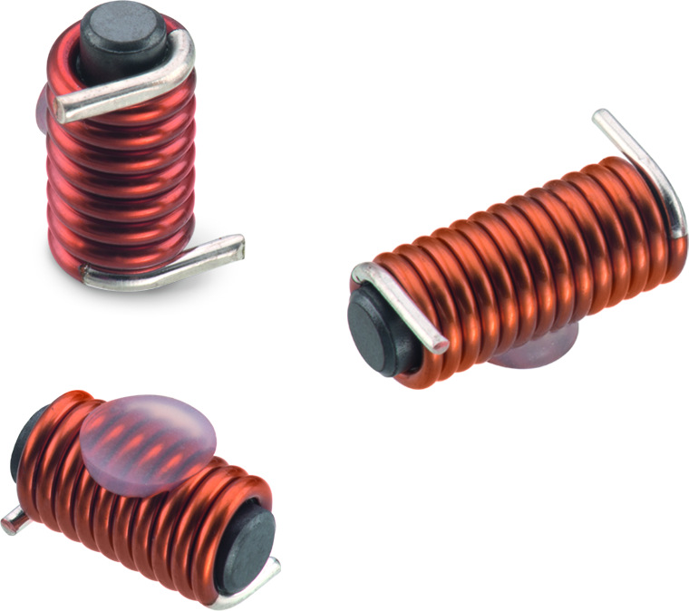
Image source: Würth Elektronik
WE-RCIS SMT-mountable rod core choke

About Würth Elektronik eiSos Group
Würth Elektronik eiSos Group is a manufacturer of electronic and electromechanical components for the electronics industry and a technology company that spearheads pioneering electronic solutions. The company currently employs 7,300 staff and generated sales of 822 million euros in 2019. Würth Elektronik eiSos is one of the largest European manufacturers of passive components and is active in 50 countries. Production sites in Europe, Asia and North America supply a growing number of customers worldwide.
The product range includes EMC components, inductors, transformers, RF components, varistors, capacitors, resistors, quartz crystals, oscillators, power modules, Wireless Power Transfer, LEDs, sensors, connectors, power supply elements, switches, push-buttons, connection technology, fuse holders and solutions for wireless data transmission.
The unrivaled service orientation of the company is characterized by the availability of all catalog components from stock without minimum order quantity, free samples and extensive support through technical sales staff and selection tools.
Through its technology partnership with the Audi Sport ABT Schaeffler Formula E Team and its support for the Formula Student racing series, the company demonstrates its innovative strength in eMobility
(www.we-speed-up-the-future.com).
Würth Elektronik eiSos is part of the Würth Group, the world market leader for assembly and fastening technology.
Würth Elektronik: more than you expect!
Further information at www.we-online.com

Further information:  Würth Elektronik eiSos GmbH & Co. KG  Sarah Hurst  Max-Eyth-Strasse 1  74638 Waldenburg  Germany  Phone: +49 7942 945-5186  E-mail: sarah.hurst@we-online.de  www.we-online.de | Press contact:  HighTech communications GmbH  Brigitte Basilio  Brunhamstrasse 21  81249 Munich  Germany  Phone: +49 89 500778-20  Telefax: +49 89 500778-77  E-mail: b.basilio@htcm.de  www.htcm.de

