PRESS RELEASE
Würth Elektronik presents robust WE-HCIT high-current inductors with AEC-Q200 qualification
Soft saturation behaviour, but very tough
Waldenburg (Germany), 2 July 2020 – Würth Elektronik presents another high-current inductor specifically optimized for applications in automotive electronic systems: the WE-HCIT inductors are robust THT inductors particularly suited for use in vibration-sensitive applications. They are characterized by a high current capability of up to 28 A and a very low RDC (0.44 – 0.88 mΩ). WE-HCIT components have a very soft saturation behavior.
The areas of application for the WE-HCIT high-current inductors are manifold: from DC/DC converters for infotainment and communication systems, EMI solutions for motors (car seats, mirrors, windshield wipers etc.) all the way to power applications and battery-management systems. The component is designed for a broad range of operating temperatures from -40 to +150 °C (AEC-Q200 Grade 1). The WE-HCIT THT High Current Inductor is available in the two construction sizes 1010 and 1008. It is available ex stock, and free-of-charge samples can also be supplied on request.

Available images
The following images can be downloaded from the Internet in printable quality: http://www.htcm.de/kk/wuerth
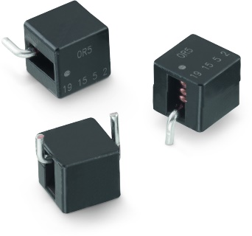

Image source: Würth Elektronik
THT inductor WE-HCIT with AEC-Q200 qualification

About the Würth Elektronik eiSos Group
Würth Elektronik eiSos Group is a manufacturer of electronic and electromechanical components for the electronics industry and a technology company that spearheads pioneering electronic solutions. Würth Elektronik eiSos is one of the largest European manufacturers of passive components and is active in 50 countries. Production sites in Europe, Asia and North America supply a growing number of customers worldwide.
The product range includes EMC components, inductors, transformers, RF components, varistors, capacitors, resistors, quartz crystals, oscillators, power modules, Wireless Power Transfer, LEDs, sensors, connectors, power supply elements, switches, push-buttons, connection technology, fuse holders and solutions for wireless data transmission.
The unrivaled service orientation of the company is characterized by the availability of all catalog components from stock without minimum order quantity, free samples and extensive support through technical sales staff and selection tools.
Through its technology partnership with the Audi Sport ABT Schaeffler Formula E Team and its support for the Formula Student racing series, the company demonstrates its innovative strength in eMobility
(www.we-speed-up-the-future.com).
Würth Elektronik is part of the Würth Group, the world market leader for assembly and fastening technology. The company employs 7,300 staff and generated sales of 822 million euros in 2019.
Würth Elektronik: more than you expect!
Further information at www.we-online.com

Further information:  Würth Elektronik eiSos GmbH & Co. KG  Sarah Hurst  Max-Eyth-Strasse 1  74638 Waldenburg  Germany  Phone: +49 7942 945-5186  E-mail: sarah.hurst@we-online.de  www.we-online.de | Press contact:  HighTech communications GmbH  Brigitte Basilio  Brunhamstrasse 21  81249 Munich  Germany  Phone: +49 89 500778-20  Telefax: +49 89 500778-77  E-mail: b.basilio@htcm.de  www.htcm.de

