PRESS RELEASE
Würth Elektronik ferrite beads WE-MPSA
AEC-Q200-certified SMD ferrites with specified peak current load ratings
Waldenburg (Germany), 7 July 2020 – With its WE-MPSA EMI Multilayer Power Suppression Bead Würth Elektronik has now launched an entire family of ferrites for the suppression of interference pulses in automotive applications. The respective peak-current capability of the ferrite beads is exactly specified. They are characterized by a high rated current of up to 10 A and extremely low resistances. WE-MPSA ferrite beads are available in the construction sizes 0805, 1206, 1612, 1812, 2220, and 3312 and can also in some cases be supplied with different specifications.
The WE-MPSA components are ideally suited for filters with high inrush current peaks. Certified for operating temperatures ranging from -55 to +125 ºC (AEC-Q200), the ferrites are designed for use e.g. in applications for noise reduction at power trains, body control and infotainment systems, motor interference suppression, in battery-management systems, DC/DC converters, audio systems, broadband suppression, and on many other areas besides. All 16 WE-MPSA versions are available ex stock. Although the components are generally supplied in component belts, limited numbers of the products can also be ordered for prototype construction purposes.

Available images
The following images can be downloaded from the Internet in printable quality: http://www.htcm.de/kk/wuerth

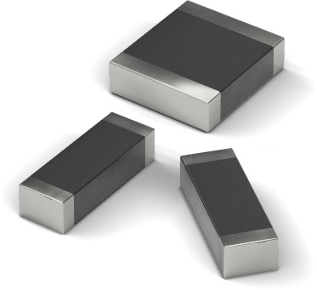

Image source: Würth Elektronik
WE-MPSA EMI Multilayer Power Suppression Beads – ferrite beads for suppressing interference pulses in automotive applications

About the Würth Elektronik eiSos Group
Würth Elektronik eiSos Group is a manufacturer of electronic and electromechanical components for the electronics industry and a technology company that spearheads pioneering electronic solutions. Würth Elektronik eiSos is one of the largest European manufacturers of passive components and is active in 50 countries. Production sites in Europe, Asia and North America supply a growing number of customers worldwide.
The product range includes EMC components, inductors, transformers, RF components, varistors, capacitors, resistors, quartz crystals, oscillators, power modules, Wireless Power Transfer, LEDs, sensors, connectors, power supply elements, switches, push-buttons, connection technology, fuse holders and solutions for wireless data transmission.
The unrivaled service orientation of the company is characterized by the availability of all catalog components from stock without minimum order quantity, free samples and extensive support through technical sales staff and selection tools.
Through its technology partnership with the Audi Sport ABT Schaeffler Formula E Team and its support for the Formula Student racing series, the company demonstrates its innovative strength in eMobility
(www.we-speed-up-the-future.com).
Würth Elektronik is part of the Würth Group, the world market leader for assembly and fastening technology. The company employs 7,300 staff and generated sales of 822 million euros in 2019.
Würth Elektronik: more than you expect!
Further information at www.we-online.com

Further information:  Würth Elektronik eiSos GmbH & Co. KG  Sarah Hurst  Max-Eyth-Strasse 1  74638 Waldenburg  Germany  Phone: +49 7942 945-5186  E-mail: sarah.hurst@we-online.de  www.we-online.de | Press contact:  HighTech communications GmbH  Brigitte Basilio  Brunhamstrasse 21  81249 Munich  Germany  Phone: +49 89 500778-20  Telefax: +49 89 500778-77  E-mail: b.basilio@htcm.de  www.htcm.de

