PRESS RELEASE
Würth Elektronik founds Belgian national company
The Reward for Success
Waldenburg (Germany), 20 February 2020 — Würth Elektronik continues its international expansion course and with the opening of Würth Elektronik België BV which celebrated the 23rd sales branch on January 29, 2020. From Turnhout, to the east of Antwerp, electronics developers and manufacturers throughout Belgium and Luxembourg are supported by five technical field staffers, who in turn are supported by a three back office staff. Components and samples are supplied within 24 hours from the central warehouses in Germany and France.
Würth Elektronik has been active in Belgium with local employees since 2006. This is now followed by the conversion into a separate national company. "The foundation of the new company is a logical step in the positive development of the Würth Elektronik eiSos Group in BeNeLux. This creates the basis for further growth," said Thomas Schrott, CEO of the Würth Elektronik eiSos Group, on the occasion of the foundation of the Belgian sales office. The Country Manager is Dimitri Verhaert, who has established Würth Elektronik in the Belgian market with growing success since 2006.

Available images
The following images can be downloaded from the Internet in printable quality: http://www.htcm.de/kk/wuerth

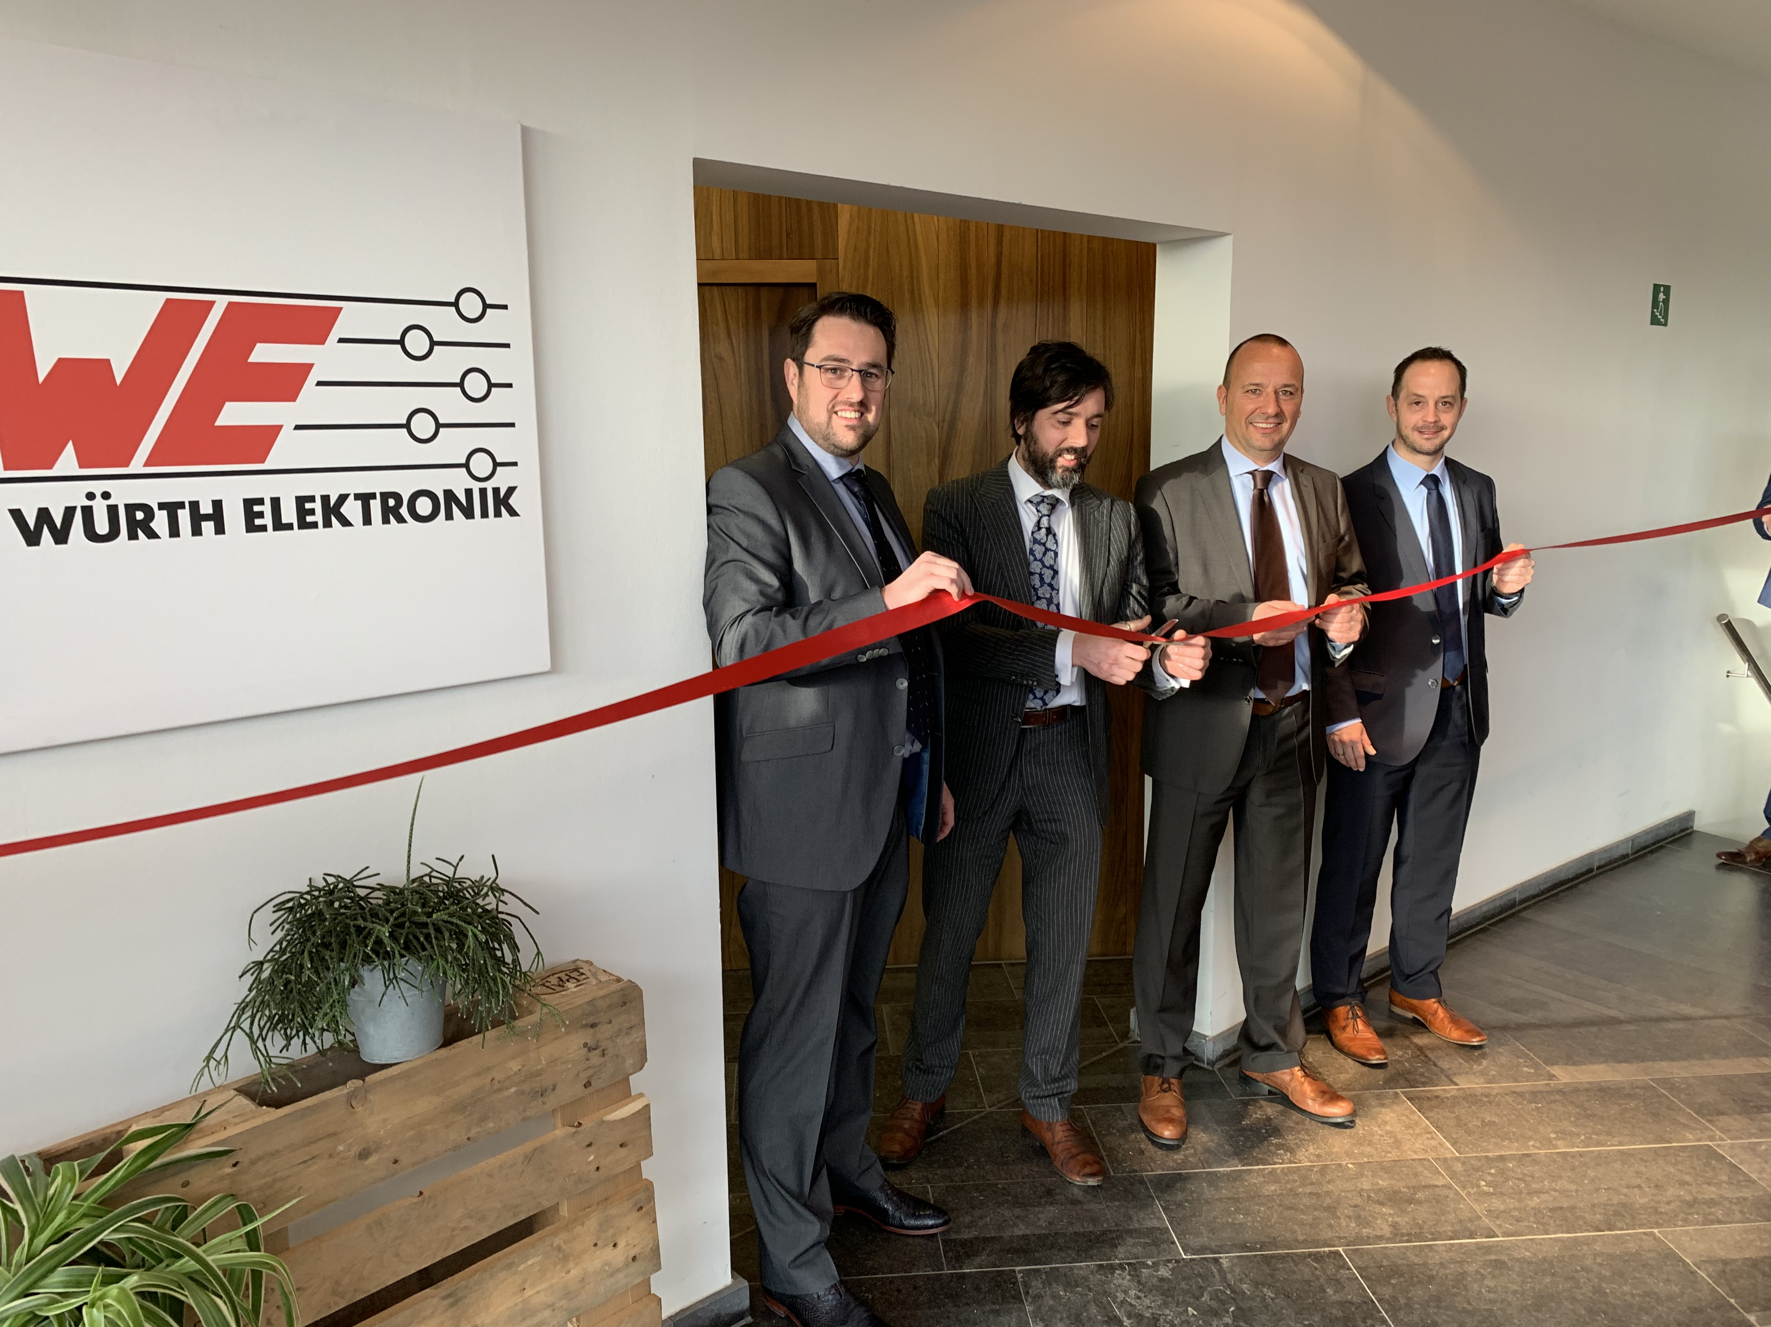Image source: Würth Elektronik
Würth Elektronik België BV is opened: Niels Braams, Country Manager Netherlands, Dimitri Verhaert, Country Manager Belgium, Thomas Schrott, CEO of the Würth Elektronik eiSos Group and Sebastian Valet, General Manager of Würth Elektronik eiSos (from left)

About Würth Elektronik eiSos Group
Würth Elektronik eiSos Group is a manufacturer of electronic and electromechanical components for the electronics industry and a technology company that spearheads pioneering electronic solutions. The company currently employs 7,300 staff and generated sales of 822 million euros in 2019. Würth Elektronik eiSos is one of the largest European manufacturers of passive components and is active in 50 countries. Production sites in Europe, Asia and North America supply a growing number of customers worldwide.
The product range includes EMC components, inductors, transformers, RF components, varistors, capacitors, resistors, quartz crystals, oscillators, power modules, Wireless Power Transfer, LEDs, sensors, connectors, power supply elements, switches, push-buttons, connection technology, fuse holders and solutions for wireless data transmission.
The unrivaled service orientation of the company is characterized by the availability of all catalog components from stock without minimum order quantity, free samples and extensive support through technical sales staff and selection tools.
Through its technology partnership with the Audi Sport ABT Schaeffler Formula E Team and its support for the Formula Student racing series, the company demonstrates its innovative strength in eMobility
(www.we-speed-up-the-future.com).
Würth Elektronik eiSos is part of the Würth Group, the world market leader for assembly and fastening technology.
Würth Elektronik: more than you expect!
Further information at www.we-online.com

Further information:  Würth Elektronik eiSos GmbH & Co. KG  Sarah Hurst  Max-Eyth-Strasse 1  74638 Waldenburg  Germany  Phone: +49 7942 945-5186  E-mail: sarah.hurst@we-online.de  www.we-online.de | Press contact:  HighTech communications GmbH  Brigitte Basilio  Brunhamstrasse 21  81249 Munich  Germany  Phone: +49 89 500778-20  Telefax: +49 89 500778-77  E-mail: b.basilio@htcm.de  www.htcm.de

