PRESS RELEASE
Würth Elektronik Releases 2020 Custom Capabilities Catalog, Featuring New Bobbin and Toroidal Packages
Waldenburg (Germany), 28 February 2020 – Released to the public in January 2020, Würth Elektronik is proud to announce the publication of the newest Capabilities Catalog. This comprehensive catalog includes capabilities for the design of custom transformers, one of the focuses of the company.
This catalog offers customers over 110 packages as the foundation for a custom design. Five new extended rail PQ bobbin packages are featured this year. This catalog also includes two new unique, patented toroid headers, TOR-10P-HT2 and TOR-10P-HT3.6. In addition to the existing technical content, the newest Custom Capabilities Catalog also includes a section that provides a comprehensive breakdown of design considerations.
Download the digital copy and find more information at www.we-online.com.

Available images
The following images can be downloaded from the Internet in printable quality: http://www.htcm.de/kk/wuerth

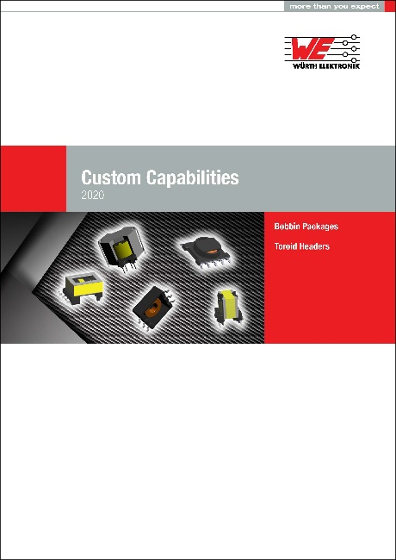
Image source: Würth Elektronik
Custom Capabilities Catalog 2020

About Würth Elektronik eiSos Group
Würth Elektronik eiSos Group is a manufacturer of electronic and electromechanical components for the electronics industry and a technology company that spearheads pioneering electronic solutions. The company currently employs 7,300 staff and generated sales of 822 million euros in 2019. Würth Elektronik eiSos is one of the largest European manufacturers of passive components and is active in 50 countries. Production sites in Europe, Asia and North America supply a growing number of customers worldwide.
The product range includes EMC components, inductors, transformers, RF components, varistors, capacitors, resistors, quartz crystals, oscillators, power modules, Wireless Power Transfer, LEDs, sensors, connectors, power supply elements, switches, push-buttons, connection technology, fuse holders and solutions for wireless data transmission.
The unrivaled service orientation of the company is characterized by the availability of all catalog components from stock without minimum order quantity, free samples and extensive support through technical sales staff and selection tools.
Through its technology partnership with the Audi Sport ABT Schaeffler Formula E Team and its support for the Formula Student racing series, the company demonstrates its innovative strength in eMobility
(www.we-speed-up-the-future.com).
Würth Elektronik eiSos is part of the Würth Group, the world market leader for assembly and fastening technology.
Würth Elektronik: more than you expect!
Further information at www.we-online.com

Further information:  Würth Elektronik eiSos GmbH & Co. KG  Sarah Hurst  Max-Eyth-Strasse 1  74638 Waldenburg  Germany  Phone: +49 7942 945-5186  E-mail: sarah.hurst@we-online.de  www.we-online.de | Press contact:  HighTech communications GmbH  Brigitte Basilio  Brunhamstrasse 21  81249 Munich  Germany  Phone: +49 89 500778-20  Telefax: +49 89 500778-77  E-mail: b.basilio@htcm.de  www.htcm.de

