PRESS RELEASE
Würth Elektronik extends its MagI³C FDSM family with 36 V versions
L78x-compatible Power Module Meets the Requirements of the 24 V Industrial Voltage Network
Waldenburg (Germany), 4 March 2020 — A new generation of MagI³C FDSM power modules: The power modules with fixed 3.3 or 5 V output voltages are now also available with an input voltage of 36 V, following on from versions with maximum input voltages of 28 and 42 V. The components in a SIP-3 package represent cost-effective solutions to meet the requirements for the transient capability of a 24 V industrial voltage network. The new modules operate from 6 to 36 V V_{IN} and generate a fixed output voltage of 3.3 or 5 V at a current of up to 1 A.
The FDSM series of MagI³C power modules are fully integrated DC/DC voltage converters with fixed output voltage. The modules comprise the power stage, controller, inductors, and effective operational input and output capacitors. They also come with thermal overload and short circuit protection.
No external components are required for operation. The workload of circuit design is thus reduced to a minimum. This allows new applications to be brought to market quickly with very low development costs. The standard THT housing for easy mounting is pin-compatible with the L78x linear controllers.
The radiated and line-bound interference of the modules is below the limit set by the EMC standard EN55032/CISPR32 Class B. They were measured with verified filter combinations on the 17800FDSM EVAL board, which, like the power modules, is available from stock.

Available images
The following images can be downloaded from the Internet in printable quality: http://www.htcm.de/kk/wuerth
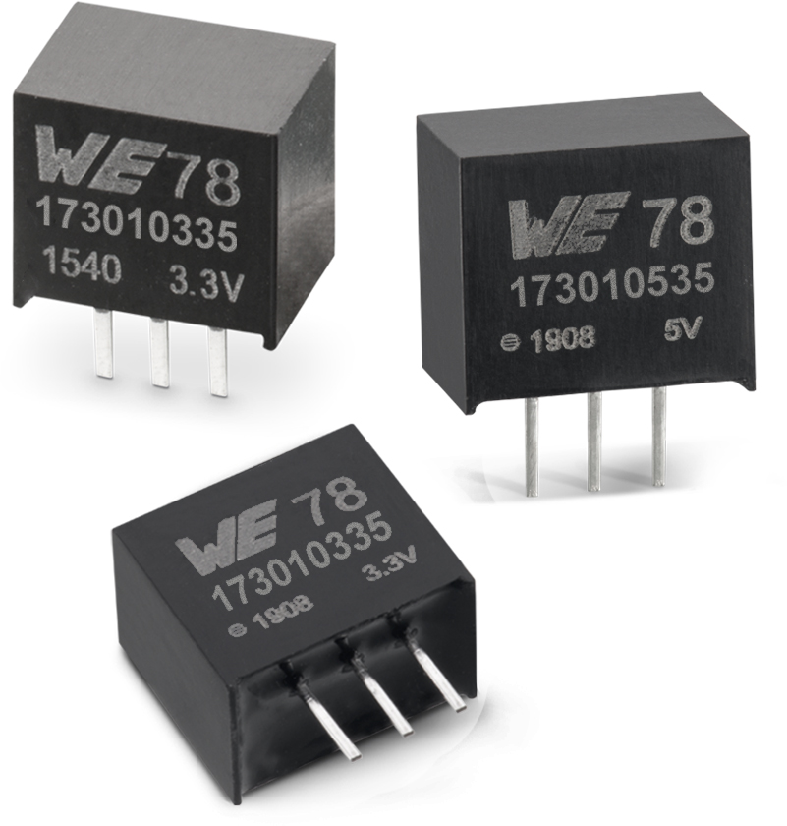
Image source: Würth Elektronik
MagI³C FDSM step-down converters with fixed output voltages

About Würth Elektronik eiSos Group
Würth Elektronik eiSos Group is a manufacturer of electronic and electromechanical components for the electronics industry and a technology company that spearheads pioneering electronic solutions. The company currently employs 7,300 staff and generated sales of 822 million euros in 2019. Würth Elektronik eiSos is one of the largest European manufacturers of passive components and is active in 50 countries. Production sites in Europe, Asia and North America supply a growing number of customers worldwide.
The product range includes EMC components, inductors, transformers, RF components, varistors, capacitors, resistors, quartz crystals, oscillators, power modules, Wireless Power Transfer, LEDs, sensors, connectors, power supply elements, switches, push-buttons, connection technology, fuse holders and solutions for wireless data transmission.
The unrivaled service orientation of the company is characterized by the availability of all catalog components from stock without minimum order quantity, free samples and extensive support through technical sales staff and selection tools.
Through its technology partnership with the Audi Sport ABT Schaeffler Formula E Team and its support for the Formula Student racing series, the company demonstrates its innovative strength in eMobility
(www.we-speed-up-the-future.com).
Würth Elektronik eiSos is part of the Würth Group, the world market leader for assembly and fastening technology.
Würth Elektronik: more than you expect!

Further information at www.we-online.com

Further information:  Würth Elektronik eiSos GmbH & Co. KG  Sarah Hurst  Max-Eyth-Strasse 1  74638 Waldenburg  Germany  Phone: +49 7942 945-5186  E-mail: sarah.hurst@we-online.de  www.we-online.de | Press contact:  HighTech communications GmbH  Brigitte Basilio  Brunhamstrasse 21  81249 Munich  Germany  Phone: +49 89 500778-20  Telefax: +49 89 500778-77  E-mail: b.basilio@htcm.de  www.htcm.de

