PRESS RELEASE
Würth Elektronik presents its radio modules — Proteus-III and Thyone-I
Safe Industrial Radio Applications
Waldenburg (Germany), 10 March 2020 - One powerful hardware, two flexible 2.4 GHz radio applications: Würth Elektronik presents the Bluetooth Low Energy 5.1 module Proteus-III and the proprietary version Thyone-I. The modules, measuring only 8 × 12 × 2 mm, with integrated antenna, encryption technology and six configurable IO pins, are based on the Nordic Semiconductor nRF52840 chipset. They can be used for IoT and M2M applications, for example, to build radio-based maintenance interfaces and sensor networks. The WE-ProWare firmware from Würth Elektronik, which has been industrial proven over many years, makes the modules extremely versatile.
Proteus-III exploits the possibilities of the Bluetooth Low Energy 5.1 standard and even goes beyond them. With a payload of up to 964 bytes, the module offers four times the throughput of previous Bluetooth Low Energy modules. It can also establish connections in the newly introduced long range mode to transmit data over long distances. A special feature from Würth Elektronik: Proteus-III offers a good alternative to the SPP (Serial Port Profile) mode for serial data transmission, which is no longer included in the standard but is extremely useful for industrial applications. NFC wake-up and NFC pairing are prepared.
Exceptional range
With the proprietary Thyone-I radio module, Würth Elektronik shows what is possible in the 2.4 GHz band: a range of up to 750 m and an end-to-end payload throughput of up to 400 kbps. A simple setup turns modules into repeaters in a mesh network, as required. WE-ProWare is an extremely versatile, easy-to-configure firmware with a lean and powerful radio protocol. If transmission standards are already specified in the application, Thyone-I can easily be converted to ZigBEE, Thread or Wirepas.
Proteus-III and Thyone-I are available from stock without a minimum order quantity. For both modules Würth Elektronik offers evaluation boards, USB radio sticks with integrated radio module and very user-friendly manuals.

Available images
The following images can be downloaded from the Internet in printable quality: http://www.htcm.de/kk/wuerth
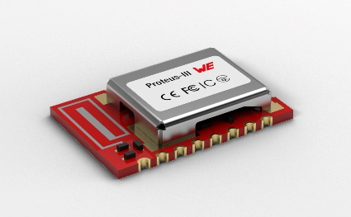Image source: Würth Elektronik  Proteus-III Bluetooth Low Energy 5.1 module | 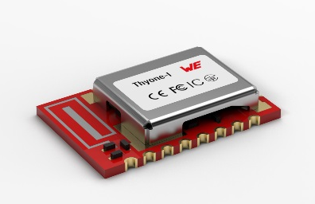  Image source: Würth Elektronik  Thyone-I — the proprietary version of the Proteus-III Bluetooth Low Energy 5.1 module

About Würth Elektronik eiSos Group
Würth Elektronik eiSos Group is a manufacturer of electronic and electromechanical components for the electronics industry and a technology company that spearheads pioneering electronic solutions. The company currently employs 7,300 staff and generated sales of 822 million euros in 2019. Würth Elektronik eiSos is one of the largest European manufacturers of passive components and is active in 50 countries. Production sites in Europe, Asia and North America supply a growing number of customers worldwide.
The product range includes EMC components, inductors, transformers, RF components, varistors, capacitors, resistors, quartz crystals, oscillators, power modules, Wireless Power Transfer, LEDs, sensors, connectors, power supply elements, switches, push-buttons, connection technology, fuse holders and solutions for wireless data transmission.
The unrivaled service orientation of the company is characterized by the availability of all catalog components from stock without minimum order quantity, free samples and extensive support through technical sales staff and selection tools.
Through its technology partnership with the Audi Sport ABT Schaeffler Formula E Team and its support for the Formula Student racing series, the company demonstrates its innovative strength in eMobility
(www.we-speed-up-the-future.com).
Würth Elektronik eiSos is part of the Würth Group, the world market leader for assembly and fastening technology.
Würth Elektronik: more than you expect!
Further information at www.we-online.com

Further information:  Würth Elektronik eiSos GmbH & Co. KG  Sarah Hurst  Max-Eyth-Strasse 1  74638 Waldenburg  Germany  Phone: +49 7942 945-5186  E-mail: sarah.hurst@we-online.de  www.we-online.de | Press contact:  HighTech communications GmbH  Brigitte Basilio  Brunhamstrasse 21  81249 Munich  Germany  Phone: +49 89 500778-20  Telefax: +49 89 500778-77  E-mail: b.basilio@htcm.de  www.htcm.de

