PRESS RELEASE

Würth Elektronik Hosts Virtual Conference
Watertown (USA), 30 March 2020 – Würth Elektronik is proud to announce the introduction of their first-ever Virtual Conference. This free Virtual Conference includes easy-access to topics including Robust Design for E-Mobility, EMI Mitigation with Wide Bandgap Devices, Wireless Power Transfer: Advanced Coil Knowledge, and more; all presented by Würth Elektronik technical experts.
All presentation slides are available for download and recorded presentations are available on demand. Access the Würth Elektronik Virtual Conference at www.we-online.com/virtualconference.

Available images
The following images can be downloaded from the Internet in printable quality: http://www.htcm.de/kk/wuerth
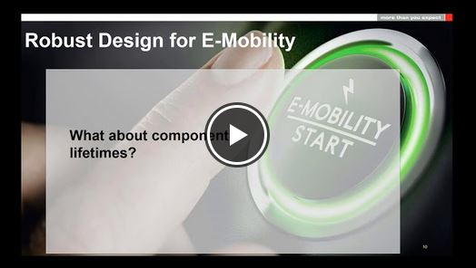
Image source: Würth Elektronik
Würth Elektronik hosts Virtual Conference. Presentation slides are available for download or on demand.

About Würth Elektronik eiSos Group
Würth Elektronik eiSos Group is a manufacturer of electronic and electromechanical components for the electronics industry and a technology company that spearheads pioneering electronic solutions. The company currently employs 7,300 staff and generated sales of 822 million euros in 2019. Würth Elektronik eiSos is one of the largest European manufacturers of passive components and is active in 50 countries. Production sites in Europe, Asia and North America supply a growing number of customers worldwide.
The product range includes EMC components, inductors, transformers, RF components, varistors, capacitors, resistors, quartz crystals, oscillators, power modules, Wireless Power Transfer, LEDs, sensors, connectors, power supply elements, switches, push-buttons, connection technology, fuse holders and solutions for wireless data transmission.
The unrivaled service orientation of the company is characterized by the availability of all catalog components from stock without minimum order quantity, free samples and extensive support through technical sales staff and selection tools.
Through its technology partnership with the Audi Sport ABT Schaeffler Formula E Team and its support for the Formula Student racing series, the company demonstrates its innovative strength in eMobility
(www.we-speed-up-the-future.com).
Würth Elektronik eiSos is part of the Würth Group, the world market leader for assembly and fastening technology.
Würth Elektronik: more than you expect!
Further information at www.we-online.com

Further information:  Wurth Electronics Midcom, Inc.  Lindsey Esche  121 Airport Drive  PO Box 1330  Watertown, SD 57201 USA  Phone: +1 605 886 4385  Toll-free (in the U.S.):  Phone: +1 800 643 2661  E-mail: lindsey.esche@we-online.com  www.we-online.com | Press contact:  HighTech communications GmbH  Brigitte Basilio  Brunhamstrasse 21  81249 Munich  Germany  Phone: +49 89 500778-20  Fax: +49 89 500778-77  E-mail: b.basilio@htcm.de  www.htcm.de

