PRESS RELEASE
Würth Elektronik GNSS modules Elara-I, Elara-II, Erinome-I and Erinome-II
Simply integrate satellite navigation
Waldenburg (Germany), 7 May 2020 - Würth Elektronik launches a product family of GNSS modules which is unique in several respects: The Elara line represents some of the smallest GNSS modules on the market - both with and without integrated antenna. For sophisticated navigation tasks, the Erinome series uses all four global navigation satellite systems at top speed: GPS, GLONASS, Galileo and BeiDou. All four modules can be operated in low-power mode and offer I²C in addition to the usual UART interface. Thanks to tools such as the Würth Elektronik Navigation Satellite Software (WENSS) and the evaluation board, developers who integrate satellite navigation into their product for the first time will quickly achieve optimum results.
Tracking of containers, navigation by agricultural machines or drones, fleet management, cartography, geotagging of cameras, monitoring of animal transports, referencing for international time synchronization - the most diverse requirements of position-based applications can be met with the GNSS modules from Würth Elektronik.
For mobile applications with smallest space requirements
Elara-I and Elara-II are particularly space-saving modules for applications where positioning by GPS and GLONASS is sufficient. Elara-I, measuring only 10 x 10 x 5.9 mm, has an integrated antenna with high rf sensitivity. Elara-II, measuring 4.1 x 4.1 x 2.2 mm, is one of the smallest GNSS modules on the market for PCB designs with external antenna. Both modules are optimised for battery operation and quickly achieve a localisation accuracy wihin 1.5 m during operation.
For responsive navigation and difficult conditions
If current position data is permanently requested and/or temporary overshadowing is to be expected, Erinome-I and Erinome-II are recommended. In addition to the American and Russian satellites, these also target the European and Chinese satellites. They provide updated data up to 10 times per second. Erinome-I (18 x 18 x 6.4 mm) is the version with an integrated antenna, Erinome-II (7 x 7 x 1.6 mm) the version with antenna pad. Detailed technical documentation is available for the antenna selection.
All GNSS modules from Würth Elektronik are designed for the industrial temperature range from -40 °C up to +85 °C. They can be ordered from stock at any time without a minimum order quantity.

Available images
The following images can be downloaded from the Internet in printable quality: http://www.htcm.de/kk/wuerth
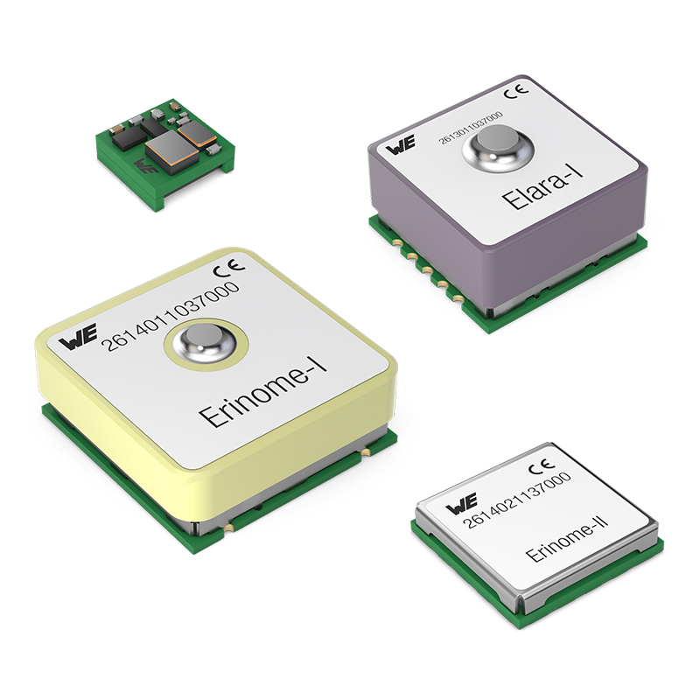Image source: Würth Elektronik
GNSS modules Elara-I, Elara-II, Erinome-I and Erinome-II: Easy to integrate into products for positioning

About the Würth Elektronik eiSos Group
Würth Elektronik eiSos Group is a manufacturer of electronic and electromechanical components for the electronics industry and a technology company that spearheads pioneering electronic solutions. Würth Elektronik eiSos is one of the largest European manufacturers of passive components and is active in 50 countries. Production sites in Europe, Asia and North America supply a growing number of customers worldwide.
The product range includes EMC components, inductors, transformers, RF components, varistors, capacitors, resistors, quartz crystals, oscillators, power modules, Wireless Power Transfer, LEDs, sensors, connectors, power supply elements, switches, push-buttons, connection technology, fuse holders and solutions for wireless data transmission.
The unrivaled service orientation of the company is characterized by the availability of all catalog components from stock without minimum order quantity, free samples and extensive support through technical sales staff and selection tools.

Through its technology partnership with the Audi Sport ABT Schaeffler Formula E Team and its support for the Formula Student racing series, the company demonstrates its innovative strength in eMobility
(www.we-speed-up-the-future.com).
Würth Elektronik is part of the Würth Group, the world market leader for assembly and fastening technology. The company employs 7,300 staff and generated sales of 822 million euros in 2019.
Würth Elektronik: more than you expect!
Further information at www.we-online.com

Further information:  Würth Elektronik eiSos GmbH & Co. KG  Sarah Hurst  Max-Eyth-Strasse 1  74638 Waldenburg  Germany  Phone: +49 7942 945-5186  E-mail: sarah.hurst@we-online.de  www.we-online.de | Press contact:  HighTech communications GmbH  Brigitte Basilio  Brunhamstrasse 21  81249 Munich  Germany  Phone: +49 89 500778-20  Telefax: +49 89 500778-77  E-mail: b.basilio@htcm.de  www.htcm.de

