PRESS RELEASE
Würth Elektronik presents its WE-CCMF Ceramic Common Mode Filter
Putting an End to Radio Interference
Waldenburg (Germany), 20 May 2020 - With WE-CCMF, Würth Elektronik offers a compact multilayer common mode choke in a 0504 package which is characterized by high common mode attenuation in the WiFi frequency range (> 30 dB @ 2450 MHz). WE-CCMF is the solution to improve the sensitivity of Wireless LAN and Bluetooth enabled devices (notebooks, laptops, routers, IoT devices) that also include interfaces with high-speed differential signal transmission. These devices include USB 3.1/3.2, SATA 3.0/3.2, HDMI 1.4/2.0 or Thunderbolt 2/3.
The high switching frequency of state-of-the-art data lines has made common mode interference a problem in radio reception. The ceramic common mode choke WE-CCMF achieves excellent attenuation in just this 2.45 GHz range. The LTCC design of the WE-CCMF ensures low losses and high reliability. The reflow solderable SMT component has high temperature stability and is suitable for operating temperatures from -40°C to +85°C. The differential cut-off frequency of the choke is 8 GHz.
WE-CCMF is now available from stock without a minimum order quantity. Free samples can be requested.

Available images
The following images can be downloaded from the Internet in printable quality: http://www.htcm.de/kk/wuerth

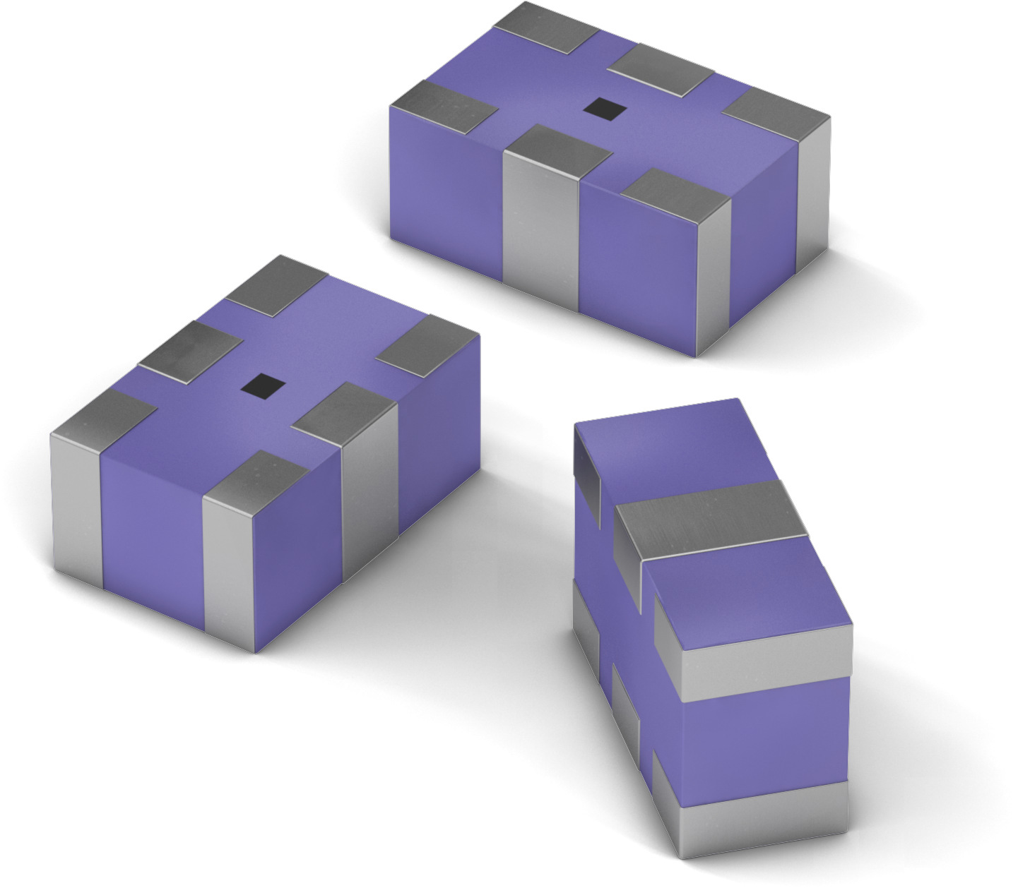
Image source: Würth Elektronik
WE-CCMF compact multilayer common mode choke

About the Würth Elektronik eiSos Group
Würth Elektronik eiSos Group is a manufacturer of electronic and electromechanical components for the electronics industry and a technology company that spearheads pioneering electronic solutions. Würth Elektronik eiSos is one of the largest European manufacturers of passive components and is active in 50 countries. Production sites in Europe, Asia and North America supply a growing number of customers worldwide.
The product range includes EMC components, inductors, transformers, RF components, varistors, capacitors, resistors, quartz crystals, oscillators, power modules, Wireless Power Transfer, LEDs, sensors, connectors, power supply elements, switches, push-buttons, connection technology, fuse holders and solutions for wireless data transmission.
The unrivaled service orientation of the company is characterized by the availability of all catalog components from stock without minimum order quantity, free samples and extensive support through technical sales staff and selection tools.
Through its technology partnership with the Audi Sport ABT Schaeffler Formula E Team and its support for the Formula Student racing series, the company demonstrates its innovative strength in eMobility
(www.we-speed-up-the-future.com).
Würth Elektronik is part of the Würth Group, the world market leader for assembly and fastening technology. The company employs 7,300 staff and generated sales of 822 million euros in 2019.
Würth Elektronik: more than you expect!
Further information at www.we-online.com

Further information:  Würth Elektronik eiSos GmbH & Co. KG  Sarah Hurst  Max-Eyth-Strasse 1  74638 Waldenburg  Germany  Phone: +49 7942 945-5186  E-mail: sarah.hurst@we-online.de  www.we-online.de | Press contact:  HighTech communications GmbH  Brigitte Basilio  Brunhamstrasse 21  81249 Munich  Germany  Phone: +49 89 500778-20  Telefax: +49 89 500778-77  E-mail: b.basilio@htcm.de  www.htcm.de

