PRESS RELEASE
Würth Elektronik presents WR-FAST single-wire connections
Robust Connection for Power
Waldenburg (Germany), 4 June 2020 — WR-FAST Fast Connection is the name of a series of THT-configurable male connectors for accommodating single wires with blade receptacles — for example in household appliances. The new connectors are available in various blade designs, orientations and dimensions and are intended for current flows up to 16 A and working voltages up to 300 V.
Straight or angled contacts in various numbers are available — for the common 6.3 mm blade receptacles but also for the 2.8 mm version. For the latter, the 2863-type WR-FAST connectors are used: the forked blades can accommodate both types of blade receptacles.
WR-FAST is designed for operating temperatures from -30 to +120°C. The connectors have passed glow wire testing according to IEC 60335-1 and meet flammability class UL94 V-0. They also have cULus approval.
The WR-FAST connector series is now available from stock without a minimum order quantity. Würth Elektronik also offers a Design Kit Interface with free refill service for this product group.

Available images
The following images can be downloaded from the Internet in printable quality: http://www.htcm.de/kk/wuerth
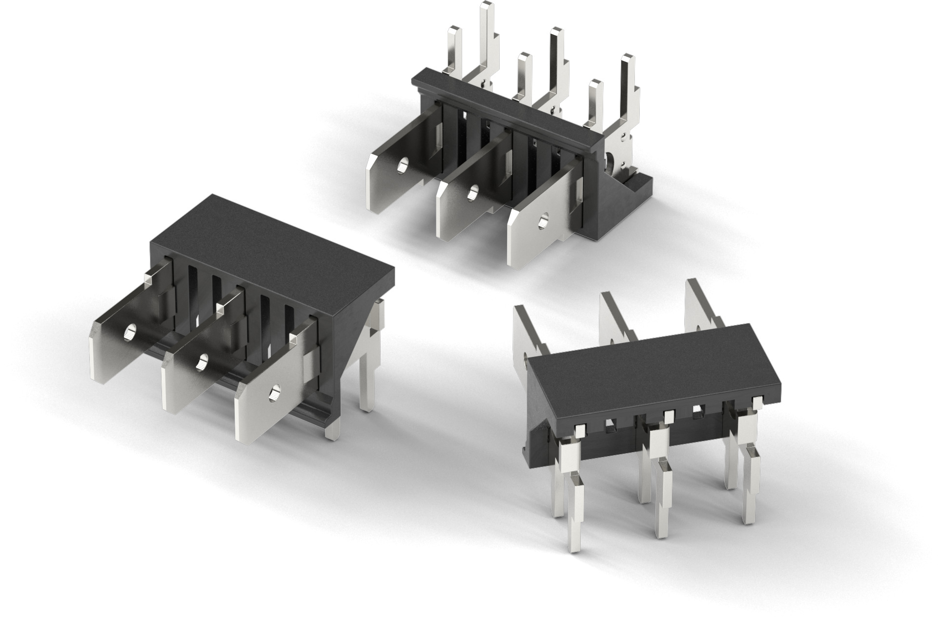
Image source: Würth Elektronik
WR-FAST single-wire connections

About the Würth Elektronik eiSos Group
Würth Elektronik eiSos Group is a manufacturer of electronic and electromechanical components for the electronics industry and a technology company that spearheads pioneering electronic solutions. Würth Elektronik eiSos is one of the largest European manufacturers of passive components and is active in 50 countries. Production sites in Europe, Asia and North America supply a growing number of customers worldwide.
The product range includes EMC components, inductors, transformers, RF components, varistors, capacitors, resistors, quartz crystals, oscillators, power modules, Wireless Power Transfer, LEDs, sensors, connectors, power supply elements, switches, push-buttons, connection technology, fuse holders and solutions for wireless data transmission.
The unrivaled service orientation of the company is characterized by the availability of all catalog components from stock without minimum order quantity, free samples and extensive support through technical sales staff and selection tools.
Through its technology partnership with the Audi Sport ABT Schaeffler Formula E Team and its support for the Formula Student racing series, the company demonstrates its innovative strength in eMobility
(www.we-speed-up-the-future.com).
Würth Elektronik is part of the Würth Group, the world market leader for assembly and fastening technology. The company employs 7,300 staff and generated sales of 822 million euros in 2019.
Würth Elektronik: more than you expect!
Further information at www.we-online.com

Further information:  Würth Elektronik eiSos GmbH & Co. KG  Sarah Hurst  Max-Eyth-Strasse 1  74638 Waldenburg  Germany  Phone: +49 7942 945-5186  E-mail: sarah.hurst@we-online.de  www.we-online.de | Press contact:  HighTech communications GmbH  Brigitte Basilio  Brunhamstrasse 21  81249 Munich  Germany  Phone: +49 89 500778-20  Telefax: +49 89 500778-77  E-mail: b.basilio@htcm.de  www.htcm.de

