PRESS RELEASE
Würth Elektronik offers the interlock-free flat flexible cable connector WR-FPC
Inexpensive and easier to assemble
Waldenburg (Germany), 23 June 2020 – Besides a broad range of flat flexible cables (FFCs) and lockable ZIF (Zero Insertion Force) plug connectors, Würth Elektronik now also offers the LIF (Low Insertion Force) connector WR-FPC.
Small and flexible flat-ribbon cables are widely used in LCD screens, board-to-board connections for medical equipment, test and measurement devices, industrial applications, entertainment electronics, and the broadest conceivable range of other types of devices. In many of these applications, it’s not important to have a vibration-free interlock for the plug-in connector. For such applications, Würth Elektronik now offers the more inexpensive and easier-to-assemble solution of an LIF connector. Fully suited for SMT pick-and-place assembly systems, the WR-FPCs in the 1-mm grid format are available in a variety of versions, from 4 to 30 pins, in horizontal and vertical plug-in directions. Besides serving as sockets for flat flexible cables, they are also intended for use as connectors for flexible printed circuit boards – hence the designation FPC. The rated current is 1 A, the operating voltage 125 V. To ensure a high degree of elasticity, low wear and tear, and a low resistance (30 mΩ), Würth Elektronik has selected phosphor bronze as the material for the contacts. The connectors have an undercoat of nickel to prevent the so-called tin whisker phenomenon.
To enable development teams and small companies to put these products to use more easily (just as for the entire range of FFC/FPC items), these new WR-FPC low-insertion-force connectors are offered ex stock in component belts without a minimum order volume. Free-of-charge samples can also be supplied on request.

Available images
The following images can be downloaded from the Internet in printable quality: http://www.htcm.de/kk/wuerth

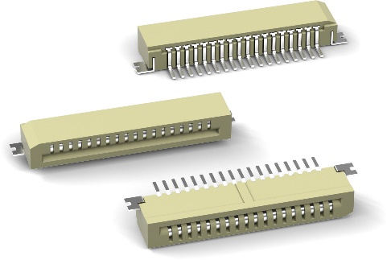
Image source: Würth Elektronik
WR-FPC with horizontal plug-in direction

About the Würth Elektronik eiSos Group
Würth Elektronik eiSos Group is a manufacturer of electronic and electromechanical components for the electronics industry and a technology company that spearheads pioneering electronic solutions. Würth Elektronik eiSos is one of the largest European manufacturers of passive components and is active in 50 countries. Production sites in Europe, Asia and North America supply a growing number of customers worldwide.
The product range includes EMC components, inductors, transformers, RF components, varistors, capacitors, resistors, quartz crystals, oscillators, power modules, Wireless Power Transfer, LEDs, sensors, connectors, power supply elements, switches, push-buttons, connection technology, fuse holders and solutions for wireless data transmission.
The unrivaled service orientation of the company is characterized by the availability of all catalog components from stock without minimum order quantity, free samples and extensive support through technical sales staff and selection tools.
Through its technology partnership with the Audi Sport ABT Schaeffler Formula E Team and its support for the Formula Student racing series, the company demonstrates its innovative strength in eMobility
(www.we-speed-up-the-future.com).
Würth Elektronik is part of the Würth Group, the world market leader for assembly and fastening technology. The company employs 7,300 staff and generated sales of 822 million euros in 2019.
Würth Elektronik: more than you expect!
Further information at www.we-online.com

Further information:  Würth Elektronik eiSos GmbH & Co. KG  Sarah Hurst  Max-Eyth-Strasse 1  74638 Waldenburg  Germany  Phone: +49 7942 945-5186  E-mail: sarah.hurst@we-online.de  www.we-online.de | Press contact:  HighTech communications GmbH  Brigitte Basilio  Brunhamstrasse 21  81249 Munich  Germany  Phone: +49 89 500778-20  Telefax: +49 89 500778-77  E-mail: b.basilio@htcm.de  www.htcm.de

