PRESS RELEASE
Würth Elektronik presents Cat6-compatible WR-MJ modular jack connectors
Modular jacks for fast ethernet
Waldenburg (Germany), 1 July 2020 – Würth Elektronik has expanded its family of WR-MJ modular jack products by launching RJ45 jacks in the 8P8C layout, intended for use in Cat6 data lines. These modular jacks are available in various designs: in horizontal and vertical directions and also with an angle of 47.5°, shielded and unshielded, and in some cases with EMI contact fingers. In their layout the components are compatible with the corresponding Cat5 products.
These new WR-MJ modular jacks from Würth Elektronik can be used for cabling LAN systems with transmission rates of up to 10.000 Mb/s (acc. to IEEE 802.3). The material used to make the contacts is a selectively gold-plated copper alloy, and the isolation fulfils the requirements of flammability class UL94 V-0. The spectrum of operating temperatures of the jacks ranges from -40 to +85 °C. The new Cat6-compatible products at a glance:
- WR-MJ Modular Jack THT Horizontal Shielded 8P8C Tab Up
- WR-MJ Modular Jack THT Horizontal Shielded EMI 8P8C
- WR-MJ Modular Jack THT Horizontal Plastic 8P8C Tab Up
- WR-MJ Modular Jack THT Vertical Shielded 8P8C
- WR-MJ Modular Jack THT Vertical Shielded EMI 8P8C
- WR-MJ Modular Jack THT Vertical Plastic 8P8C
- WR-MJ Modular Jack THT 47.5° 8P8C
- WR-MJ Modular Jack THT 47.5° Shielded 8P8C
All WR-MJ products supplied by Würth Elektronik are available ex stock without a minimum order volume. Free-of-charge samples can also be supplied on request.

Available images
The following images can be downloaded from the Internet in printable quality: http://www.htcm.de/kk/wuerth

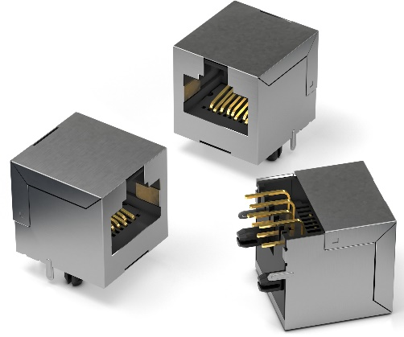
Image source: Würth Elektronik
WR-MJ Modular Jack THT Horizontal Shielded 8P8C Tab Up

About the Würth Elektronik eiSos Group
Würth Elektronik eiSos Group is a manufacturer of electronic and electromechanical components for the electronics industry and a technology company that spearheads pioneering electronic solutions. Würth Elektronik eiSos is one of the largest European manufacturers of passive components and is active in 50 countries. Production sites in Europe, Asia and North America supply a growing number of customers worldwide.
The product range includes EMC components, inductors, transformers, RF components, varistors, capacitors, resistors, quartz crystals, oscillators, power modules, Wireless Power Transfer, LEDs, sensors, connectors, power supply elements, switches, push-buttons, connection technology, fuse holders and solutions for wireless data transmission.
The unrivaled service orientation of the company is characterized by the availability of all catalog components from stock without minimum order quantity, free samples and extensive support through technical sales staff and selection tools.
Through its technology partnership with the Audi Sport ABT Schaeffler Formula E Team and its support for the Formula Student racing series, the company demonstrates its innovative strength in eMobility
(www.we-speed-up-the-future.com).
Würth Elektronik is part of the Würth Group, the world market leader for assembly and fastening technology. The company employs 7,300 staff and generated sales of 822 million euros in 2019.
Würth Elektronik: more than you expect!
Further information at www.we-online.com

Further information:  Würth Elektronik eiSos GmbH & Co. KG  Sarah Hurst  Max-Eyth-Strasse 1  74638 Waldenburg  Germany  Phone: +49 7942 945-5186  E-mail: sarah.hurst@we-online.de  www.we-online.de | Press contact:  HighTech communications GmbH  Brigitte Basilio  Brunhamstrasse 21  81249 Munich  Germany  Phone: +49 89 500778-20  Telefax: +49 89 500778-77  E-mail: b.basilio@htcm.de  www.htcm.de

