MEDIA INFORMATION
Würth Elektronik publishes coaxial connectors catalog
Wide Selection of High-Frequency Connectors
Waldenburg (Germany), 27 May 2020 – Würth Elektronik has extended its range of coaxial connectors and published a new catalog. On 174 pages, the "Coax Connectors" English language catalog presents nine product groups. The new product families of SMB and SMP connectors is the highlight.
The following product families are featured in the coaxial catalog available today: SMA and Reverse Polarity SMA, MCX and MMCX, SMP and SMB Moreover, a range of adapters, tools and services for cable assembly is presented.
Two additional standards
The coaxial standards SMB and SMP expand the portfolio with the appearance of the new catalog. SMBs are suitable for applications up to 4 GHz with a characteristic impedance of 50 Ohm. The SMB series is smaller than the SMAs and contact via snap-in connection. The SMP series — designed for transmission rates up to 40 GHz at 50 ohms including versions with different insertion and retention forces — is also new to the program.
The Coax Connector Catalog can be ordered now from the Würth Elektronik website or downloaded here as a pdf.

Available images
The following images can be downloaded from the Internet in printable quality: http://www.htcm.de/kk/wuerth

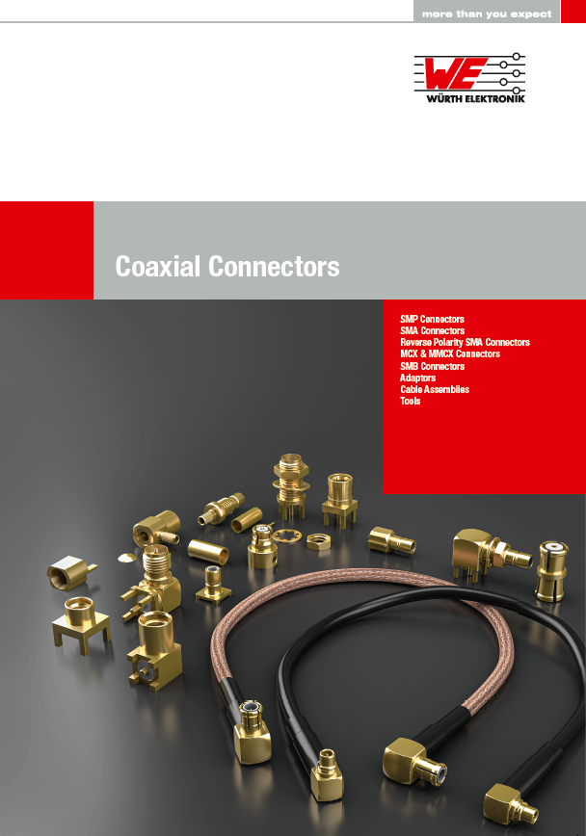
Image source: Würth Elektronik
Small SMB and SMP connectors for fast and secure contacting

About the Würth Elektronik eiSos Group
Würth Elektronik eiSos Group is a manufacturer of electronic and electromechanical components for the electronics industry and a technology company that spearheads pioneering electronic solutions. Würth Elektronik eiSos is one of the largest European manufacturers of passive components and is active in 50 countries. Production sites in Europe, Asia and North America supply a growing number of customers worldwide.
The product range includes EMC components, inductors, transformers, RF components, varistors, capacitors, resistors, quartz crystals, oscillators, power modules, Wireless Power Transfer, LEDs, sensors, connectors, power supply elements, switches, push-buttons, connection technology, fuse holders and solutions for wireless data transmission.
The unrivaled service orientation of the company is characterized by the availability of all catalog components from stock without minimum order quantity, free samples and extensive support through technical sales staff and selection tools.
Through its technology partnership with the Audi Sport ABT Schaeffler Formula E Team and its support for the Formula Student racing series, the company demonstrates its innovative strength in eMobility
(www.we-speed-up-the-future.com).
Würth Elektronik is part of the Würth Group, the world market leader for assembly and fastening technology. The company employs 7,300 staff and generated sales of 822 million euros in 2019.
Würth Elektronik: more than you expect!
Further information at www.we-online.com

Further information:  Würth Elektronik eiSos GmbH & Co. KG  Sarah Hurst  Max-Eyth-Strasse 1  74638 Waldenburg  Germany  Phone: +49 7942 945-5186  E-mail: sarah.hurst@we-online.de  www.we-online.de | Press contact:  HighTech communications GmbH  Brigitte Basilio  Brunhamstrasse 21  81249 Munich  Germany  Phone: +49 89 500778-20  Telefax: +49 89 500778-77  E-mail: b.basilio@htcm.de  www.htcm.de

