PRESS RELEASE
Würth Elektronik extends its WE-CBA product family
Miniature SMT Ferrites with Top Filter Properties
Waldenburg (Germany), 15 July 2020 – Würth Elektronik extends its "WE-CBA SMT EMI Suppression Ferrite Bead” product families. They now include 0402, 0603, 0805, 1206, 1806 and 1812 packages. The SMDs are AEC-Q200 qualified as part of Würth Elektronik's automotive electronics portfolio. WE-CBA features high-quality Ni-Sn electrodes, a very high current carrying capacity up to 6 A, and operating temperatures from -55 to +125ºC. The ferrites, which are available in various specifications, are ideally suited as data line filters and for decoupling the supply voltage.
The miniature SMT ferrites in multilayer technology are soldered directly onto the PCB. They have very good filter characteristics and low RDC. Placed close to the source of interference, maximum impedances around 1000 Ω can be achieved even with the smallest package (0402).
Different interpretations
The SMT ferrites referred to as "High Speed” have significantly lower impedances in the lower frequency range and therefore only low attenuation for fast signals. Applications include USB 2.0, IEEE1394 and LVDS. The ferrites of the WE-CBA family referred to as "Wide Band" already have high impedances in the lower frequency range and thus have a broadband effect over the entire spectrum. Applications include control signals, RS232, RS422 and DC/DC converters. In the automotive electronics catalog, ferrites designed for higher currents above 1 A are found in the "High Current” category.
All WE-CBA ferrites are available from stock – also in small quantities for prototyping. Free samples can be requested. In addition, Würth Elektronik offers design kits for developers with a lifelong replenishment service, so that they always have ferrites with the appropriate values at hand.

Available images
The following images can be downloaded from the Internet in printable quality: http://www.htcm.de/kk/wuerth

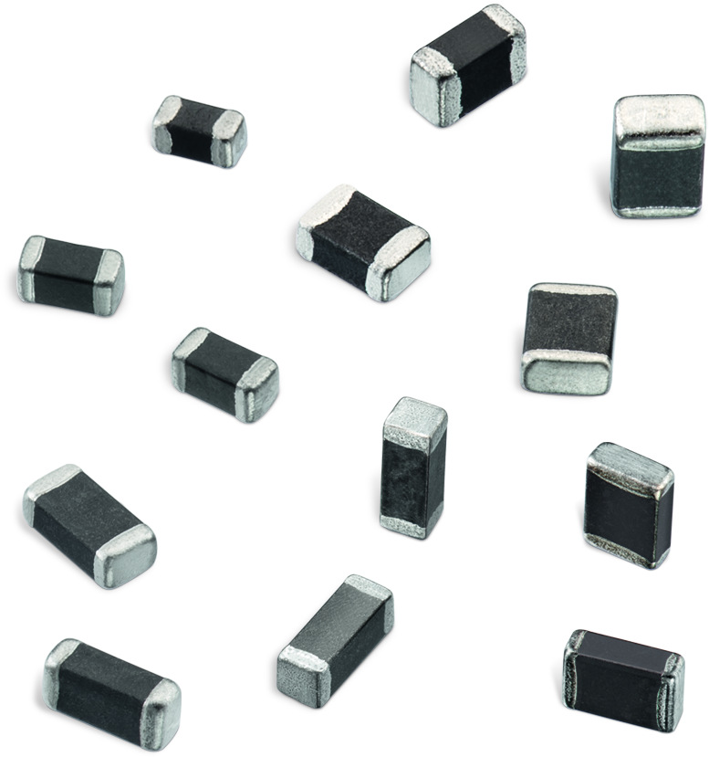
Image source: Würth Elektronik
WE-CBA SMT EMI suppression ferrite beads - now in 0402, 0603, 0805, 1206, 1806 and 1812 packages

About the Würth Elektronik eiSos Group
Würth Elektronik eiSos Group is a manufacturer of electronic and electromechanical components for the electronics industry and a technology company that spearheads pioneering electronic solutions. Würth Elektronik eiSos is one of the largest European manufacturers of passive components and is active in 50 countries. Production sites in Europe, Asia and North America supply a growing number of customers worldwide.
The product range includes EMC components, inductors, transformers, RF components, varistors, capacitors, resistors, quartz crystals, oscillators, power modules, Wireless Power Transfer, LEDs, sensors, connectors, power supply elements, switches, push-buttons, connection technology, fuse holders and solutions for wireless data transmission.
The unrivaled service orientation of the company is characterized by the availability of all catalog components from stock without minimum order quantity, free samples and extensive support through technical sales staff and selection tools.
Through its technology partnership with the Audi Sport ABT Schaeffler Formula E Team and its support for the Formula Student racing series, the company demonstrates its innovative strength in eMobility
(www.we-speed-up-the-future.com).
Würth Elektronik is part of the Würth Group, the world market leader for assembly and fastening technology. The company employs 7,300 staff and generated sales of 822 million euros in 2019.
Würth Elektronik: more than you expect!
Further information at www.we-online.com

Further information:  Würth Elektronik eiSos GmbH & Co. KG  Sarah Hurst  Max-Eyth-Strasse 1  74638 Waldenburg  Germany  Phone: +49 7942 945-5186  E-mail: sarah.hurst@we-online.de  www.we-online.de | Press contact:  HighTech communications GmbH  Brigitte Basilio  Brunhamstrasse 21  81249 Munich  Germany  Phone: +49 89 500778-20  Telefax: +49 89 500778-77  E-mail: b.basilio@htcm.de  www.htcm.de

