PRESS RELEASE
Würth Elektronik presents its Wireless Power Transfer Coil
WE-WPCC WPT/NFC
Charging Function and NFC Combined
Waldenburg (Germany), 28 May 2020 — Würth Elektronik expands its portfolio of wireless power coils. WE-WPCC WPT/NFC combines wireless power transmission with the Near Field Communication (NCF) standard thus enabling, for example, the combination of a charging station for smartphones with identification and payment functions. Other new additions to the world's largest range of wireless power transfer coils include a high power coil (WE-WPCC 760308101311) with 400 W output and a "flat" version, two coils whose respective heights of 2.8 mm and 3.1 mm are only half as high as those of other transmitter coils (WE-WPCC 760308101411 and 760308101410).
The NFC coil in the WE-WPCC WPT/NFC enables data rates up to 848 kbps and the WPT coil allows wireless power transmission output up to 100 W (at 20 V input voltage) in one efficient solution. Data can be transferred while wirelessly charging sensors, smartphones, wearables, handhelds, digital cameras, smart watches or tablets. The coil combination in the compact PET sleeve with adhesive surface can be used according to the Qi (5 W and 15 W) and AirFuel Alliance standards as well as in proprietary solutions with higher power. This means the transmitter is equally suitable for consumer electronics and industrial applications. Stranded wire and high-quality ferrite material ensure maximum energy transmission efficiency and the high permeability of the shielding concentrates the magnetic field and protects sensitive electronics or batteries from interference signals.
For the optimal combination of transmitter and receiver coils, Würth Elektronik recommends its "Mix and Match" tool and also the Wireless Power Development Kits.
The new transmitter coils are now available from stock without a minimum order quantity. Free samples can be requested.

Available images
The following images can be downloaded from the Internet in printable quality: http://www.htcm.de/kk/wuerth

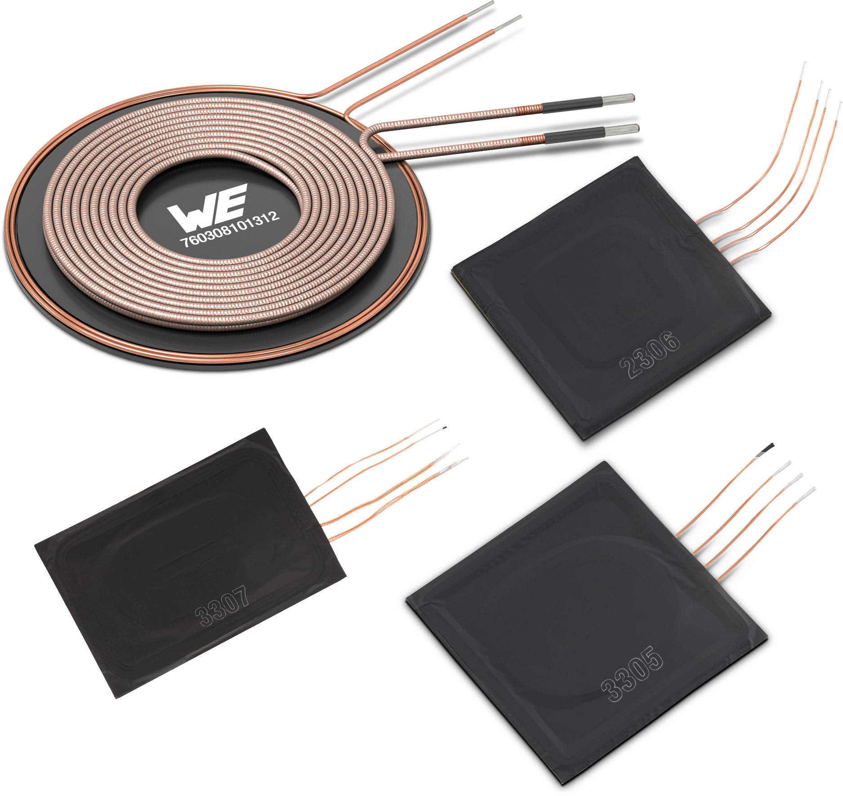
Image source: Würth Elektronik
Wireless Power Transfer Coil
WE-WPCC WPT/NFC

About the Würth Elektronik eiSos Group
Würth Elektronik eiSos Group is a manufacturer of electronic and electromechanical components for the electronics industry and a technology company that spearheads pioneering electronic solutions. Würth Elektronik eiSos is one of the largest European manufacturers of passive components and is active in 50 countries. Production sites in Europe, Asia and North America supply a growing number of customers worldwide.
The product range includes EMC components, inductors, transformers, RF components, varistors, capacitors, resistors, quartz crystals, oscillators, power modules, Wireless Power Transfer, LEDs, sensors, connectors, power supply elements, switches, push-buttons, connection technology, fuse holders and solutions for wireless data transmission.
The unrivaled service orientation of the company is characterized by the availability of all catalog components from stock without minimum order quantity, free samples and extensive support through technical sales staff and selection tools.
Through its technology partnership with the Audi Sport ABT Schaeffler Formula E Team and its support for the Formula Student racing series, the company demonstrates its innovative strength in eMobility
(www.we-speed-up-the-future.com).
Würth Elektronik is part of the Würth Group, the world market leader for assembly and fastening technology. The company employs 7,300 staff and generated sales of 822 million euros in 2019.
Würth Elektronik: more than you expect!
Further information at www.we-online.com

Further information:  Würth Elektronik eiSos GmbH & Co. KG  Sarah Hurst  Max-Eyth-Strasse 1  74638 Waldenburg  Germany  Phone: +49 7942 945-5186  E-mail: sarah.hurst@we-online.de  www.we-online.de | Press contact:  HighTech communications GmbH  Brigitte Basilio  Brunhamstrasse 21  81249 Munich  Germany  Phone: +49 89 500778-20  Telefax: +49 89 500778-77  E-mail: b.basilio@htcm.de  www.htcm.de

