PRESS RELEASE

Würth Elektronik offers WE-CLFS EMC Line Filters

Watertown (USA), 27 April 2020 – Würth Elektronik is available to help prevent EMI problems with non-compliant equipment.
Würth Elektronik offers complete WE-CLFS EMC Line Filters. These have most components one needs for an EMC filter inside of a welded enclosure for perfect shielding. All WE-CLFS filters have at least 65dB of peak attenuation, and come with UL and VDE certifications, which ensures safety requirements are already factored into the design. With 3 different types available: single stage, single-stage advanced, and two-stage, with options of with a rated current up to 20A.
Another solution Würth Elektronik offers is the “Design Your Own EMC Filter” kit, which includes different common mode chokes (CMCs), X capacitors, Y capacitors, and connectors, as well as a booklet including pre-determined filters which eliminate calculations and component selection. This kit will enable the user to assemble a working EMC filter during design.
For the off-the-shelf power supply’s radiated emissions, a cable ferrite is the easiest solution. Würth Elektronik’s free component selection tool, REDEXPERT, allows users to sort through all cable ferrites, including parts to fit specific cables, to find the best solution in just a few seconds.
To view the Würth Elektronik EMC line filters, and to order the “Design Your Own EMC Filter” kit, visit www.we-online.com/we-clfs.

Available images
The following images can be downloaded from the Internet in printable quality: http://www.htcm.de/kk/wuerth
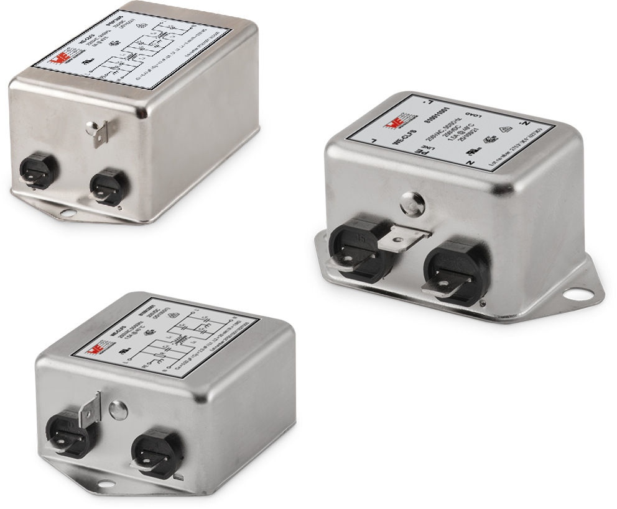  Image source: Wurth Electronics  Würth Elektronik offers complete WE-CLFS EMC Line Filters. | 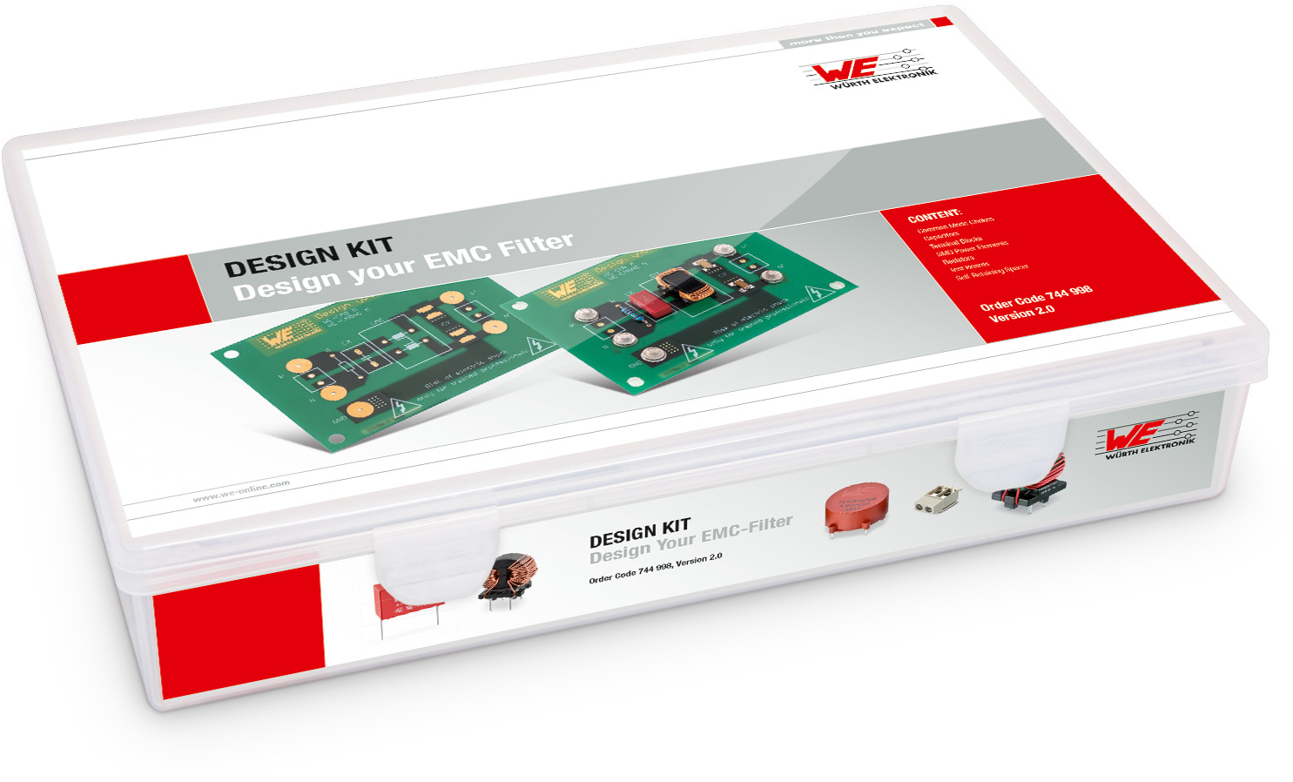  Image source: Wurth Electronics  Würth Elektronik’s “Design Your Own EMC Filter” kit

About Würth Elektronik eiSos Group
Würth Elektronik eiSos Group is a manufacturer of electronic and electromechanical components for the electronics industry and a technology company that spearheads pioneering electronic solutions. The company currently employs 7,300 staff and generated sales of 822 million euros in 2019. Würth Elektronik eiSos is one of the largest European manufacturers of passive components and is active in 50 countries. Production sites in Europe, Asia and North America supply a growing number of customers worldwide.
The product range includes EMC components, inductors, transformers, RF components, varistors, capacitors, resistors, quartz crystals, oscillators, power modules, Wireless Power Transfer, LEDs, sensors, connectors, power supply elements, switches, push-buttons, connection technology, fuse holders and solutions for wireless data transmission.
The unrivaled service orientation of the company is characterized by the availability of all catalog components from stock without minimum order quantity, free samples and extensive support through technical sales staff and selection tools.
Through its technology partnership with the Audi Sport ABT Schaeffler Formula E Team and its support for the Formula Student racing series, the company demonstrates its innovative strength in eMobility
(www.we-speed-up-the-future.com).
Würth Elektronik eiSos is part of the Würth Group, the world market leader for assembly and fastening technology.
Würth Elektronik: more than you expect!
Further information at www.we-online.com

Further information:  Wurth Electronics Midcom, Inc.  Lindsey Esche  121 Airport Drive  PO Box 1330  Watertown, SD 57201 USA  Phone: +1 605 886 4385  Toll-free (in the U.S.):  Phone: +1 800 643 2661  E-mail: lindsey.esche@we-online.com  www.we-online.com | Press contact:  HighTech communications GmbH  Brigitte Basilio  Brunhamstrasse 21  81249 Munich  Germany  Phone: +49 89 500778-20  Fax: +49 89 500778-77  E-mail: b.basilio@htcm.de  www.htcm.de

