PRESS RELEASE
Würth Elektronik presents Development Kit for horticultural lighting applications
Controlling plant growth with LEDs
Waldenburg (Germany), 18 June 2020 - The new Lighting Development Kit from Würth Elektronik with horticulture LEDs accelerates the development of systems for targeted plant lighting. Companies developing solutions for vertical farming in cities or optimized "supplemental lighting" in greenhouses can use the Development Kit to explore the effect of different "lighting recipes" on plants and in their different growth phases. The circuit developed by Würth Elektronik thus accelerates the development of lighting control systems.
The aim of horticulture LED solutions is to optimize various properties such as: the light spectrum, lighting intensity growth intervals for different plants and other quality parameters in order to increase the yield or to increase the content of valuable secondary substances such as flavonols. The Lighting Development Kit offers a simple solution to mix RGBW colors for different lighting strategies and to control plant growth with the supplied Horticulture Panel (includes LEDs with wavelength 450 nm, 660 nm, 730 nm and RGBW LEDs). The Magl³C multi-color LED driver supplies the panel with power. With four Magl³C LED Step Down High Current Modules at its centerpiece, it is possible to individually control the intensity of the four LED strings. This makes it possible to generate light with different wavelength ratios and to investigate their effect on different plants in their growth phases.
The control is done with the free iOS app "WEilluminate" via Bluetooth LE. A version for Android will be available soon.
Blueprint for commercial solutions
The kit is suitable for individual developers, start-ups, agricultural research and lighting manufacturers. The board contains an EMI filter to meet the limits of the lighting standard specified in EN55015 and the industry standard CISPR32, even when dimming the LED strings. The circuit is therefore also a prototype for larger applications.
Under this link Lighting Development Kit you can find all further information as well as a Quick Start Guide and Application Notes.

Available images
The following images can be downloaded from the Internet in printable quality: http://www.htcm.de/kk/wuerth
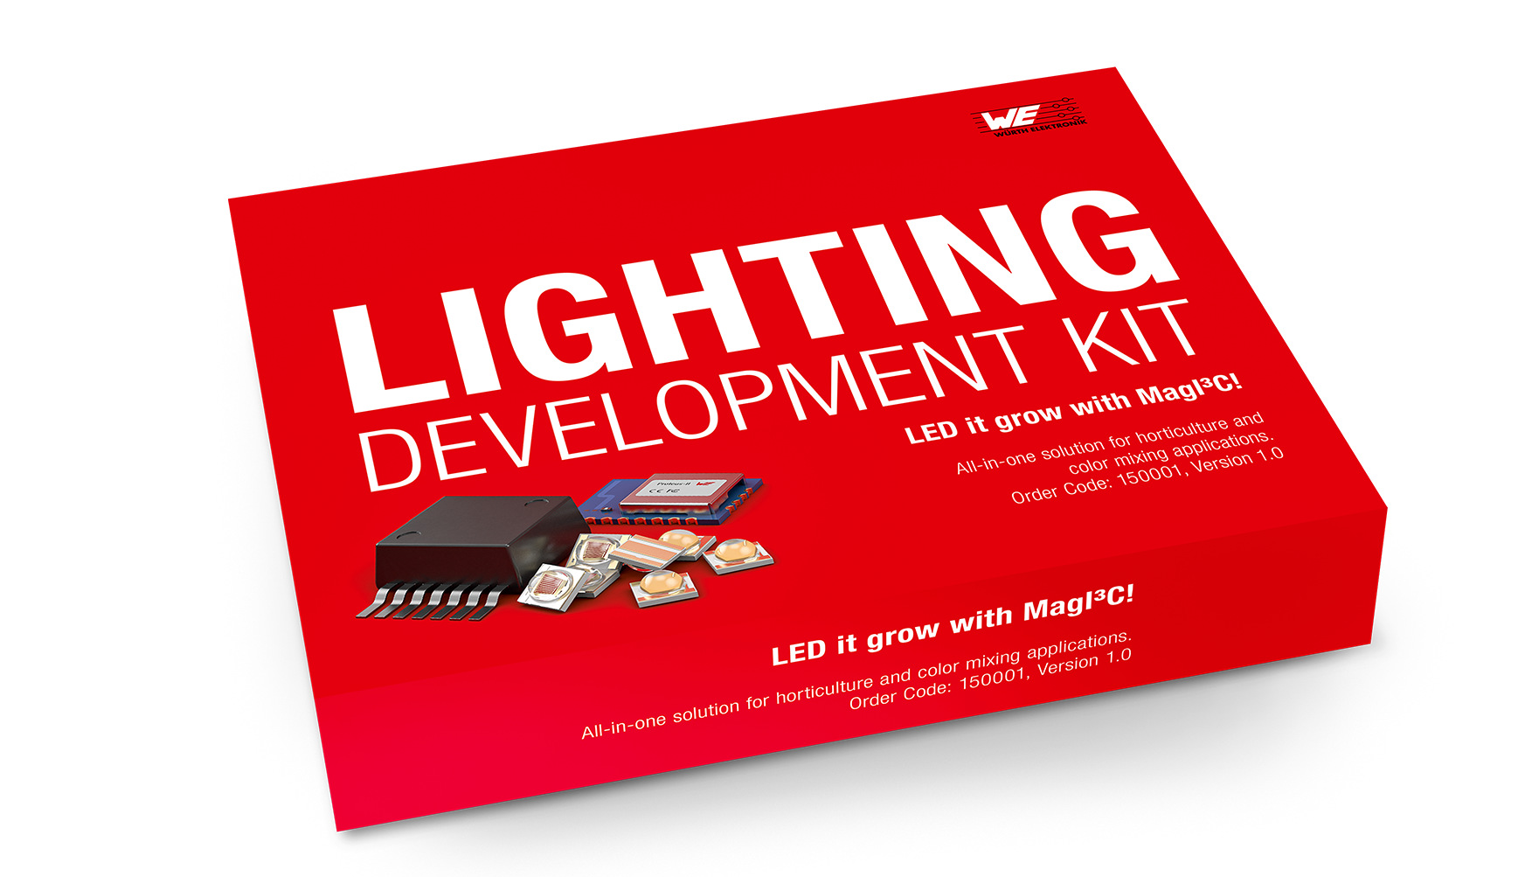

Image source: Würth Elektronik
Lighting Development Kit for the development of lighting control systems

About the Würth Elektronik eiSos Group
Würth Elektronik eiSos Group is a manufacturer of electronic and electromechanical components for the electronics industry and a technology company that spearheads pioneering electronic solutions. Würth Elektronik eiSos is one of the largest European manufacturers of passive components and is active in 50 countries. Production sites in Europe, Asia and North America supply a growing number of customers worldwide.
The product range includes EMC components, inductors, transformers, RF components, varistors, capacitors, resistors, quartz crystals, oscillators, power modules, Wireless Power Transfer, LEDs, sensors, connectors, power supply elements, switches, push-buttons, connection technology, fuse holders and solutions for wireless data transmission.
The unrivaled service orientation of the company is characterized by the availability of all catalog components from stock without minimum order quantity, free samples and extensive support through technical sales staff and selection tools.
Through its technology partnership with the Audi Sport ABT Schaeffler Formula E Team and its support for the Formula Student racing series, the company demonstrates its innovative strength in eMobility
(www.we-speed-up-the-future.com).
Würth Elektronik is part of the Würth Group, the world market leader for assembly and fastening technology. The company employs 7,300 staff and generated sales of 822 million euros in 2019.
Würth Elektronik: more than you expect!
Further information at www.we-online.com

Further information:  Würth Elektronik eiSos GmbH & Co. KG  Sarah Hurst  Max-Eyth-Strasse 1  74638 Waldenburg  Germany  Phone: +49 7942 945-5186  E-mail: sarah.hurst@we-online.de  www.we-online.de | Press contact:  HighTech communications GmbH  Brigitte Basilio  Brunhamstrasse 21  81249 Munich  Germany  Phone: +49 89 500778-20  Telefax: +49 89 500778-77  E-mail: b.basilio@htcm.de  www.htcm.de

