PRESS RELEASE
Würth Elektronik extends its MagI³C series
MagI³C Micro Power Module Reports Status
Waldenburg (Germany), 21 July 2020 – Würth Elektronik extends its MagI³C power module product family to include a compact 1 A version in LGA-6EP package. The special feature of the module (type 171010501) is the “power good” function. The module indicates on one pin whether the output voltage is in the nominal range.
The signal for the correct output voltage can be collected and used by a microcontroller to make applications more reliable and efficient. The failure of a power module can therefore be detected more quickly. It is also possible to implement a switch-on sequence using the “power good” signal. This prevents several power modules on a common power supply from switching on simultaneously thus generating a current peak.
High efficiency
The "Variable Step Down MicroModule" (VDMM) supplies an output current of up to 1 A. It operates with an input voltage of 2.5 to 5.5 V and the output voltage can be set variably between 0.8 and 5.5 V. Measuring just 3.2 x 2.5 x 1.6 mm, the module maintains high efficiency (up to 96%) across the entire output current range by automatically switching between operating modes depending on load requirements. It offers integrated protection circuitry to prevent damage from overheating, overcurrent voltage, short-circuit voltage and undervoltage. Typical applications include point-of-load DC/DC applications with 5 or 3.3 V bus voltages, replacing linear regulators, supplying I/O interfaces and MCUs, supplying DSPs and FPGAs with auxiliary voltage, portable devices, and battery powered applications. The module is EMC compliant in accordance with EN55032 Class B/CISPR-32. The LGA-6EP package of the new MagI³C-VDMM represents a pin-compatible version of the previous 1 A and 0.6 A MicroModules, along with the new “power good” pin.
The MagI³C-VDMM with “power good” function is available immediately from stock without minimum order quantity. Free samples can be requested. An evaluation board is also available for the product.

Available images
The following images can be downloaded from the Internet in printable quality: http://www.htcm.de/kk/wuerth
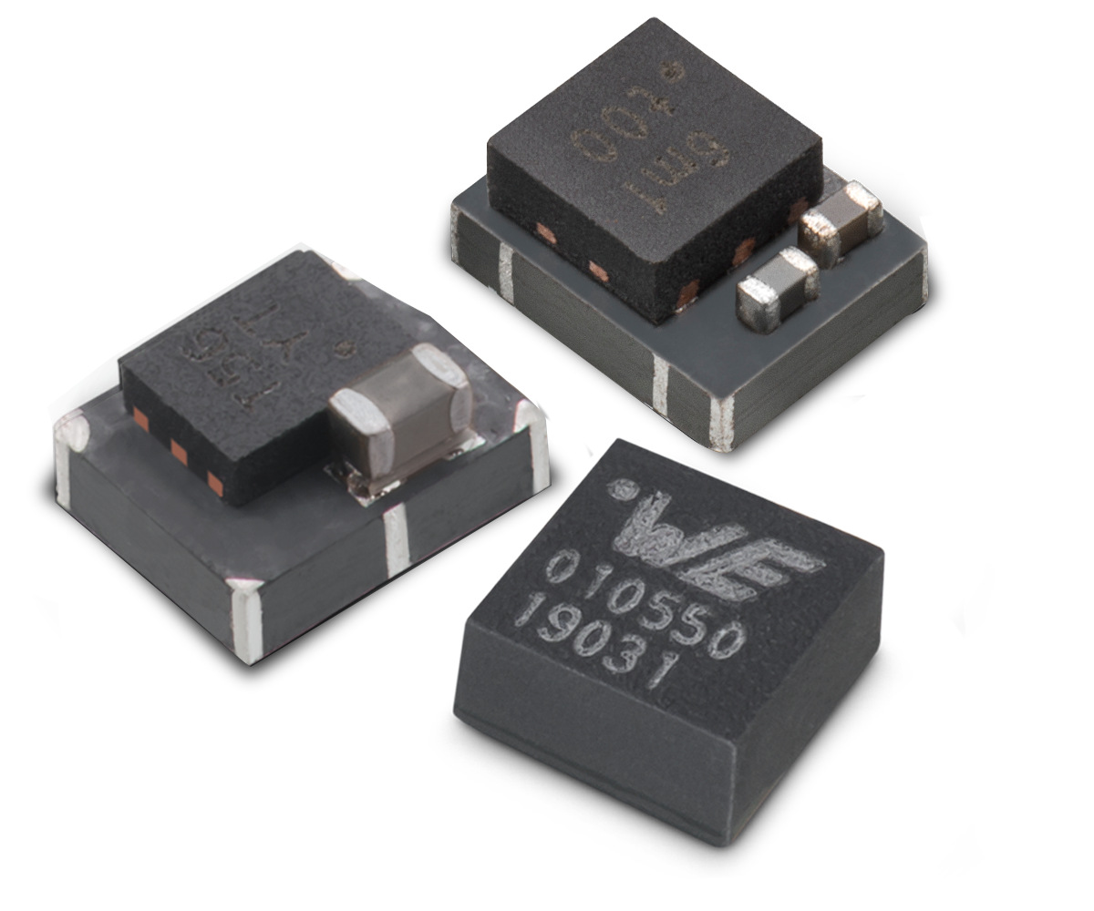
Image source: Würth Elektronik
MagI³C-VDMM with “power good” function

About the Würth Elektronik eiSos Group
Würth Elektronik eiSos Group is a manufacturer of electronic and electromechanical components for the electronics industry and a technology company that spearheads pioneering electronic solutions. Würth Elektronik eiSos is one of the largest European manufacturers of passive components and is active in 50 countries. Production sites in Europe, Asia and North America supply a growing number of customers worldwide.
The product range includes EMC components, inductors, transformers, RF components, varistors, capacitors, resistors, quartz crystals, oscillators, power modules, Wireless Power Transfer, LEDs, sensors, connectors, power supply elements, switches, push-buttons, connection technology, fuse holders and solutions for wireless data transmission.
The unrivaled service orientation of the company is characterized by the availability of all catalog components from stock without minimum order quantity, free samples and extensive support through technical sales staff and selection tools.
Through its technology partnership with the Audi Sport ABT Schaeffler Formula E Team and its support for the Formula Student racing series, the company demonstrates its innovative strength in eMobility
(www.we-speed-up-the-future.com).
Würth Elektronik is part of the Würth Group, the world market leader for assembly and fastening technology. The company employs 7,300 staff and generated sales of 822 million euros in 2019.
Würth Elektronik: more than you expect!
Further information at www.we-online.com

Further information:  Würth Elektronik eiSos GmbH & Co. KG  Sarah Hurst  Max-Eyth-Strasse 1  74638 Waldenburg  Germany  Phone: +49 7942 945-5186  E-mail: sarah.hurst@we-online.de  www.we-online.de | Press contact:  HighTech communications GmbH  Brigitte Basilio  Brunhamstrasse 21  81249 Munich  Germany  Phone: +49 89 500778-20  Telefax: +49 89 500778-77  E-mail: b.basilio@htcm.de  www.htcm.de

