PRESS RELEASE
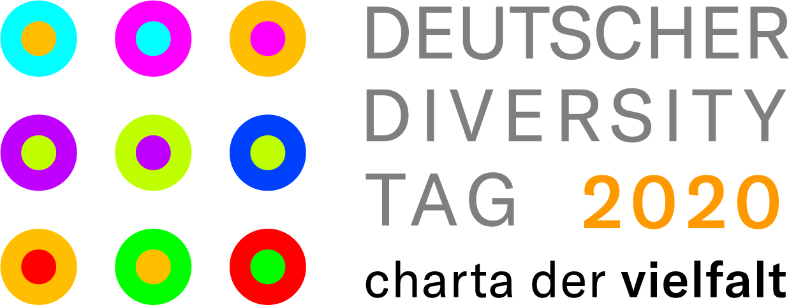
Würth Elektronik celebrates internationality on Diversity Day
Because of Corona online this time
Waldenburg (Germany), 3 June 2020 - On the occasion of the Diversity Day on 26 May, Würth Elektronik celebrated its own diversity this time in terms of internationality. For five years now, the company has been part of the Diversity Charter, which this year called for online activities under the hashtag #FlagforDiversity against the background of the Corona pandemic.
For the Diversity Day, employees from all locations sent in photos of themselves in their home office or at work with the flag of their nation of origin for a large diversity collage. Würth Elektronik is a global group of companies and this is also reflected in the workforce. At the Würth Elektronik eiSos Group alone, one of the largest European manufacturers of electronic and electromechanical components, people of 40 different nationalities work in Germany. The motto "We live diversity and value diversity" in the company's job advertisements is therefore both a commitment and an expression of the reality in the company. The result of the action can be admired
on Facebook (https://www.facebook.com/Wuerth.Elektronik.Karriere and https://www.facebook.com/Wuerth.Elektronik.eiSos.Group/),
Instagram (https://www.instagram.com/we_karriere/).

Available images
The following images can be downloaded from the Internet in printable quality: http://www.htcm.de/kk/wuerth
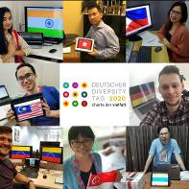
For the Diversity Day, employees from all locations took photos of themselves in their home offices. The image here shows an example of a collage that was created.
Image source: Würth Elektronik

About the Würth Elektronik eiSos Group
Würth Elektronik eiSos Group is a manufacturer of electronic and electromechanical components for the electronics industry and a technology company that spearheads pioneering electronic solutions. Würth Elektronik eiSos is one of the largest European manufacturers of passive components and is active in 50 countries. Production sites in Europe, Asia and North America supply a growing number of customers worldwide.
The product range includes EMC components, inductors, transformers, RF components, varistors, capacitors, resistors, quartz crystals, oscillators, power modules, Wireless Power Transfer, LEDs, sensors, connectors, power supply elements, switches, push-buttons, connection technology, fuse holders and solutions for wireless data transmission.
The unrivaled service orientation of the company is characterized by the availability of all catalog components from stock without minimum order quantity, free samples and extensive support through technical sales staff and selection tools.
Through its technology partnership with the Audi Sport ABT Schaeffler Formula E Team and its support for the Formula Student racing series, the company demonstrates its innovative strength in eMobility
(www.we-speed-up-the-future.com).
Würth Elektronik is part of the Würth Group, the world market leader for assembly and fastening technology. The company employs 7,300 staff and generated sales of 822 million euros in 2019.
Würth Elektronik: more than you expect!
Further information at www.we-online.com

Further information:  Würth Elektronik eiSos GmbH & Co. KG  Sarah Hurst  Max-Eyth-Strasse 1  74638 Waldenburg  Germany  Phone: +49 7942 945-5186  E-mail: sarah.hurst@we-online.de  www.we-online.de | Press contact:  HighTech communications GmbH  Brigitte Basilio  Brunhamstrasse 21  81249 Munich  Germany  Phone: +49 89 500778-20  Telefax: +49 89 500778-77  E-mail: b.basilio@htcm.de  www.htcm.de

