PRESS RELEASE
Würth Elektronik sets up a virtual exhibition stand
Communication without mask
Waldenburg (Germany), 30 June 2020 – As Würth Elektronik is not able to present new products to customers and interested parties in personal contact at trade fairs due to the COVID-19 pandemic, the manufacturer of electronic and electromechanical components has now set up a virtual exhibition stand (www.we-online.de/virtual). Instead of visiting a trade fair, visitors will find an attractive online presentation of product innovations and the possibility to have a direct conversation in the chat.
The Würth Elektronik team offers a creative answer to the current situation with its virtual trade fair stand. Interested developers and manufacturers can use this platform to stay in close, personal contact with the manufacturer. Products are visualized with their technical data and can be discussed with Würth Elektronik specialists in the chat. Component samples and developer support can be requested directly from the virtual booth. Also available: Tools for precise product selection such as the measurement database application REDEXPERT as well as order forms, catalogues and specialist books.
Focus topic Single Pair Ethernet
As lectures are held at exhibition stands, webinars can be found at the virtual exhibition stand. The current focus topic here is Single Pair Ethernet. Würth Elektronik offers solutions and standard-compliant reference designs that make this copper-saving cabling, which originates from the automotive sector, usable for industrial applications - for example for connecting sensors or as a replacement for other bus systems. Of course, visitors can also reach job advertisements and company information from Würth Elektronik in addition to the focus topic from the virtual booth.

Available images
The following images can be downloaded from the Internet in printable quality: http://www.htcm.de/kk/wuerth

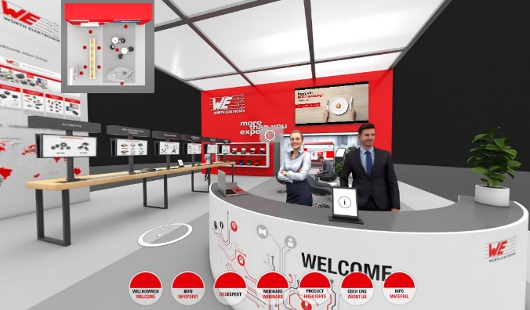
Image source: Würth Elektronik
At www.we-online.de/virtual Würth Elektronik presents a virtual booth

About the Würth Elektronik eiSos Group
Würth Elektronik eiSos Group is a manufacturer of electronic and electromechanical components for the electronics industry and a technology company that spearheads pioneering electronic solutions. Würth Elektronik eiSos is one of the largest European manufacturers of passive components and is active in 50 countries. Production sites in Europe, Asia and North America supply a growing number of customers worldwide.
The product range includes EMC components, inductors, transformers, RF components, varistors, capacitors, resistors, quartz crystals, oscillators, power modules, Wireless Power Transfer, LEDs, sensors, connectors, power supply elements, switches, push-buttons, connection technology, fuse holders and solutions for wireless data transmission.
The unrivaled service orientation of the company is characterized by the availability of all catalog components from stock without minimum order quantity, free samples and extensive support through technical sales staff and selection tools.
Through its technology partnership with the Audi Sport ABT Schaeffler Formula E Team and its support for the Formula Student racing series, the company demonstrates its innovative strength in eMobility
(www.we-speed-up-the-future.com).
Würth Elektronik is part of the Würth Group, the world market leader for assembly and fastening technology. The company employs 7,300 staff and generated sales of 822 million euros in 2019.
Würth Elektronik: more than you expect!
Further information at www.we-online.com

Further information:  Würth Elektronik eiSos GmbH & Co. KG  Sarah Hurst  Max-Eyth-Strasse 1  74638 Waldenburg  Germany  Phone: +49 7942 945-5186  E-mail: sarah.hurst@we-online.de  www.we-online.de | Press contact:  HighTech communications GmbH  Brigitte Basilio  Brunhamstrasse 21  81249 Munich  Germany  Phone: +49 89 500778-20  Telefax: +49 89 500778-77  E-mail: b.basilio@htcm.de  www.htcm.de

