PRESS RELEASE
Würth Elektronik introduces its WE-CST EE4.4 current sense transformers
Smaller and Better Insulated
Waldenburg (Germany), 17 August 2020 - Würth Elektronik expands the product family of WE-CST current sense transformers with the new WE-CST EE4.4 series. An innovative manufacturing process not only makes these current sense transformers extremely small (4.7 x 4.65, 3.55 mm), but also provides better insulation. Their insulation voltage of 750 V_{AC}, is 50 percent higher than that of market competitors. The WE-CST series type EE4.4 is suitable for a broad range of high frequency applications up to 1 MHz with currents up to 7 A.
Applications for the minute SMT-mountable current sense transformers include AC current measurement, switched mode power supplies, overload detection, load shedding and disconnect detection, metering, load measurement and high frequency current sensing. The current sense transformer displays excellent temperature behavior and is approved for the operating temperature range of -40 to +125°C. WE-CST EE4.4 is available from stock in four different winding ratios from 1:20 to 1:150. Five further variants are set to be added in August. Developers can receive free samples on request. Würth Elektronik does not specify a minimum order quantity.

Available image material
The following image material ready for printing is available for downloading at: http://www.htcm.de/kk/wuerth
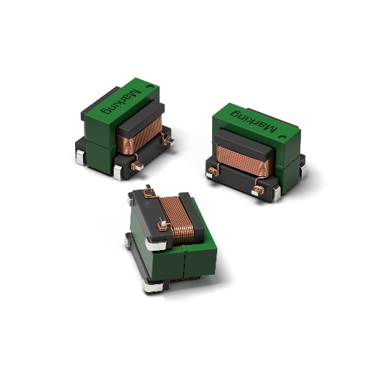
Image source: Würth Elektronik
WE-CST EE4.4 current sense transformers

About the Würth Elektronik eiSos Group
Würth Elektronik eiSos Group is a manufacturer of electronic and electromechanical components for the electronics industry and a technology company that spearheads pioneering electronic solutions. Würth Elektronik eiSos is one of the largest European manufacturers of passive components and is active in 50 countries. Production sites in Europe, Asia and North America supply a growing number of customers worldwide.
The product range includes EMC components, inductors, transformers, RF components, varistors, capacitors, resistors, quartz crystals, oscillators, power modules, Wireless Power Transfer, LEDs, sensors, connectors, power supply elements, switches, push-buttons, connection technology, fuse holders and solutions for wireless data transmission.
The unrivaled service orientation of the company is characterized by the availability of all catalog components from stock without minimum order quantity, free samples and extensive support through technical sales staff and selection tools.
Through its technology partnership with the Audi Sport ABT Schaeffler Formula E Team and its support for the Formula Student racing series, the company demonstrates its innovative strength in eMobility
(www.we-speed-up-the-future.com).
Würth Elektronik is part of the Würth Group, the world market leader for assembly and fastening technology. The company employs 7,300 staff and generated sales of 822 million euros in 2019.
Würth Elektronik: more than you expect!
Further information at www.we-online.com

Further information:  Würth Elektronik eiSos GmbH & Co. KG  Sarah Hurst  Max-Eyth-Strasse 1  74638 Waldenburg  Germany  Phone: +49 7942 945-5186  E-mail: sarah.hurst@we-online.de  www.we-online.de | Press contact:  HighTech communications GmbH  Brigitte Basilio  Brunhamstrasse 21  81249 Munich  Germany  Phone: +49 89 500778-20  Telefax: +49 89 500778-77  E-mail: b.basilio@htcm.de  www.htcm.de

