PRESS RELEASE
Würth Elektronik presents the WE-TGF thermoconductive gap filler
Conducts heat, not current
Waldenburg (Germany), 2 September 2020 – With its WE-TGF (Thermal Gap Filler) Würth Elektronik now offers a new solution for heat dissipation. The outstanding feature of the self-adhesive gap-filler material: The non-conductive barrier with a high dielectric strength has a high thermoconductivity index of 1 W/(m*K). The material easily adapts to the differing thicknesses of components on the PCB and fills the gaps between hot electronic components and metal casings or cooling components.
WE-TGF is made of silicone incorporating ceramic particles. For applications in which the PCB is screwed onto a metal plate, the material is also reinforced with a glass-fibre mesh. The thermoconductive gap filler is suited for use e.g. in power electronics, entertainment technology, or in networking devices. WE-TGF is available ex stock in a variety of dimensions and in thicknesses ranging from 0.23 to 5 mm. Developers working in the prototype construction area can request individually cut samples, which are shipped within 48 hours of ordering. Customization comes at no extra charge for the customer.

Available images
The following images can be downloaded from the Internet in printable quality: http://www.htcm.de/kk/wuerth
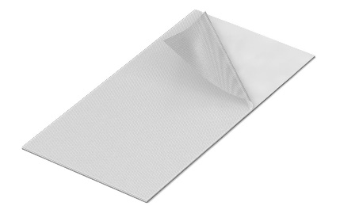
Image source: Würth Elektronik
WE-TGF thermoconductive gap filler

About the Würth Elektronik eiSos Group
Würth Elektronik eiSos Group is a manufacturer of electronic and electromechanical components for the electronics industry and a technology company that spearheads pioneering electronic solutions. Würth Elektronik eiSos is one of the largest European manufacturers of passive components and is active in 50 countries. Production sites in Europe, Asia and North America supply a growing number of customers worldwide.
The product range includes EMC components, inductors, transformers, RF components, varistors, capacitors, resistors, quartz crystals, oscillators, power modules, Wireless Power Transfer, LEDs, sensors, connectors, power supply elements, switches, push-buttons, connection technology, fuse holders and solutions for wireless data transmission.
The unrivaled service orientation of the company is characterized by the availability of all catalog components from stock without minimum order quantity, free samples and extensive support through technical sales staff and selection tools.
Through its technology partnership with the Audi Sport ABT Schaeffler Formula E Team and its support for the Formula Student racing series, the company demonstrates its innovative strength in eMobility
(www.we-speed-up-the-future.com).
Würth Elektronik is part of the Würth Group, the world market leader for assembly and fastening technology. The company employs 7,300 staff and generated sales of 822 million euros in 2019.
Würth Elektronik: more than you expect!
Further information at www.we-online.com

Further information:  Würth Elektronik eiSos GmbH & Co. KG  Sarah Hurst  Max-Eyth-Strasse 1  74638 Waldenburg  Germany  Phone: +49 7942 945-5186  E-mail: sarah.hurst@we-online.de  www.we-online.de | Press contact:  HighTech communications GmbH  Brigitte Basilio  Brunhamstrasse 21  81249 Munich  Germany  Phone: +49 89 500778-20  Telefax: +49 89 500778-77  E-mail: b.basilio@htcm.de  www.htcm.de

