PRESS RELEASE
Just published: the Electronic Components 2020 catalogue
New product releases and services
Waldenburg (Germany), 25 August 2020 – The new “Electronic Components 2020” catalogue is now available, and can be ordered from Würth Elektronik in the print version or downloaded as a PDF. The 184-page catalogue presents new products and services in the area of passive components, optoelectronics, and power modules. Separate special catalogues are available for many other product categories of Würth Elektronik. All products in the new catalogue are available ex stock. Würth Elektronik is glad to supply free-of-charge samples to support developers in their projects: in connection with the design kits, which can be refilled at no extra charge, they can also be supplied to development labs over their entire product life.
Among the many highlights of the new “Electronic Components 2020” catalogue are the new high-current flat-wire inductors (WE-HCM), multilayer ceramic inductors (WE-MK), and current sense transformers of the WE-CST EE4.4 series. Thanks to an innovative manufacturing process, these transformers are smaller and better insulated than comparable products available on the market. In the optoelectronics field, the WL-OCPT optocoupler phototransistors and the extensions of the LED range by white LEDs with five different color temperatures deserve particular attention. The new additions to the range of the MagI³C-FDSM family of particularly efficient power modules will surely also whet the appetites of developers and suppliers.

Available images
The following images can be downloaded from the Internet in printable quality: http://www.htcm.de/kk/wuerth

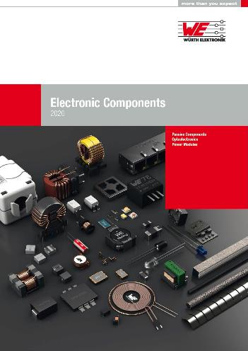
Image source: Würth Elektronik
The “Electronic Components 2020” Catalogue

About the Würth Elektronik eiSos Group
Würth Elektronik eiSos Group is a manufacturer of electronic and electromechanical components for the electronics industry and a technology company that spearheads pioneering electronic solutions. Würth Elektronik eiSos is one of the largest European manufacturers of passive components and is active in 50 countries. Production sites in Europe, Asia and North America supply a growing number of customers worldwide.
The product range includes EMC components, inductors, transformers, RF components, varistors, capacitors, resistors, quartz crystals, oscillators, power modules, Wireless Power Transfer, LEDs, sensors, connectors, power supply elements, switches, push-buttons, connection technology, fuse holders and solutions for wireless data transmission.
The unrivaled service orientation of the company is characterized by the availability of all catalog components from stock without minimum order quantity, free samples and extensive support through technical sales staff and selection tools.
Through its technology partnership with the Audi Sport ABT Schaeffler Formula E Team and its support for the Formula Student racing series, the company demonstrates its innovative strength in eMobility
(www.we-speed-up-the-future.com).
Würth Elektronik is part of the Würth Group, the world market leader for assembly and fastening technology. The company employs 7,300 staff and generated sales of 822 million euros in 2019.
Würth Elektronik: more than you expect!
Further information at www.we-online.com

Further information:  Würth Elektronik eiSos GmbH & Co. KG  Sarah Hurst  Max-Eyth-Strasse 1  74638 Waldenburg  Germany  Phone: +49 7942 945-5186  E-mail: sarah.hurst@we-online.de  www.we-online.de | Press contact:  HighTech communications GmbH  Brigitte Basilio  Brunhamstrasse 21  81249 Munich  Germany  Phone: +49 89 500778-20  Telefax: +49 89 500778-77  E-mail: b.basilio@htcm.de  www.htcm.de

