PRESS RELEASE
New General Managers at Würth Elektronik eiSos GmbH & Co. KG
Dirk Knorr and Josef Wörner take over management
Waldenburg (Germany), 30 July 2020 – As of the 1st of May 2020, Dirk Knorr and Josef Wörner have been appointed as General Managers for the German business of the Würth Elektronik eiSos GmbH & Co. KG, having been a part of the management circle of the company for years.
Dirk Knorr, a graduate industrial engineer and trained industrial electronics technician, was recently head of international quality and environmental management at Würth Elektronik. The 44-year-old was also responsible for risk management and material compliance. Before joining Würth Elektronik in 2005, he worked as a project manager for key accounts at a company for system solutions in the electronics industry.
Josef Wörner (51) started his training as a telecommunications engineer at Deutsche Bundespost and made his career in sales at a German manufacturer of passive components. Since 2001, he has held various positions at Würth Elektronik eiSos GmbH & Co. KG, including the title of Director responsible for the Electromechanics Division since 2017. Josef Wörner will continue to be responsible for this division.
"We are pleased that we could win and appoint two experienced General Managers for Würth Elektronik eiSos in Germany. Dirk Knorr and Josef Wörner will be the contact persons for all concerns of the German parent company. This step had been planned for quite some time and we would like to thank Mr. Knorr and Mr. Wörner for their extraordinary work so far and wish them continuing success for the next years", say Thomas Schrott, Alexander Gerfer and Thomas Wild. They will remain as General Managers of the German Würth Elektronik eiSos GmbH & Co. KG, but as part of their functions on the Management Board, they will devote more time to the management and strategic orientation of the entire Würth Elektronik eiSos Group, which includes a continuously growing number of companies and production sites all over the world.

Available images
The following images can be downloaded from the Internet in printable quality: http://www.htcm.de/kk/wuerth
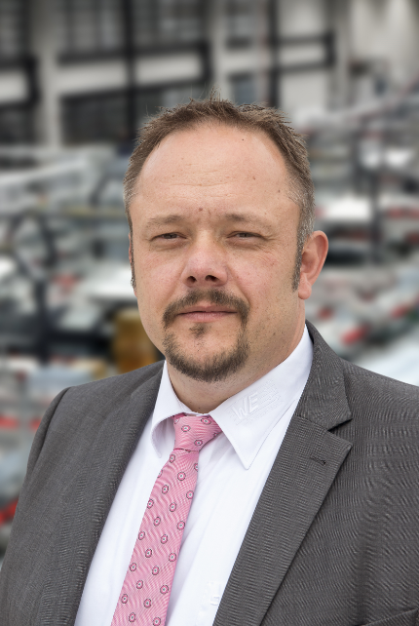  Image source: Würth Elektronik  Dirk Knorr, General Manager of Würth Elektronik eiSos GmbH & Co. KG | 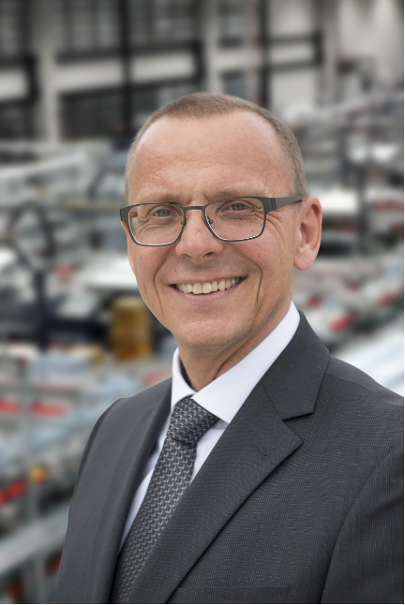  Image source: Würth Elektronik  Josef Wörner, General Manager of Würth Elektronik eiSos GmbH & Co. KG

About Würth Elektronik eiSos Group
Würth Elektronik eiSos Group is a manufacturer of electronic and electromechanical components for the electronics industry and a technology company that spearheads pioneering electronic solutions. The company currently employs 7,300 staff and generated sales of 822 million euros in 2019. Würth Elektronik eiSos is one of the largest European manufacturers of passive components and is active in 50 countries. Production sites in Europe, Asia and North America supply a growing number of customers worldwide.
The product range includes EMC components, inductors, transformers, RF components, varistors, capacitors, resistors, quartz crystals, oscillators, power modules, Wireless Power Transfer, LEDs, sensors, connectors, power supply elements, switches, push-buttons, connection technology, fuse holders and solutions for wireless data transmission.
The unrivaled service orientation of the company is characterized by the availability of all catalog components from stock without minimum order quantity, free samples and extensive support through technical sales staff and selection tools.
Through its technology partnership with the Audi Sport ABT Schaeffler Formula E Team and its support for the Formula Student racing series, the company demonstrates its innovative strength in eMobility
(www.we-speed-up-the-future.com).
Würth Elektronik eiSos is part of the Würth Group, the world market leader for assembly and fastening technology.
Würth Elektronik: more than you expect!
Further information at www.we-online.com

Further information:  Würth Elektronik eiSos GmbH & Co. KG  Sarah Hurst  Max-Eyth-Strasse 1  74638 Waldenburg  Germany  Phone: +49 7942 945-5186  E-mail: sarah.hurst@we-online.de  www.we-online.de | Press contact:  HighTech communications GmbH  Brigitte Basilio  Brunhamstrasse 21  81249 Munich  Germany  Phone: +49 89 500778-20  Telefax: +49 89 500778-77  E-mail: b.basilio@htcm.de  www.htcm.de

