PRESS RELEASE

Würth Elektronik introduces its WL-OCPT optocoupler
Signal Transmission with Reliable Galvanic Isolation
Waldenburg (Germany), 28 July 2020 – With its new WL-OCPT Series 816 product family, Würth Elektronik offers phototransistor-type optocouplers for the first time. These coplanar design optocouplers consist of an infrared LED on the input side and a phototransistor on the output side. They are characterized by a high insulation voltage of 5 kV and a stable current transfer ratio (CTR) over the entire operating temperature range. The WL-OCPT is available in five different THT and SMT contacting variants each with five CTR binnings each from 50 to 600 percent. Würth Elektronik decided for a copper lead-frame instead of the otherwise usual iron lead-frames for these robust and durable components. WL-OCPT is suitable for use in power supplies and chargers, computers and microprocessors, electricity meters and many other applications that require signal transmission together with safe galvanic isolation.
The coplanar structure inside the white housing keeps a fixed distance gap to ensure overvoltage protection. The operating temperature range of the WL-OCPT is -55 to +110°C and the CTR is stable over this entire range. The maximum collector-emitter voltage for this series is 80 V.
The WL-OCPT 816 series is certified according to VDE EN60747-5-5:2011 (No. 40051484), UL 1577 (No. E513104) and CQC GB4943.1-2001; GB8898-2011(No. CQC20001244742).
Free samples of the optocouplers with phototransistor output are available now. All 25 products in 816 series are available from stock without a minimum order quantity.

Available images
The following images can be downloaded from the Internet in printable quality: http://www.htcm.de/kk/wuerth
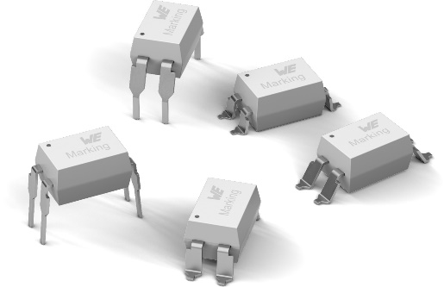
Image source: Würth Elektronik
WL-OCPT 816 Series Optocoupler Phototransistor

About the Würth Elektronik eiSos Group
Würth Elektronik eiSos Group is a manufacturer of electronic and electromechanical components for the electronics industry and a technology company that spearheads pioneering electronic solutions. Würth Elektronik eiSos is one of the largest European manufacturers of passive components and is active in 50 countries. Production sites in Europe, Asia and North America supply a growing number of customers worldwide.
The product range includes EMC components, inductors, transformers, RF components, varistors, capacitors, resistors, quartz crystals, oscillators, power modules, Wireless Power Transfer, LEDs, sensors, connectors, power supply elements, switches, push-buttons, connection technology, fuse holders and solutions for wireless data transmission.
The unrivaled service orientation of the company is characterized by the availability of all catalog components from stock without minimum order quantity, free samples and extensive support through technical sales staff and selection tools.
Through its technology partnership with the Audi Sport ABT Schaeffler Formula E Team and its support for the Formula Student racing series, the company demonstrates its innovative strength in eMobility
(www.we-speed-up-the-future.com).
Würth Elektronik is part of the Würth Group, the world market leader for assembly and fastening technology. The company employs 7,300 staff and generated sales of 822 million euros in 2019.
Würth Elektronik: more than you expect!
Further information at www.we-online.com

Further information:  Würth Elektronik eiSos GmbH & Co. KG  Sarah Hurst  Max-Eyth-Strasse 1  74638 Waldenburg  Germany  Phone: +49 7942 945-5186  E-mail: sarah.hurst@we-online.de  www.we-online.de | Press contact:  HighTech communications GmbH  Brigitte Basilio  Brunhamstrasse 21  81249 Munich  Germany  Phone: +49 89 500778-20  Telefax: +49 89 500778-77  E-mail: b.basilio@htcm.de  www.htcm.de

